

AI-DRIVEN COMPLEX EMOTION RECOGNITION USING FACIAL EXPRESSION IMAGES
Mosaic: Basic and compound emotion estimation from a single face with a CNN multi-label classifier and a conditional GAN
A project report submitted in partial fulfilment of the requirements for the award of the degree of
BACHELOR OF TECHNOLOGY
in
COMPUTER SCIENCE AND ENGINEERING (DATA SCIENCE)
Submitted by
B. SHIRISHA | 23K91A6730
B. ASHRITH | 23K91A6731
B. MURALI | 23K91A6724
B. GOUTHAM | 23K91A6727
Batch A16 (CSDS-A)
Under the esteemed guidance of
[GUIDE NAME]
[DESIGNATION]
DEPARTMENT OF COMPUTER SCIENCE AND ENGINEERING (DATA SCIENCE)
[COLLEGE NAME]
[COLLEGE ADDRESS]
Academic year [ACADEMIC YEAR]

CERTIFICATE
This is to certify that the project report entitled "AI-Driven Complex Emotion Recognition Using Facial Expression Images" is a bonafide record of the work carried out by B. SHIRISHA (23K91A6730), B. ASHRITH (23K91A6731), B. MURALI (23K91A6724), B. GOUTHAM (23K91A6727), in partial fulfilment of the requirements for the award of the degree of Bachelor of Technology in Computer Science and Engineering (Data Science), during the academic year [ACADEMIC YEAR], under my supervision.

Project Guide | Head of the Department | Principal
[GUIDE NAME] | [HOD NAME] | [PRINCIPAL NAME]
[DESIGNATION] | Department of Computer Science and Engineering (Data Science) | [COLLEGE NAME]

External Examiner: [NAME AND SIGNATURE]
Place: [PLACE]
Date: [DATE]

DECLARATION
We hereby declare that the project report entitled "AI-Driven Complex Emotion Recognition Using Facial Expression Images", submitted to the Department of Computer Science and Engineering (Data Science), [COLLEGE NAME], in partial fulfilment of the requirements for the award of the degree of Bachelor of Technology in Computer Science and Engineering (Data Science), is a record of original work carried out by us under the guidance of [GUIDE NAME], [DESIGNATION]. The results embodied in this report have not been submitted to any other university or institution for the award of any degree or diploma.

B. SHIRISHA 23K91A6730
B. ASHRITH 23K91A6731
B. MURALI 23K91A6724
B. GOUTHAM 23K91A6727

Place: [PLACE]
Date: [DATE]

ACKNOWLEDGEMENT
We express our sincere gratitude to our project guide, [GUIDE NAME], [DESIGNATION], for valuable guidance, encouragement and constructive suggestions throughout this project.
We thank [HOD NAME], Head of the Department of Computer Science and Engineering (Data Science), for providing the facilities and support needed to complete this work, and [PRINCIPAL NAME], Principal, [COLLEGE NAME], for the encouragement given to us.
We thank the project coordinators and all faculty and staff members of the department for their help, and our families and friends for their constant support.
We also acknowledge the authors of the base paper and of the related work cited in this report, the creators and maintainers of the FER2013 dataset and of its Hugging Face mirror used for training and evaluation, and the maintainers of the open-source software used in this project (Python, PyTorch, OpenCV, FastAPI, SQLAlchemy, scikit-learn, NumPy, matplotlib, Next.js, React, Recharts, pytest and Playwright).

B. SHIRISHA
B. ASHRITH
B. MURALI
B. GOUTHAM

ABSTRACT
Most facial emotion recognition systems assign one basic emotion (happy, sad, angry, fear, disgust, surprise or neutral) to a face, although real expressions often mix several emotions, such as happiness with surprise. Labelled data for such compound expressions is scarce, and expression-editing methods that could create it tend to distort the person's identity. This project builds Mosaic, a working web application that follows the analysis-by-synthesis approach of Khine et al. (IEEE Access, 2025): a conditional GAN (cEmoGAN) is trained to synthesise faces, eleven compound-emotion classes are synthesised by conditioning the generator on two emotions at once, and a convolutional neural network with 18 sigmoid outputs (7 basic and 11 compound labels) is trained on real FER2013 faces plus the synthetic ones. A FastAPI service detects the largest face with an OpenCV Haar cascade, runs the network, stores history for signed-in users in SQLite, and serves a Next.js console that shows a basic-emotion chart, compound-emotion scores and the dominant emotion.
Measured on the 7,178-image FER2013 test set, the multi-label network reaches 58.14 % basic-emotion accuracy (macro-F1 0.538) against 50.56 % (macro-F1 0.473) for the single-label backbone it was initialised from; a seeded ablation in Chapter 8 shows how much of that difference comes from the synthetic images. The compound outputs, however, are not functional in the shipped model: on real test faces their largest probability averages 0.0002, so the dominant emotion is never a compound label, and on 1,100 freshly generated compound faces their ROC-AUC is 0.50, which is chance. The generator itself does not obey its condition (a classifier recovers the intended basic emotion on only 15.0 % of its faces, chance being 14.3 %), and FER2013 contains no compound ground truth, so compound recognition could not be validated on real data. The base paper's scores were measured on its own generated images and are not comparable. 28 automated tests pass and the API answers an analysis in about 19 ms on a CPU-only computer. The report documents these gaps and the product defects found, and proposes concrete next steps.
Keywords: complex emotion recognition, compound facial expressions, conditional GAN, multi-label CNN, FER2013, FastAPI, Next.js.

TABLE OF CONTENTS
CERTIFICATE i
DECLARATION ii
ACKNOWLEDGEMENT iii
ABSTRACT iv
TABLE OF CONTENTS v
LIST OF FIGURES viii
LIST OF TABLES x
LIST OF ABBREVIATIONS xi
1. INTRODUCTION 1
1.1 Domain and Background 1
1.2 Motivation 2
1.3 Problem Statement 3
1.4 Need for the System 3
1.5 Objectives 4
1.6 Scope of the Work 4
1.7 Contributions 5
1.8 Limitations and Assumptions 5
1.9 Organisation of the Report 6
2. LITERATURE SURVEY 7
2.1 Overview 7
2.2 Base Paper Analysis 7
2.3 Related Work 9
2.4 Datasets and Algorithms Used in the Surveyed Work 11
2.5 Comparison, Strengths and Limitations 11
2.6 Research Gap 12
3. FEASIBILITY STUDY 14
3.1 Introduction 14
3.2 Technical Feasibility 14
3.3 Economic Feasibility 15
3.4 Operational Feasibility 15
3.5 Schedule Feasibility 16
3.6 Advantages and Constraints 16
4. SYSTEM REQUIREMENTS AND ANALYSIS 17
4.1 Introduction 17
4.2 Existing System and Its Limitations 17
4.3 Proposed System 17
4.4 Functional Requirements 18
4.5 Non-Functional Requirements 18
4.6 Hardware Requirements 19
4.7 Software Requirements 19
4.8 User Roles 20
4.9 Constraints and Assumptions 20
5. SYSTEM DESIGN 21
5.1 Design Goals and Architecture 21
5.2 High-Level Workflow 23
5.3 Data Flow Diagrams 23
5.4 UML Class Design 25
5.5 Sequence Design of the Main Flow 26
5.6 Use-Case Design 27
5.7 Database Design 28
5.8 Core Algorithms 29
5.9 Module Design 30
5.10 API Design 31
5.11 User Interface Design 32
5.12 Design Decisions and Their Reasons 34
6. METHODOLOGY AND SOFTWARE IMPLEMENTATION 35
6.1 Overall Methodology 35
6.2 Dataset 36
6.3 Preprocessing 37
6.4 Algorithm Choice and Justification 37
6.5 Mathematical Formulation 38
6.6 Model Architecture and Training 39
6.7 Application Architecture 41
6.8 API Design 43
6.9 Security and Error Handling 44
6.10 Installation and Execution 44
7. SYSTEM TESTING 46
7.1 Testing strategy 46
7.2 Test environment 46
7.3 Unit testing 47
7.4 Integration testing 47
7.5 Functional testing: a walk-through with real data 48
7.6 Security testing 49
7.7 Validation and edge cases 50
7.8 Performance testing 51
7.9 User acceptance 52
7.10 The limits of the testing done 53
8. RESULTS AND OUTPUT SCREENS 54
8.1 What was measured and how 54
8.2 Output screens 54
8.3 Basic-emotion recognition 57
8.4 Does the synthetic data help? A seeded ablation 58
8.5 Compound emotions 60
8.6 Quality of the conditional GAN 61
8.7 Comparison with the base paper and related work 63
8.8 Face detection and the serving path 64
8.9 Success and failure analysis 65
8.10 Limitations of these results 65
8.11 Objectives versus outcomes 66
8.12 Summary of findings 66
9. CONCLUSION 67
9.1 Summary of the work 67
9.2 Objectives achieved and not achieved 67
9.3 Key findings 68
9.4 Practical applications 69
9.5 Known limitations 69
10. FUTURE SCOPE 70
10.1 Improvements to the existing system 70
10.2 Additional features 71
10.3 Scalability and deployment 71
10.4 Further research 72
REFERENCES 73
APPENDIX A: IMPORTANT CODE 75
A.1 Face crop to scores: preprocessing and `analyze_image_bytes()` (`ml/inference.py`) 75
A.2 The conditional generator (`ml/gan_model.py`) 75
A.3 Synthesising compound-emotion faces (`ml/synthesize_compound.py`) 76
A.4 Training the 18-output classifier (`ml/train_final_classifier.py`) 76
A.5 The analysis endpoint (`routers/analyze.py`) 76
A.6 Password hashing and tokens (`security.py`) 77
APPENDIX B: INSTALLATION AND USER GUIDE 78
B.1 Requirements 78
B.2 Backend set-up 78
B.3 Training the models (one time) 78
B.4 Starting the API 78
B.5 Starting the console 79
B.6 Using Mosaic 79
B.7 Running the automated tests 79
B.8 Troubleshooting 80
APPENDIX C: ADDITIONAL SCREENS 80

LIST OF FIGURES
Figure 1: System architecture of Mosaic: browser tier, FastAPI service, ML modules and local files. 2
Figure 2: Class distribution of the FER2013 data used by Mosaic. Disgust has only 436 training images, a point that matters again in Chapter 8. 11
Figure 3: System architecture of Mosaic: browser tier, FastAPI service, ML modules and local files. 22
Figure 4: High-level workflow: three offline training stages, then one online pass per uploaded image. 23
Figure 5: Level 0 data flow diagram: Mosaic and its four external entities. 23
Figure 6: Level 1 data flow diagram: seven processes and four data stores. 24
Figure 7: Level 2 data flow diagram: processes 3.0 (classify) and 4.0 (rank and respond) expanded. 25
Figure 8: UML class diagram of the classes and module-level interfaces present in the code. 25
Figure 9: Sequence diagram: a signed-in user uploads a photo and receives a result. 26
Figure 10: Use-case diagram: what the end user, an API client and the developer can do. 27
Figure 11: Entity-relationship diagram of the SQLite database: two tables joined one-to-many. 28
Figure 12: Flowchart of analyze_image_bytes(), the algorithm every request passes through. 29
Figure 13: Flowchart of the training pipeline: backbone, cEmoGAN, synthesis and the final multi-label classifier. 30
Figure 14: Landing page: hero with the animated particle canvas and the call to action. 32
Figure 15: Analyse page before an upload: Upload and Webcam tabs, drop zone and an empty results panel. 32
Figure 16: Analyse page after uploading a real FER2013 face: dominant card, basic-emotion chart and compound bars. 33
Figure 17: History page: one card per stored analysis with its dominant label, confidence and time. 33
Figure 18: Training pipeline of Mosaic: backbone, cEmoGAN, compound synthesis and the final multi-label classifier. 36
Figure 19: Application architecture of Mosaic: browser, FastAPI service, ML modules and local files. 42
Figure 20: Haar detection rate against image size (left) and accuracy of the final model on the same faces through the product path and by direct resizing (right). 51
Figure 21: Median and 95th-percentile latency of each measured request (log scale). 52
Figure 22: Result for a happy face: the card names Happy (47 % confidence); the bar chart shows Surprise (44 %) as the runner-up; every compound bar reads 0 %. The thumbnail is a broken image (defect F6, Chapter 7). 55
Figure 23: Result for an angry face: Angry is dominant with 75 % confidence, the highest of the seven samples. 55
Figure 24: A neutral face read as Fear (24 % confidence, the lowest of the samples): a low-confidence error, typical of the confusion between neutral, sad and fear. 55
Figure 25: A native 48 x 48 face: the Haar detector finds nothing, the API answers 200 with face_detected false and the console shows 'No face was detected in that image'. 55
Figure 26: A face synthesised by the cEmoGAN under the condition 'happily surprised'. The image is a blurred blob, classified Sad (53 %); the happily-surprised bar shows 1 %. 56
Figure 27: History page: one card per analysis, newest first, with the dominant label, confidence and time; the entry without a face is listed as 'No face detected'. 56
Figure 28: History detail route /app/history/[id], opened by typing its address because no link leads to it; it re-renders the stored result. 56
Figure 29: Normalised confusion matrix of the final model on the FER2013 test set (counts and row percentages). 57
Figure 30: Per-class F1 of the single-label baseline and of the final multi-label model. 58
Figure 31: Normalised confusion matrix of the single-label baseline, for comparison with the final model. 58
Figure 32: Ablation over seeds: test accuracy and macro-F1 with and without synthetic compound faces; dots are single seeds, bars the mean. 59
Figure 33: Accuracy and macro-F1 against the number of synthetic faces per compound class (single seed). 60
Figure 34: Synthetic hold-out: micro-F1 and compound recall against the decision threshold (left) and compound ROC-AUC compared with the real-only control and with chance (right). 61
Figure 35: Real FER2013 training faces, one row per basic emotion. 62
Figure 36: Generator output for the same seven one-hot conditions: blurred, low-contrast face-like patterns. 62
Figure 37: Generator output for the eleven compound conditions (0.5 / 0.5 on the two component emotions). 62
Figure 38: Condition fidelity of the generator, judged by the stage-1 classifier: one-hot conditions (left) and compound conditions (right). 63
Figure 39: Landing page: hero with the animated particle canvas and the call to action. 80
Figure 40: Landing page: the four product features (compound states, multi-label scores, generative augmentation, history). 80
Figure 41: Landing page: the three steps and the ribbon of compound-emotion names. 81
Figure 42: Log-in page: e-mail and password fields. 81
Figure 43: Registration page before input. 81
Figure 44: Registration page filled in with the demonstration account (the password field is masked). 81
Figure 45: Analysis page before any image: upload area and the placeholder results panel. 81
Figure 46: Analysis page re-opened from the side bar; the Webcam tab was not exercised in this run, the image shows the Upload tab. 81
Figure 47: Result for a real FER2013 face labelled sad: dominant emotion Sad. 82
Figure 48: Result for a real FER2013 face labelled fear: dominant emotion Fear. 82
Figure 49: Result for a real FER2013 face labelled surprise, read as Fear. 82
Figure 50: Result for a cEmoGAN-generated face conditioned on angrily disgusted: dominant Angry, compound bars about 1 %. 82

LIST OF TABLES
Table 1: Abbreviations used in this report xi
Table 2: Project objectives and where they are addressed 4
Table 3: Organisation of the report 6
Table 4: Results reported in the base paper (read from its Tables 2 to 5 and Section IV) 8
Table 5: Datasets named in the surveyed work and in this project 11
Table 6: Surveyed work: approach, finding and limitation 11
Table 7: Strengths and limitations of the approach families 12
Table 8: Technology choices and the evidence that they are feasible 14
Table 9: Cost summary 15
Table 10: Work plan 16
Table 11: Limitations of the existing approaches 17
Table 12: Functional requirements 18
Table 13: Non-functional requirements 18
Table 14: Hardware 19
Table 15: Software (pinned in backend/requirements.txt and frontend/package.json) 19
Table 16: User roles 20
Table 17: The EmotionCNN layers (ml/classifier_model.py) 26
Table 18: Table users 28
Table 19: Table analyses 28
Table 20: Backend modules (backend/app) 30
Table 21: Front-end modules (frontend/src) 31
Table 22: Endpoints 31
Table 23: Principal design decisions 34
Table 24: FER2013 class counts as loaded by the product 36
Table 25: Algorithms chosen, the reason and the alternative 37
Table 26: Layers of EmotionCNN with 18 outputs 40
Table 27: Layers of the conditional generator 40
Table 28: Training configuration copied from the defaults of the three training scripts 40
Table 29: Backend modules 42
Table 30: Endpoints 43
Table 31: Security measures and what they do not cover 44
Table 32: Test activities and where their evidence is recorded. 46
Table 33: Unit tests by area. 47
Table 34: Integration tests by area. 47
Table 35: Functional test cases and observed behaviour. 48
Table 36: Probes sent to the running API (127.0.0.1) and what came back. 49
Table 37: Latency of the Mosaic API (milliseconds). 52
Table 38: The seven real faces of the walk-through (dominant label returned by the running API). 56
Table 39: Seven-class results on the FER2013 test set (7,178 faces). 57
Table 40: Per-class results of the final model, with the baseline's F1 for comparison. 57
Table 41: Final-stage retraining with and without the synthetic faces (FER2013 test set, seven basic labels). 59
Table 42: Effect of the number of synthetic faces per compound class (seed 1). 59
Table 43: Final model on the synthetic hold-out, over all 18 labels. 60
Table 44: Mosaic against the base paper and the related results quoted in this report. 64
Table 45: The five objectives of the batch and what was measured. 66
Table 46: Batch objectives against the outcome 67
Table 47: Common problems 80

LIST OF ABBREVIATIONS
Table 1: Abbreviations used in this report
Abbreviation | Expansion
API | Application Programming Interface
AUC | Area Under the Curve
BCE | Binary Cross-Entropy
BGR | Blue-Green-Red colour order (OpenCV)
CK+ | Extended Cohn-Kanade facial expression dataset
CNN | Convolutional Neural Network
CORS | Cross-Origin Resource Sharing
CPU | Central Processing Unit
cEmoGAN | Conditioned Emotion Generative Adversarial Network
CSS | Cascading Style Sheets
DFD | Data Flow Diagram
EMR | Exact Match Ratio
ER | Entity-Relationship
FER | Facial Expression Recognition
FER2013 | Facial Expression Recognition 2013 dataset
FID | Fréchet Inception Distance
GAN | Generative Adversarial Network
GPU | Graphics Processing Unit
HOG | Histogram of Oriented Gradients
HTTP | Hypertext Transfer Protocol
JAFFE | Japanese Female Facial Expression dataset
JPEG | Joint Photographic Experts Group image format
JSON | JavaScript Object Notation
JWT | JSON Web Token
MUG | Multimedia Understanding Group facial expression dataset
ORM | Object-Relational Mapping
RAF-DB | Real-world Affective Faces Database
ReLU | Rectified Linear Unit
REST | Representational State Transfer
ROC | Receiver Operating Characteristic
SQL | Structured Query Language
SVM | Support Vector Machine
UI | User Interface
UML | Unified Modeling Language
ViT | Vision Transformer

1. INTRODUCTION

1.1 Domain and Background
Emotions shape how people communicate, and the face is one of the richest signals of emotional state. Facial expression recognition (FER) is therefore studied for human-computer interaction, mental-health monitoring, driver-safety systems, smart classrooms and customer-experience analysis [15]. The dominant way to frame the task is categorical: following Ekman and Friesen [10], a face is assigned one of six basic emotions (anger, disgust, fear, happiness, sadness and surprise), usually with a neutral class added, which gives the seven classes of the FER2013 benchmark [11] used in this project.
Real expressions are often not that simple. A winner at a sports event may look both happy and tearful, and a person on a roller coaster may look both happy and frightened. Du, Tao and Martinez [9] showed that people routinely produce and recognise compound facial expressions, combinations of two basic emotions such as "happily surprised" or "sadly angry", and the base paper of this project, Khine et al. [1], argues that a six- or seven-class system "oversimplifies emotional expression" and proposes to estimate complex emotions as a multi-label problem.
The technical difficulty is data. Datasets with compound labels are small, and the large in-the-wild datasets that exist are labelled with a single category per face. The base paper therefore uses analysis by synthesis: a conditional generative adversarial network [17] (its cEmoGAN) is trained to generate faces for a requested mixture of emotions, and a recognition network is then trained on those generated faces with one sigmoid output per emotion, so that a single image can carry several labels at once.
This project builds Mosaic, a complete, runnable application around that idea: a training pipeline (a seven-class backbone, a conditional GAN, and a final 18-output multi-label network trained on real and synthetic faces), a FastAPI service with accounts and history, and a Next.js web console in which a user uploads a photo or takes a webcam frame and sees a basic-emotion chart, compound-emotion scores and a dominant emotion.
Two design choices of the base paper are worth keeping in mind throughout the report. The first is that the recogniser is multi-label: instead of one softmax over seven classes it has one sigmoid per emotion, so "happy" and "surprise" can both be high at the same time and a compound class such as "happily surprised" can be added as one more output. The second is that the generator is conditional: a vector that says which emotions are present is fed to the generator, so the person building the training set controls what is produced. Mosaic keeps both choices and builds the compound label set from eleven pairs of basic emotions.
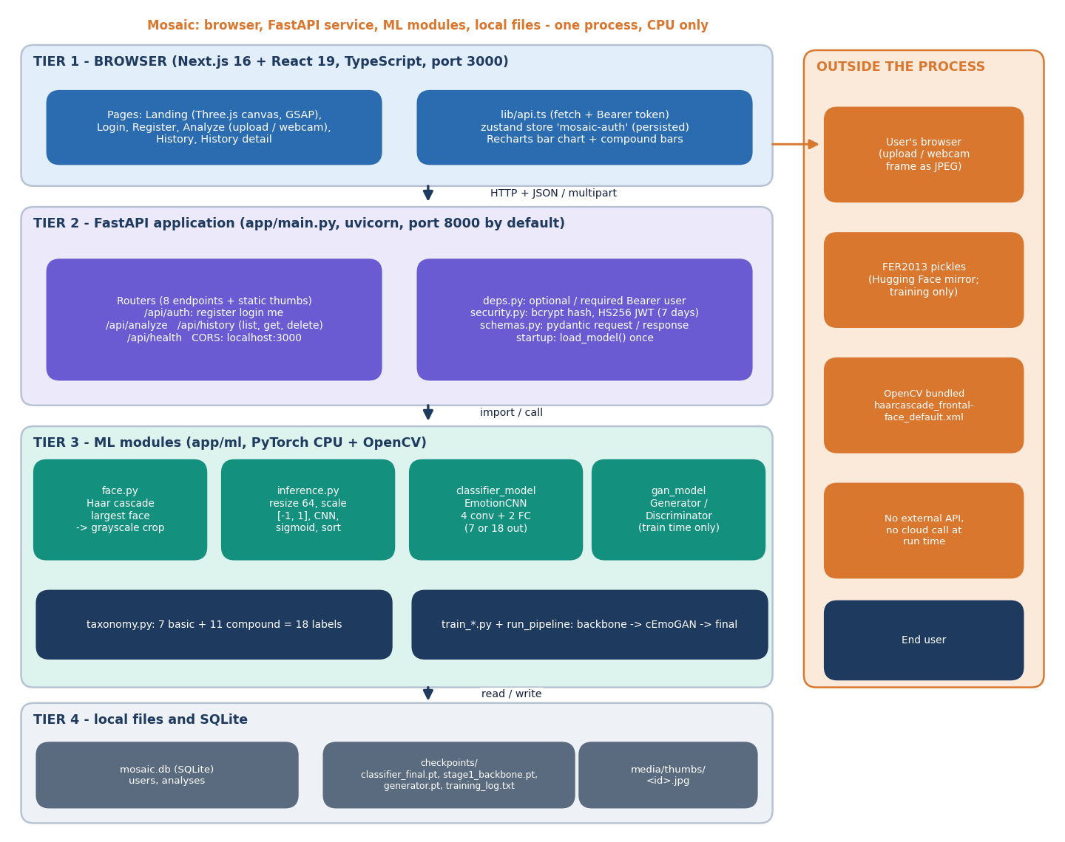
Figure 1: System architecture of Mosaic: browser tier, FastAPI service, ML modules and local files.
The figure shows the four tiers. The browser tier is a Next.js application; the FastAPI process owns the routers, token handling and the inference module; the ML modules detect the face, classify it and (at training time only) synthesise faces; SQLite, the checkpoint files and a folder of face thumbnails hold the state. Chapter 5 explains each tier.

1.2 Motivation
Three observations from the batch survey and the base paper motivate the work.
• Single-label systems cannot express mixtures. A model with a softmax output must pick one class, so a face that is both happy and surprised is forced into one of them.
• Compound-emotion data is scarce. The base paper builds its compound ground truth by morphing two peak-expression images and then trains its generator on those morphs and uses it to generate new images, because labelled mixtures hardly exist.
• Editing methods distort identity. Expression-editing GANs can change the emotion but often change the person; the base paper's encoder-plus-conditional-GAN design is meant to keep the identity fixed while the label changes the expression.
A fourth, practical motivation is that published pipelines of this kind are rarely available as an end-to-end application that a non-specialist can run. Building one forces every stage to be made explicit and measurable: how many images go in, what the generator actually produces, and what the final network does on real photographs.

1.3 Problem Statement
The batch problem statement is reproduced here, followed by the engineering questions it raises.
• Existing systems recognise only single basic emotions.
• Real expressions often contain several emotions at once.
• Complex-emotion training data is scarce.
• Expression-editing methods distort facial identity.
Need. A system that generates realistic complex-emotion data and recognises multiple emotions in a single face.
In engineering terms the project asks four questions. (1) Can a conditional GAN trained on a few thousand labelled faces produce faces that carry two emotions at once? (2) Does adding such faces to the training set give a multi-label network that recognises both basic and compound emotions? (3) How does that network compare with a single-label baseline on real faces? (4) Can all of this be delivered as an application that a user can operate from a browser? Chapters 6 to 8 answer these questions with measurements, including the answers that turned out to be negative.

1.4 Need for the System
• Applications such as driver monitoring, well-being tools and customer-experience analytics need to know more than "this person is happy"; a mixture such as "happily surprised" or "sadly fearful" changes what the right response is.
• Researchers need a working reference implementation in which the synthetic-data step can be switched on and off, so that its effect can be measured rather than assumed.
• Students and practitioners need a documented, tested example of a face-analysis service that keeps uploaded photographs off disk and stores only a cropped grayscale thumbnail for signed-in users.
The need is also methodological. A claim such as "the synthetic images improve recognition" can only be tested by training the same network with and without them under the same seeds and evaluating on data the generator never saw. This report treats that as a requirement of the system, not an afterthought, and the measurement scripts that produce every number in Chapter 8 are part of the delivered code. A service that analyses faces also handles personal data, so the design stores no uploaded photograph, keeps only a cropped grayscale thumbnail for signed-in users, protects passwords with bcrypt, signs session tokens and lets a user delete any history entry.

1.5 Objectives
The five objectives of the batch (document 6) and where this report addresses each are listed below. Their measured status is given in Chapter 8.
Table 2: Project objectives and where they are addressed
No. | Objective | Where addressed
1 | Generate identity-preserving facial images with complex emotions using cEmoGANs | Chapter 6 (cEmoGAN training and synthesis); Chapter 8 (generator fidelity)
2 | Enlarge the complex-emotion dataset with generated images | Chapter 6 (11 compound classes x 200 synthetic faces); Chapter 8 (sweep over 0, 50, 200 and 800 per class)
3 | Train a CNN multi-label classifier for basic and complex emotions | Chapter 6 (18-output network and its training)
4 | Evaluate recognition performance against single-label baselines | Chapter 8 (baseline, seeded ablation, per-class results)
5 | Provide an interface for emotion recognition from uploaded images | Chapters 5 and 6 (API and web console); Chapter 7 (tests); Chapter 8 (output screens)

1.6 Scope of the Work
In scope.
• Training, on a CPU, of a seven-class backbone, a conditional GAN and an 18-output classifier on FER2013 (28,709 training and 7,178 test images, 48 by 48 pixels, resized to 64 by 64).
• Synthesis of faces for eleven compound-emotion classes by conditioning the generator on two basic emotions at once.
• A FastAPI service with registration, login, optional-token analysis, history list, read and delete, a health check, and static thumbnails.
• A Next.js console with landing page, authentication pages, an upload and webcam analysis page and a history page.
• Measurements: basic-emotion accuracy and F1 with confusion matrices, a seeded ablation with and without synthetic faces, generator fidelity, compound-output behaviour, face-detection rate, API latency and abuse probes, and automated tests.
Out of scope. Identity-preserving encoders, video or temporal modelling, other modalities (voice, text, physiology), GPU training, deployment beyond a single machine and any claim of clinical or safety-critical validity. These are discussed again as limitations in Section 1.8 and in Chapter 10.

1.7 Contributions
1. An end-to-end, runnable implementation of the analysis-by-synthesis pipeline of the base paper: training scripts, 18-label taxonomy, API, database and web console, with a one-command training run.
2. A seeded, controlled evaluation on FER2013 that isolates the effect of the synthetic images: the same network is trained with and without them, over three seeds, and compared with the single-label baseline.
3. A measurement of the generator that the application depends on: how often a classifier recovers the requested emotion from its faces, and a feature-space distance to real faces.
4. An honest account of the compound outputs: on real test faces their largest probability averages 0.0002, and on 1,100 synthetic compound faces their macro ROC-AUC is 0.50 (chance).
5. A tested service: 28 automated tests, 24 abuse probes, latency measurements and a list of the defects found in the shipped application.

1.8 Limitations and Assumptions
Limitations that shape every result in this report are stated here once and revisited in Chapters 7, 8 and 10.
• No compound ground truth. FER2013 carries one basic label per image, so the eleven compound outputs cannot be scored on real data; the only compound-labelled images are the synthetic ones the model was trained on.
• Small, low-resolution data and short training. Faces are 48 by 48 pixels; the backbone, generator and final network were trained for 5, 10 and 5 epochs on a shared CPU. The generator saw only 2,800 faces.
• The generator does not follow its condition. A classifier recovers the requested basic emotion on 15.0 % of generated faces (chance 14.3 %), and generated faces are blurry; identity preservation, which is the base paper's main generative contribution, is not implemented (there is no encoder).
• Base-paper numbers are not comparable. The base paper reports f-beta 0.99, 0.99 and 0.80 on CK+, JAFFE and MUG, measured on 7:3 splits of images generated by its own cEmoGANs. This project's test set is real FER2013 data.
• Framing mismatch. The network is trained on aligned 48 by 48 crops, but the service feeds it a Haar-cascade crop of the uploaded photograph.
The main assumptions are that FER2013 labels are correct enough to evaluate on (they are known to be noisy), that the Hugging Face copy of FER2013 matches the original partition, that users upload roughly frontal faces with one dominant face, and that a single machine without a GPU is the deployment target.

1.9 Organisation of the Report
Table 3: Organisation of the report
Chapter | Content
1 Introduction | Domain, motivation, problem, objectives, scope, contributions, limitations.
2 Literature Survey | Base paper, related work by theme, datasets and algorithms, research gap.
3 Feasibility Study | Technical, economic, operational and schedule feasibility.
4 System Requirements and Analysis | Existing and proposed system, requirements, hardware, software, users.
5 System Design | Architecture, workflow, data flow diagrams, UML, database, modules, user interface.
6 Methodology and Software Implementation | Data, preprocessing, model, training, formulation, API, security, installation.
7 System Testing | Strategy, unit, integration, functional, security, performance, edge cases, limits.
8 Results and Output Screens | Output screens, model performance, ablation, generator fidelity, comparison, objectives versus outcomes.
9 Conclusion | Summary, findings, applications, known limitations.
10 Future Scope | Improvements, features, scalability, further research.
References and Appendices | IEEE reference list; important code; installation and user guide; additional screens.

2. LITERATURE SURVEY

2.1 Overview
This chapter surveys the work behind the project in five steps. It first analyses the base paper in detail, because the pipeline of Mosaic is a re-implementation of its idea; it then groups the related work by theme (compound-expression theory and datasets, deep facial expression recognition, GAN-based recognition, compound-expression recognition, and generative-model evaluation); it describes the datasets and algorithms that appear in that work; it compares the strengths and limitations of the approaches; and it closes with the research gap that the project addresses.
Sources fall into three groups according to how much of each could be read. The base paper, the three papers kept in the batch folder (Galkaduwa, Liu et al. and Su and Rosdi) and the standard references were read or checked against their records; four items of the batch survey (references [2] to [5]) were verified only through their bibliographic records and, for two of them, the abstract. For those items this chapter states only what the record or abstract says and never quotes a result.

2.2 Base Paper Analysis
The base paper is "Complex Emotion Estimation Using Analysis-by-Synthesis of Facial Expression Images" by Khine, Siritanawan and Kotani, published in IEEE Access, volume 13, 2025 [1]. Its aim is to estimate complex emotions, defined as mixtures of two or more basic emotions, from a still face image.

2.2.1 Method
The approach has two parts, shown in the paper as analysis by synthesis.
1. Generation (cEmoGANs). A conditional GAN generator takes a latent vector z and a six-dimensional multi-hot label (anger, disgust, fear, happiness, sadness, surprise; a dimension is 1 when the emotion is present) and produces a face. The discriminator receives the same label. An encoder with two convolution layers, trained to minimise the mean absolute error between an estimated latent and the one predicted from an image, projects a real face into the latent space so that the identity can be held fixed while the label changes the expression. The discriminator learned faster than the generator in preliminary experiments, so learning rates of 1e-5 (discriminator) and 1e-4 (generator) were used with Adam.
2. Recognition. A small convolutional network (convolution layers, a max-pooling layer, flattening and a sigmoid output layer) is trained on the generated faces with a cross-entropy loss applied to each sigmoid output independently, so that each emotion is detected on its own and several can be active together.
The conditional-GAN training objective is the usual one, with the label y given to both networks:
L_cGAN = E_x[ log D(x | y) ] + E_z[ log( 1 − D( G(z | y) | y ) ) ] (1)
The paper prints the second term without the "1 −"; the standard form is shown here. Because a single sigmoid output per emotion cannot be judged by accuracy alone, the paper evaluates recognition with the f-beta score (computed one emotion against the rest) and with the exact match ratio (EMR), the share of images whose whole predicted label set equals the true set.

2.2.2 Data and experimental setting
Experiments use CK+, JAFFE and MUG (laboratory datasets; MUG peak frames, morphed to create two-emotion ground truth). Because these datasets are posed, laboratory collections, the authors select peak-expression images (for the MUG image sequences) and morph two expressions together to obtain ground-truth mixtures. The reported hardware is Intel i9-9900K, NVIDIA RTX A6000. For the recognition experiments, 15,000 images generated by cEmoGANs (and, for comparison, by StyleGANs) are split 7:3 into training and test sets.

2.2.3 Reported results
Table 4: Results reported in the base paper (read from its Tables 2 to 5 and Section IV)
Evaluation | CK+ | JAFFE | MUG
Inception score of generated faces (15-class expression model; higher is better) | 8.8 | 9.0 | 11.4 (best of all models)
Fréchet distance of generated faces (lower is better) | 56.4 | 107.8 | 136.6
BRISQUE distortion score (lower is better) | 20.1 | 31.8 | 11.0 (best of all models)
Identity kept (cosine similarity above 0.7 between a generated face and its re-encoded version) | 98 % | 94 % | 99 %
f-beta of the multi-label recogniser trained on cEmoGAN faces | 0.99 | 0.99 | 0.80
Exact match ratio of the same recogniser | 100 % | 99 % | 68.7 %
f-beta of an EfficientNet-B0 trained on the same data | 0.45 | 0.60 | 0.51
f-beta of the same CNN trained on StyleGAN faces | 0.42 | 0.54 | 0.53

The paper also checks that the generator really mixes expressions, by counting the facial action units that fire in generated faces and comparing them with the action units of the morphed ground truth, and checks feature disentanglement by swapping the label vectors of two latent samples and observing that the expressions swap. For unconstrained photographs (an award ceremony, an Olympic win, a roller coaster) it reports only a qualitative comparison with the Py-Feat recogniser, and it notes that its recogniser, compared with EfficientNet-B0 on basic emotions, misreads sadness as anger and fear as happiness on CK+.

2.2.4 Strengths, weaknesses and what this project takes from it
• Strength: the idea of generating the scarce class (mixtures) instead of collecting it, and of formulating the recogniser as multi-label so that exactly the compound outputs are available.
• Strength: a broad set of generator checks (action units, identity cosine similarity, inception score, Fréchet distance, BRISQUE) rather than a single number.
• Weakness: every recognition score in Table 5 is measured on images produced by the same generator that trained the model, on posed laboratory data, so it does not show performance on real photographs; the authors acknowledge possible demographic bias.
• Weakness: the work depends on a GPU workstation and a morphing step to obtain ground truth that most projects do not have.
Mosaic adopts the two-stage idea (condition a generator on two emotions, train a sigmoid-output network on the result) and the multi-label formulation. It does not implement the identity encoder, and it evaluates on real FER2013 faces rather than on generated ones; Chapter 8 therefore does not rank Mosaic against Table 5 but sets the figures side by side and states plainly that the conditions differ.

2.3 Related Work

2.3.1 Compound expressions: theory and datasets
Du, Tao and Martinez [9] established, from images of people producing them on request, that compound facial expressions of emotion are consistently produced and recognised, and defined categories such as happily surprised and sadly angry. The eleven compound labels of Mosaic (happily surprised, happily disgusted, sadly fearful, sadly angry, sadly surprised, sadly disgusted, fearfully angry, fearfully surprised, angrily surprised, angrily disgusted and disgustedly surprised) are pairs of basic emotions in that spirit. A real-world source of compound labels is RAF-DB [12], whose crowd-sourced annotation includes compound categories; it is the data on which the ABAW7 solution discussed below was pre-trained [7]. It is distributed on request and was not available to this project.

2.3.2 Deep facial expression recognition and baselines
The survey of Li and Deng [15] describes the shift from hand-crafted features to deep networks and the datasets used. A recent controlled comparison by Galkaduwa [6] trains HOG with an SVM, local binary patterns with logistic regression and a lightweight three-block CNN on FER-2013, CK+ and KDEF. On FER-2013 it reports accuracies of 44.0 % (HOG+SVM), 25.0 % (LBP) and 51.6 % (CNN), while on the laboratory dataset CK+ the numbers are 98.4 %, 25.0 % and 96.9 %; the paper concludes that dataset complexity matters more than the choice of feature representation. This is the context for the 50.6 % of Mosaic's single-label backbone and 58.1 % of its final network: FER2013 is a hard, noisy dataset on which small CNNs score around half of the images. Su and Rosdi [8] review 62 multimodal emotion-recognition studies published between 2020 and 2025 and report that CNNs remain the main choice for visual features, while models are computationally demanding and generalise poorly across settings.

2.3.3 GAN-based expression recognition
Several recent papers use GANs to improve recognition rather than to create mixtures. Liu, Ni and Cai [2] propose a contrastive disentangled GAN (CD-GAN) that uses separate encoders for identity and expression, combined with contrastive learning, because expression features overlap strongly with identity features; the abstract reports results comparable to state of the art on laboratory and in-the-wild datasets. Khemakhem and Ltifi [4] propose NST-GAN, which uses neural style transfer to remove identity cues and keep expression, and test it on CK+, FER-2013 and JAFFE. Two further batch-survey items, a multi-level integration disentangled GAN [3] and a face-cycle GAN for cross-domain recognition [5], are cited here for completeness; only their titles and venues were verified. All of these assign one basic label to a face.
General-purpose conditional generators are also relevant: StarGAN [19] translates a face between several attribute domains with a single network, and GANimation [20] animates a face from a single image under action-unit control. They show that expression can be edited with a condition vector, which is the mechanism cEmoGANs use.

2.3.4 Compound-expression recognition
Liu et al. [7] address the ABAW7 compound-expression challenge with an ensemble of a ResNet-50, a Vision Transformer and PosterV2, pre-trained on RAF-DB and fused late. On the RAF-DB compound validation set (seven compound classes) their Table 1 gives an accuracy of 62.13 % and F1 of 54.23 % for the ViT, 64.34 % and 55.36 % for PosterV2 and 60.35 % and 51.54 % for the ResNet; the paper adds that the ensemble can recognise some compound expressions of the challenge videos through zero-shot learning. These numbers are the only compound-class scores on real faces in the surveyed material, and they were obtained with real compound labels, which Mosaic lacks.

2.3.5 Generative models, their evaluation and multi-label learning
The generative adversarial network of Goodfellow et al. [16] trains a generator and a discriminator against each other; the conditional version of Mirza and Osindero [17] feeds a label to both, and DCGAN [18] established convolutional architectures with batch normalisation as a stable design, which the Mosaic generator follows (transposed convolutions with batch normalisation and ReLU, tanh output). Quality is judged with the inception score [22] and the Fréchet inception distance [21], both of which the base paper uses with an expression network in place of Inception. For the recognition side, multi-label learning [27] treats each label as its own binary decision, which is what a bank of sigmoid outputs trained with binary cross-entropy implements.

2.4 Datasets and Algorithms Used in the Surveyed Work
Table 5: Datasets named in the surveyed work and in this project
Dataset | Kind | Labels | Role
FER2013 [11] | Unconstrained, 48x48 grayscale | 7 basic emotions | Used by Mosaic: 28,709 training and 7,178 test images
CK+ [13] | Laboratory, posed | Basic emotions | Base paper; Galkaduwa (constrained, low difficulty)
JAFFE | Laboratory, Japanese female subjects | Basic emotions | Base paper; image morphing for mixtures
MUG | Laboratory image sequences | Basic emotions | Base paper; peak frames, morphed mixtures
KDEF | Laboratory, medium difficulty | Basic emotions | Galkaduwa
RAF-DB [12] | In the wild | Basic and compound | ABAW7 pre-training; on request, not available here
AffectNet [14] | In the wild, large | Categories, valence, arousal | Cited for context

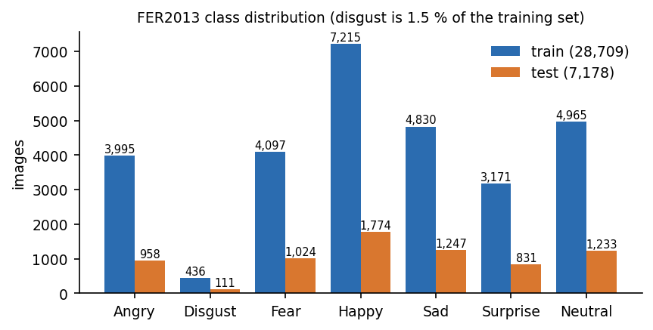
Figure 2: Class distribution of the FER2013 data used by Mosaic. Disgust has only 436 training images, a point that matters again in Chapter 8.
The algorithms that recur are convolutional networks (the base paper's small CNN, Galkaduwa's three-block CNN, the CNN branch of the ABAW7 ensemble), transformers (ViT, PosterV2), and conditional or disentangled GANs. For face localisation, Mosaic uses the Viola-Jones boosted cascade of Haar-like features [23] as implemented in OpenCV [29], trained with Adam [24], batch normalisation [25] and dropout [26] on PyTorch [28].

2.5 Comparison, Strengths and Limitations
Table 6: Surveyed work: approach, finding and limitation
Work | Year | Approach | Finding / limitation
Khine et al. [1] (base paper) | 2025 | cEmoGANs (encoder + conditional GAN, 6-d multi-hot label) generate mixed faces; CNN with sigmoid outputs | f-beta 0.99 / 0.99 / 0.80 on CK+ / JAFFE / MUG, scored on generated images; qualitative tests only on real photos
Liu, Ni, Cai [2] | 2025 | CD-GAN: separate identity and expression encoders, contrastive + adversarial learning | Abstract: comparable to state of the art on field and laboratory sets; single-label recognition
Ni et al. [3] | 2024 | Multi-level integration disentangled GAN for expression recognition (title only) | Batch survey item; abstract not available, results not quoted
Khemakhem, Ltifi [4] | 2023 | NST-GAN: style-transfer GAN that removes identity cues, tested on CK+, FER-2013, JAFFE | Single basic label per image; numbers not quoted (abstract only)
Zhou et al. [5] | 2024 | Transfer learning + Face-Cycle GAN for cross-domain recognition (title only) | Batch survey item; abstract not available, results not quoted
Galkaduwa [6] | 2026 | HOG+SVM, LBP+LogReg and a light CNN on FER-2013, CK+ and KDEF | FER-2013 accuracy: CNN 51.6 %, HOG+SVM 44.0 %, LBP 25.0 %; basic labels only
Liu et al. [7] | 2024 | ViT / PosterV2 / ResNet-50 ensemble for compound expressions (ABAW7), pre-trained on RAF-DB | RAF-DB compound validation: accuracy 60.4-64.3 %, F1 51.5-55.4 % (7 classes); needs real compound labels
Du, Tao, Martinez [9] | 2014 | Compound facial expressions of emotion: psychology study of mixed categories | Defines the compound categories used by the base paper and by Mosaic's taxonomy
Li, Deng, Du [12] | 2017 | RAF-DB: crowd-sourced real-world faces including compound labels | Source of real compound labels; licence on request (not available in this project)
Su, Rosdi [8] | 2026 | Systematic review of 62 multimodal emotion-recognition studies (2020-2025) | CNNs remain the main visual extractor; models heavy, poor generalisation across settings

Two patterns stand out. First, the recognition papers that use GANs (CD-GAN, NST-GAN, the face-cycle GAN) use them to clean identity out of the features and still give one basic label per face; only the base paper uses the generator to create mixtures. Second, the only compound scores on real faces (the ABAW7 solution) rely on real compound labels and heavy models, and the only high compound scores that rely on synthetic data (the base paper) are measured on the synthetic data itself.
Table 7: Strengths and limitations of the approach families
Family | Strength | Limitation
Hand-crafted features + classical classifier | Cheap, interpretable, strong on controlled data | Collapses on unconstrained data (FER-2013: 44.0 % and 25.0 %)
Small CNN, single label | Learns features end to end; runs on a CPU | One label per face; about half the FER-2013 images right
Disentangling / style-transfer GANs | Separate identity from expression, improve robustness | Still one basic label; heavier training
Analysis by synthesis (base paper) | Creates the scarce mixed-emotion data; multi-label output | Evaluated on its own generated images; needs encoder, morphing and a GPU
Ensembles of large models on real compound labels | Real compound scores; transferable | Needs a compound-labelled dataset; heavy

2.6 Research Gap
The survey leaves the following gap, which is both the batch statement and what the reading shows.
• Most facial emotion recognition handles only single basic emotions, and datasets with mixed-emotion samples are small (batch survey).
• The base paper scores its recogniser on images produced by its own generator; recognition of compound emotions on real photographs is shown only qualitatively.
• Few open implementations connect generation, multi-label training and an end-user application, and the effect of the synthetic images on a real test set is rarely isolated with a no-synthesis control.
Mosaic positions itself in that gap as a transparent, runnable and tested re-implementation. It cannot close the gap on real compound recognition, because the data is missing; what it can do, and what Chapters 6 to 8 do, is to build the whole chain, switch the synthetic step on and off under controlled seeds, and report the generator's fidelity and the behaviour of the compound outputs as measured, so that the next iteration (Chapter 10) starts from facts.

3. FEASIBILITY STUDY

3.1 Introduction
Before the design was fixed, the project was examined for technical, economic, operational and schedule feasibility. This chapter records that examination with the evidence gathered while building and measuring Mosaic: what was available, what it cost, who would run it and how the work was organised. The idea under test is the one taken from the base paper [1]: generate faces that show two emotions at once, then train a multi-label classifier on them.

3.2 Technical Feasibility
The product needs six capabilities: a face dataset, a face detector, a convolutional classifier, a conditional generator, a web service with storage, and a browser interface. Each is available in free, widely used libraries, and each was shown to run on the development machine (an Intel Core i5-12500 class desktop with 6 cores and 12 threads, 15.7 GB of memory, Windows 11 Pro, no GPU). All training in this project therefore ran on the CPU.
Table 8: Technology choices and the evidence that they are feasible
Capability | Choice (pinned version) | Evidence
Dataset | FER2013 pickles from a Hugging Face mirror [11] | 28,709 training and 7,178 test faces (48 x 48, grayscale) load in about a minute.
Face detection | OpenCV 4.10 headless, Haar cascade [23][29] | Bundled cascade file; no model download, no GPU. Finds 0 % of raw 48-pixel faces and about half of upscaled ones (Chapter 8).
Classifier and generator | PyTorch 2.4.1, torchvision 0.19.1 [28], CPU only | EmotionCNN with 770,130 parameters trains five epochs in roughly 2 minutes per epoch on a shared CPU.
Web service | FastAPI 0.115.0 [30], uvicorn 0.30.6, SQLAlchemy 2.0.35, pydantic 2.9.2 | Eight JSON endpoints plus a static thumbnail mount; median analyse request 19.3 ms over HTTP on 127.0.0.1.
Accounts | python-jose 3.3.0 (HS256), passlib 1.7.4 with bcrypt 4.0.1 | Login median 219.2 ms, dominated by the bcrypt work factor.
Storage | SQLite through SQLAlchemy | Two tables; no database server to install.
Interface | Next.js 16.3.6, React 19.2.8, TypeScript 5, Tailwind CSS 4 [31], Recharts 3, zustand 5 | Seven routes built (landing, login, register, analyze, history, history detail, not-found); 19 screens captured with data.
Tests | pytest with FastAPI TestClient | 28 automated tests pass in about 4 seconds.

Capacity was judged against the smallest and largest jobs the product performs. A single analysis is one face crop through a network of 770,130 parameters, which the measurements put at a median of 19.3 ms end to end. Training is the heavy part: the final classifier took 10 minutes 37 seconds for five epochs on 30,909 images while other jobs were running on the same machine, and each seeded re-training in Chapter 8 took 8 to 10 minutes. A GPU would shorten this but is not required.
Three technical risks were identified and examined. The first is data: FER2013 has no compound-emotion labels, so the compound half of the system can be trained only on synthetic faces and cannot be validated on real ones. The second is generator quality: the conditional GAN is small (about 1.1 million parameters) and was trained for ten epochs on 2,800 faces, which is far less than the base paper's setting. The third is recognition accuracy on real faces: the single-label baseline reaches 50.6 % and the final model 58.1 % on the 7,178 test faces, in line with the 51.6 % that a lightweight CNN is reported to reach on FER-2013 in a recent study [6], but well below what laboratory datasets allow. These are feasibility results in the sense that the pipeline runs end to end and is measurable; Chapter 8 reports honestly where the compound objective was not met.

3.3 Economic Feasibility
The project was carried out with no expenditure on licences, cloud services or special hardware. Every library used is open source under a permissive licence (FastAPI, React, Next.js and Tailwind under MIT, PyTorch under a BSD-style licence, OpenCV under Apache 2.0 or BSD depending on version). The computer was an ordinary desktop; no GPU, database server, message broker or paid API is needed, and no calls leave the machine at run time.
The dataset is the one external asset. The Hugging Face mirror used here tags FER2013 as apache-2.0; the original competition terms are less clear, so the data is not redistributed in the documents and the code reads it from backend/data/, which the repository ignores. No cost was incurred for data, software or hosting.
Table 9: Cost summary
Item | Cost incurred | Remark
Software licences | None | All components open source
Cloud or hosting | None | Runs on one local machine; the API binds to localhost
GPU or special hardware | None | CPU-only training and inference
Dataset | None | Public FER2013 mirror; licence caveat above
Staff time | Team effort only | Four students, one guide; no cost is estimated here

For a real deployment the main recurring costs would be hosting a CPU server and, more importantly, obtaining a licensed, consented dataset with genuine compound labels; neither was needed for this project and neither is priced here.

3.4 Operational Feasibility
A user needs only a browser. Registration takes a name, an e-mail address and a password of at least six characters; analysing a face is a drag-and-drop or one webcam click; the result appears in well under a second on the test machine and is stored in a history list. An operator needs Python 3.11, Node.js and two commands per tier (uvicorn app.main:app and npm run start), plus a one-off training run if the checkpoint is absent. The last point mattered in practice: the batch was received without classifier_final.pt, so the API answered model_loaded: false until the final training stage was run. A start-up message or a bundled checkpoint would remove this hurdle; the repository ignores checkpoints/ for size reasons.
The system keeps no photographs: only the cropped grayscale face of a signed-in user's analysis is written to media/thumbs/, and the user can delete any history entry. Passwords are stored as bcrypt hashes. Facial-expression analysis is nevertheless sensitive, and the base paper itself notes that informed consent and data protection must be respected when such methods are used at scale [1].

3.5 Schedule Feasibility
The work was planned in phases of one to three weeks. The table gives the relative order and duration of each phase; calendar dates are not recorded here because they are not part of the repository history.
Table 10: Work plan
Phase | Weeks | Main outputs
1. Study and planning | 1 - 2 | Base paper read, objectives and taxonomy fixed, API contract written
2. Data and backbone | 3 - 4 | FER2013 loader, 7-class backbone CNN, first accuracy figure
3. Generator and synthesis | 5 - 7 | Conditional GAN, compound-face synthesis, 18-label classifier
4. Service | 6 - 8 | FastAPI routers, JWT accounts, SQLite history, Haar face detection
5. Interface | 7 - 10 | Next.js landing, auth, analyse and history screens, charts
6. Testing and measurement | 10 - 12 | pytest suite, seeded ablation, GAN fidelity and API measurements
7. Documentation | 11 - 13 | Diagrams, decks, chapter documents, report and IEEE paper

Schedule risk came mostly from CPU training time and from a shared machine: one training run is minutes, but a seeded study of eight runs is more than an hour. The risk was handled by running the studies unattended in a single chained script.

3.6 Advantages and Constraints
• Advantages. Everything is local, free and reproducible; the code base is small (about 1,000 lines of backend Python); the same 64 x 64 network serves seven basic and eleven compound outputs; the evaluation includes a no-synthesis control, so the effect of the generated faces can be isolated.
• Constraints. FER2013 is small, low-resolution (48 x 48) and noisily labelled, and has no compound labels. Training and serving frames differ (aligned dataset crops versus Haar crops of arbitrary photographs). The generator is small and under-trained. There is no real compound test set, so the compound objective can be examined only on synthetic faces.

4. SYSTEM REQUIREMENTS AND ANALYSIS

4.1 Introduction
This chapter states what was built and why. It describes the existing approaches and their limits, the proposed system, the requirements it was held to, the hardware and software needed to run it, the user roles and the constraints. Requirement identifiers (FR for functional, NFR for non-functional) are used again in the testing and results chapters.

4.2 Existing System and Its Limitations
Facial emotion recognition is normally framed as single-label classification of the six basic emotions of Ekman and Friesen [10] plus neutral. Public datasets such as FER2013 [11], CK+ [13] and AffectNet [14] follow that framing, and CNN classifiers trained on them are the standard baseline [15]; a recent comparison reports 51.6 % accuracy for a lightweight CNN on FER-2013 against 44.0 % for HOG with an SVM [6]. Real expressions mix emotions, a fact studied by Du, Tao and Martinez [9] and addressed by compound-expression challenges built on RAF-DB [12], where an ensemble of ViT, PosterV2 and ResNet reaches 60.4 to 64.3 % accuracy on seven compound classes [7]. Those systems need real compound labels, which are scarce. Expression-editing GANs such as StarGAN and GANimation [19][20] can create new expressions but may distort identity.
Table 11: Limitations of the existing approaches
Approach | What it does | Limitation addressed by this project
Single-label CNN on FER2013 | One of seven labels per image | Cannot express two emotions in one face
Classical features (HOG, LBP) with SVM or regression | Hand-made descriptors | Weak on unconstrained images; far below CNNs on FER-2013
Compound recognition on RAF-DB or C-EXPR-DB | Supervised on real compound labels | Depends on scarce, licensed data
Generic expression-editing GANs | Transfer or edit an expression | No multi-label training target; identity may drift
Research code without an application | Offline scores on a split | No service, accounts or history for an end user

4.3 Proposed System
Mosaic follows the analysis-by-synthesis idea of the base paper [1] at a much smaller scale. A conditional GAN, trained on real faces with a seven-dimensional emotion condition, is asked for faces whose condition has two active components at 0.5 each; those faces, labelled with both basic emotions and the matching compound emotion, are added to the real training faces. A compact CNN with 18 sigmoid outputs (seven basic and eleven compound labels) is trained on the union with binary cross-entropy, so that one image can carry several positive labels. A FastAPI service wraps the detector and the network, adds accounts and history, and a Next.js console lets a user upload a photo or take a webcam frame and read the result.
• Multi-label output. Every analysis returns 18 independent confidences instead of one forced class.
• Synthetic enlargement. The compound classes are populated with generated faces, because no real compound faces were available.
• Single pipeline. The same inference function serves anonymous and signed-in calls; only signed-in calls are stored.
• Local and private. No call leaves the machine; only the cropped grayscale face is kept, and only for signed-in users.
• Measurable. The repository includes the training log, a test suite and scripts that produced every number in this report.
The advantages are architectural and practical; whether the synthetic faces actually teach the classifier compound emotions is an empirical question answered in Chapter 8, where the result is negative for this implementation.

4.4 Functional Requirements
Table 12: Functional requirements
ID | Requirement | Where implemented
FR1 | A visitor can register with name, e-mail and a password of at least six characters; duplicate e-mails are rejected (HTTP 409) | routers/auth.py, schemas.RegisterRequest
FR2 | A registered user can log in and receives a signed token valid for seven days; wrong credentials give HTTP 401 | routers/auth.py, security.py
FR3 | The client can retrieve the current user from a token | GET /api/auth/me
FR4 | A user can submit a JPEG or PNG by upload, drag and drop, or webcam capture | CaptureWidget.tsx, POST /api/analyze
FR5 | The system detects the largest face in the image and rejects images with no face | ml/face.py, ml/inference.py
FR6 | The system returns the seven basic and eleven compound confidences, each list sorted, plus the dominant emotion and its kind | ml/inference.py
FR7 | The result is displayed as a dominant-emotion card, a basic-emotion bar chart and the six highest compound scores | ResultsView.tsx
FR8 | A signed-in user's analyses are stored with a cropped-face thumbnail | routers/analyze.py, models.Analysis
FR9 | A user can list their history, newest first, with limit and offset | GET /api/history
FR10 | A user can open and delete one of their own history entries; others' entries answer 404 | /api/history/{id}
FR11 | Anyone can check whether the model is loaded | GET /api/health
FR12 | The classifier is trained from FER2013 and synthetic compound faces by one command, which logs its results | ml/run_pipeline.py
FR13 | The generator synthesises faces for the eleven compound classes by blending two basic conditions | ml/synthesize_compound.py
FR14 | Users can log out; the token is cleared in the browser | DashboardShell.tsx, lib/store.ts

4.5 Non-Functional Requirements
Table 13: Non-functional requirements
ID | Requirement | How it is met or measured
NFR1 | Responsiveness: an analysis should finish in well under a second on a CPU | Measured median 19.3 ms (anonymous) and 27.8 ms (stored) over 127.0.0.1
NFR2 | Passwords are never stored in clear text | bcrypt hash; the response never contains the hash
NFR3 | Protected routes reject missing or forged tokens | HTTP 401 for no, tampered or expired tokens; tested
NFR4 | One user cannot read or delete another's history | Queries filter on user_id; tested (HTTP 404)
NFR5 | Browser access is restricted to the known front-end origin | CORS allows localhost:3000 and 127.0.0.1:3000 only
NFR6 | The system runs without a GPU or cloud service | PyTorch CPU build; no outbound calls
NFR7 | The code is covered by automated tests | 28 tests, 0 failures
NFR8 | Invalid input should produce a clean error, not a crash | Validation errors give HTTP 422; undecodable uploads currently give HTTP 500 (documented defect)
NFR9 | Recognition accuracy comparable to published lightweight CNNs on FER2013 | 58.1 % on the 7,178 test faces (Chapter 8)
NFR10 | Reproducibility | Scripts and JSON metrics for every reported number; seeds fixed in the ablation study

4.6 Hardware Requirements
Table 14: Hardware
Item | Minimum | Used in this project
Processor | x86-64, 4 cores | Intel Core i5-12500 class, 6 cores / 12 threads
Memory | 8 GB | 15.7 GB
Disk | 2 GB free (dependencies, data, checkpoints) | Local SSD
GPU | Not required | None
Camera | Optional (webcam tab) | Not used for the screenshots; real FER2013 faces were uploaded
Display | 1280 x 720 | 1440 x 900 for screenshots

4.7 Software Requirements
Table 15: Software (pinned in backend/requirements.txt and frontend/package.json)
Layer | Package | Version
Runtime | Python / Node.js | 3.11 (used 3.11.9) / 24.x (used 24.19.0)
Web service | fastapi, uvicorn[standard], pydantic, pydantic-settings | 0.115.0, 0.30.6, 2.9.2, 2.5.2
Data layer | sqlalchemy, python-multipart | 2.0.35, 0.0.9
Security | python-jose[cryptography], passlib[bcrypt], bcrypt | 3.3.0, 1.7.4, 4.0.1
ML | torch, torchvision, opencv-python-headless, numpy, pandas, pillow, requests | 2.4.1, 0.19.1, 4.10.0.84, 1.26.4, 2.2.2, 10.4.0, 2.32.3
Front end | next, react, react-dom, typescript | 16.3.6, 19.2.8, 19.2.8, ^5
Front-end libraries | tailwindcss, framer-motion, gsap, lenis, three, @react-three/fiber, @react-three/drei, recharts, zustand, react-webcam, lucide-react | ^4, ^13.4.1, ^3.15.0, ^1.3.26, ^0.186.0, ^9.8.0, ^10.7.8, ^3.10.1, ^5.0.15, ^7.2.0, ^1.47.0
Testing | pytest, FastAPI TestClient (httpx) | 8.2.0 (used), 0.28.1 (used)
Browser | Chrome-class browser | Chrome via Playwright for screenshots

The documentation run used newer installed versions of several packages than the pins (for example FastAPI 0.143.3, torch 2.14.1 and uvicorn 0.54.0 in the system interpreter), with bcrypt pinned back to 4.0.1 because bcrypt 5 breaks passlib hashing. The pinned backend/.venv shipped in the batch was a Python 3.10 environment from another machine and could not be used.

4.8 User Roles
Table 16: User roles
Role | Access | Can do
Anonymous caller (API only) | No token | Call POST /api/analyze and GET /api/health; the result is returned but not stored. The web UI does not offer this path: /app redirects to login.
Registered user | Bearer token, seven days | Analyse faces, view and delete own history, read own profile
Developer / operator | Command line | Run the training pipeline, start the servers, run the tests and measurement scripts

There is no administrator role and no moderation interface; every user is equal and sees only their own data.

4.9 Constraints and Assumptions
• The compound taxonomy has eleven categories taken as a subset of the compound categories described by Du, Tao and Martinez [9]; it is fixed in code and mirrored in the front end and API contract.
• The classifier input is a 64 x 64 grayscale face; colour, pose and occlusion are not modelled.
• FER2013 labels are single basic emotions; the classifier's compound outputs rest entirely on generated faces.
• Face detection relies on the OpenCV Haar cascade and assumes a roughly frontal face of at least 40 x 40 pixels.
• The service is designed for a single machine; there is no rate limiting, e-mail verification or password reset.
• Ports used in code are 8000 (API) and 3000 (UI); during this documentation run port 8000 was occupied by another program, so the API ran on 8116.

5. SYSTEM DESIGN
This chapter describes how Mosaic is built: the architecture and workflow, the data flow, the class, sequence and use-case design, the data design, the core algorithms, the module and API design and the user interface. Every diagram was drawn from the code in backend/app (main.py, routers/, ml/, models.py, security.py) and frontend/src; the complete set, each with a longer explanation, is also collected in the Block Diagrams document.
Three facts about the design are stated at the outset because they shape everything below. Mosaic is a single Python process with a browser front end: there is no queue, no worker and no external service, and the network, the face detector and the SQLite file are all used inside the request that needs them. Its recognition is multi-label: the final network has 18 independent sigmoid outputs (seven basic and eleven compound), so one face can carry several positive labels, and the rule that picks the single dominant emotion is just an argmax over those 18. And its compound half is trained on synthetic faces only, because the real dataset has no compound labels. The design follows the two-stage analysis-by-synthesis scheme of the base paper [1] (generate, then recognise) at a much smaller scale and omits its identity-preserving encoder.

5.1 Design Goals and Architecture
Five goals shaped the design. First, one model for basic and compound emotions, so that the service stays a single forward pass. Second, make the generator's contribution testable: the final network is initialised from a separately trained 7-class backbone, so that the effect of the synthetic faces can be compared with a no-synthesis control. Third, be private by default: uploaded photographs are never written to disk, only the cropped grayscale face of a signed-in user is kept, and a user can delete it. Fourth, run on a laptop without special hardware: everything is CPU-only PyTorch. Fifth, keep the API contract small and stable, so that the front end and back end could be built independently from API_CONTRACT.md.
Figure 3: System architecture of Mosaic: browser tier, FastAPI service, ML modules and local files.
The architecture has four tiers. The browser tier is a Next.js 16 application (React 19, TypeScript) served on port 3000; it keeps the session token in a persisted zustand store named mosaic-auth and calls the API with fetch. The FastAPI application (uvicorn) listens on port 8000 by default (port 8116 during this documentation run, because another program held 8000) and mounts the thumbnail folder as static files under /api/media/thumbs. CORS admits only http://localhost:3000 and http://127.0.0.1:3000. The ML tier is a set of plain Python modules: face.py (Haar detector), inference.py (preprocessing, forward pass, ranking), classifier_model.py (the CNN), gan_model.py and the training scripts. State lives in mosaic.db, in the three checkpoint files under checkpoints/, and in media/thumbs/. At start-up main.py creates the tables and tries to load classifier_final.pt; if the file is absent the server still starts and /api/health reports model_loaded: false.

5.2 High-Level Workflow
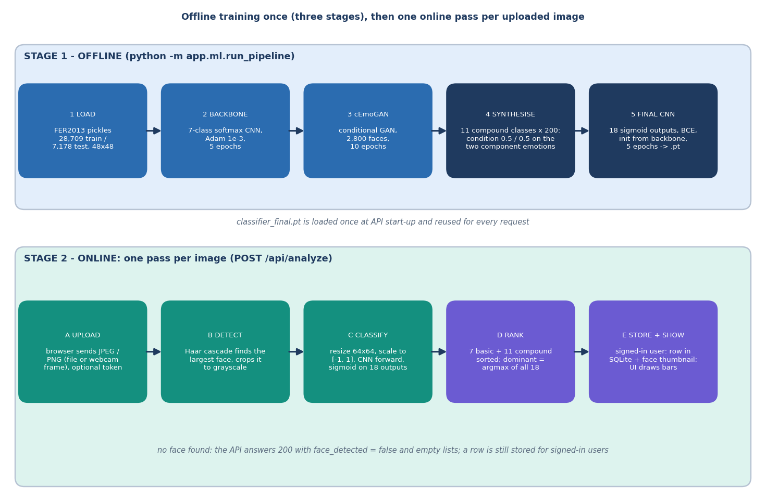
Figure 4: High-level workflow: three offline training stages, then one online pass per uploaded image.
The workflow has two time scales. Training is a command-line program, python -m app.ml.run_pipeline, which runs three stages in order and appends one line per stage to checkpoints/training_log.txt: the 7-class backbone (five epochs), the conditional GAN (ten epochs on 2,800 faces) and the final 18-output classifier (five epochs on 28,709 real and 2,200 synthetic faces). Serving is a request-driven path: each upload is decoded, a face is located, the face is classified and the answer is returned and, for a signed-in user, stored. There is no batching and no queue; the measured median for the whole path is about 19 ms on the development machine.

5.3 Data Flow Diagrams

5.3.1 Level 0: context
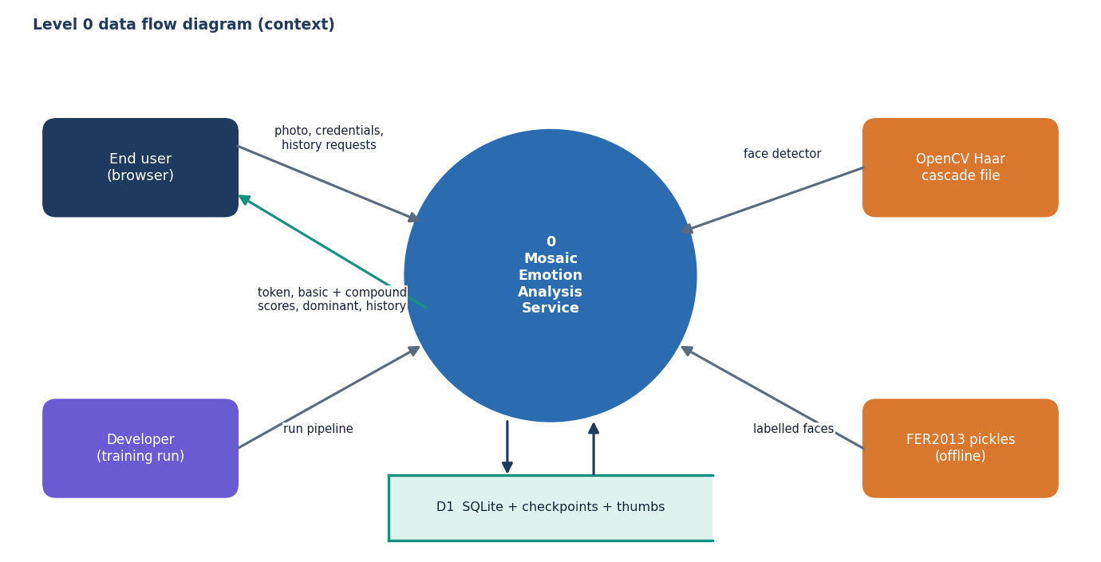
Figure 5: Level 0 data flow diagram: Mosaic and its four external entities.
At level 0 the system has four neighbours. The end user supplies photographs and credentials and receives tokens, scores and history; the developer starts the training pipeline; the OpenCV package supplies the Haar cascade file; the FER2013 pickles supply labelled faces at training time only. A single store, D1, stands for the SQLite database, the checkpoints and the thumbnail folder.

5.3.2 Level 1: seven processes
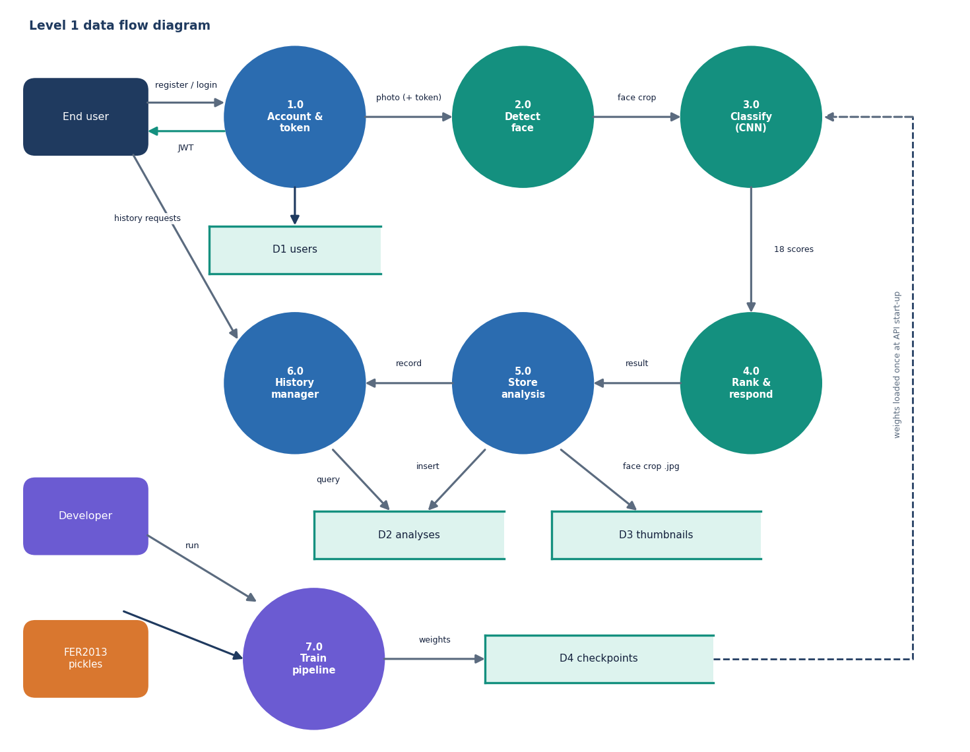
Figure 6: Level 1 data flow diagram: seven processes and four data stores.
Level 1 separates seven processes. Process 1.0 handles registration and login against the users store D1. Processes 2.0 (face detection), 3.0 (classification) and 4.0 (ranking and response) run once per upload. Process 5.0 stores the analysis row in D2 and the face thumbnail in D3, and 6.0 lists, reads and deletes history rows. Process 7.0, the offline training pipeline, produces the checkpoint files of D4 from the FER2013 pickles; process 3.0 loads them once when the server starts. Process 5.0 runs for every signed-in call, including calls where no face was found (the row then has empty emotion lists and no thumbnail).

5.3.3 Level 2: classification and ranking
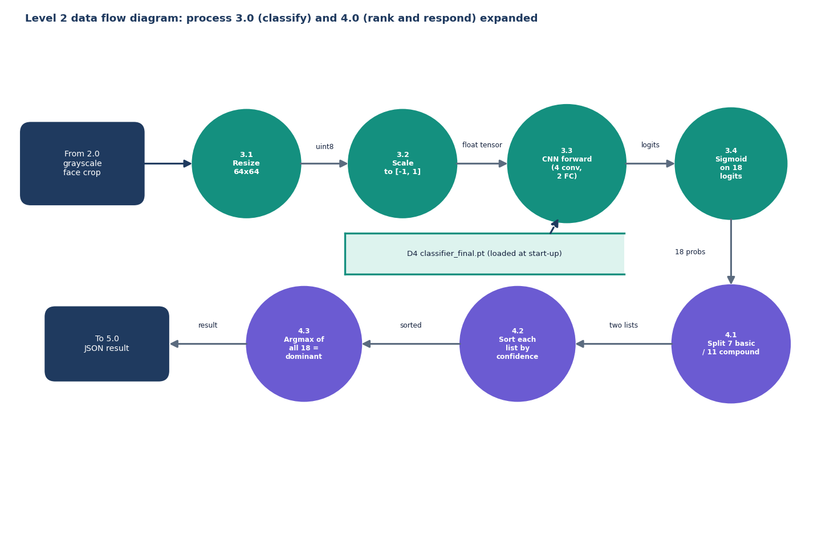
Figure 7: Level 2 data flow diagram: processes 3.0 (classify) and 4.0 (rank and respond) expanded.
Process 3.0 is expanded into resizing the crop to 64 x 64 pixels, scaling intensities to the range minus one to one (x/255, then (x - 0.5)/0.5), the forward pass through the four convolutional blocks and two fully connected layers, and a sigmoid on the 18 logits. Process 4.0 splits the 18 probabilities into the seven basic and eleven compound scores, sorts each list by confidence in descending order, and takes the index of the largest of all 18 as the dominant emotion, labelled basic if the index is below seven and compound otherwise.

5.4 UML Class Design
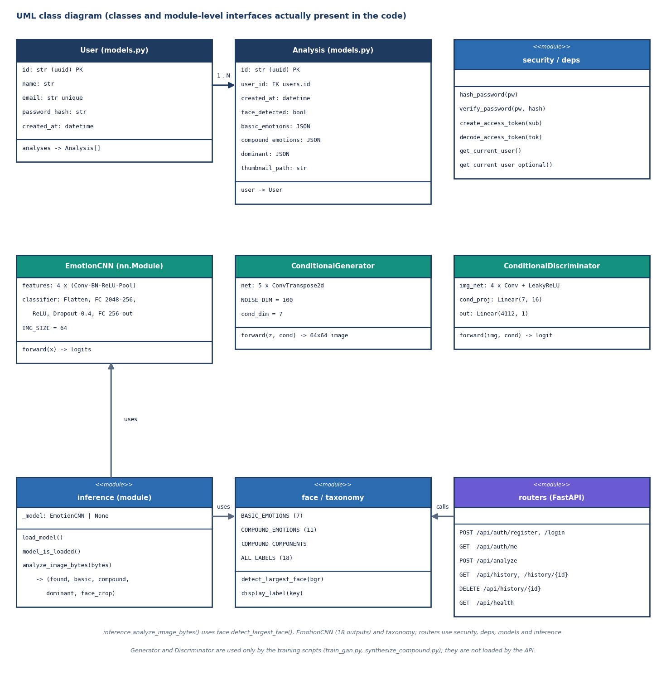
Figure 8: UML class diagram of the classes and module-level interfaces present in the code.
The class diagram contains only what exists in the code. User and Analysis are SQLAlchemy models joined by a one-to-many relationship with cascading delete. EmotionCNN is one class used with two output sizes: seven for the backbone and 18 for the final model. ConditionalGenerator (1,128,353 parameters) maps 100 noise values plus a seven-element condition to a 64 x 64 image through five transposed convolutions and a tanh; ConditionalDiscriminator scores an image together with its condition. The remaining boxes are function modules (security, dependencies, inference, face detection plus taxonomy, routers) drawn with the stereotype <<module>>. The generator and discriminator are used only by the training scripts.
Table 17: The EmotionCNN layers (ml/classifier_model.py)
Stage | Layers | Output shape
Input | 1-channel 64 x 64 face, scaled to [-1, 1] | 1 x 64 x 64
Block 1 | Conv 3x3 (32), BatchNorm, ReLU, MaxPool 2 | 32 x 32 x 32
Block 2 | Conv 3x3 (64), BatchNorm, ReLU, MaxPool 2 | 64 x 16 x 16
Block 3 | Conv 3x3 (128), BatchNorm, ReLU, MaxPool 2 | 128 x 8 x 8
Block 4 | Conv 3x3 (128), BatchNorm, ReLU, MaxPool 2 | 128 x 4 x 4
Classifier | Flatten (2,048), Linear 256, ReLU, Dropout 0.4, Linear out_dim | 7 (backbone) or 18 (final); 770,130 parameters at 18

The architecture combines standard components: batch normalisation [25], dropout [26] and, for the final model, sigmoid outputs with binary cross-entropy, the usual formulation of multi-label learning [27]. It is deliberately close to the 'simple CNN' of the base paper, which also ends in a sigmoid layer, but it is a different, smaller network trained on different data.

5.5 Sequence Design of the Main Flow
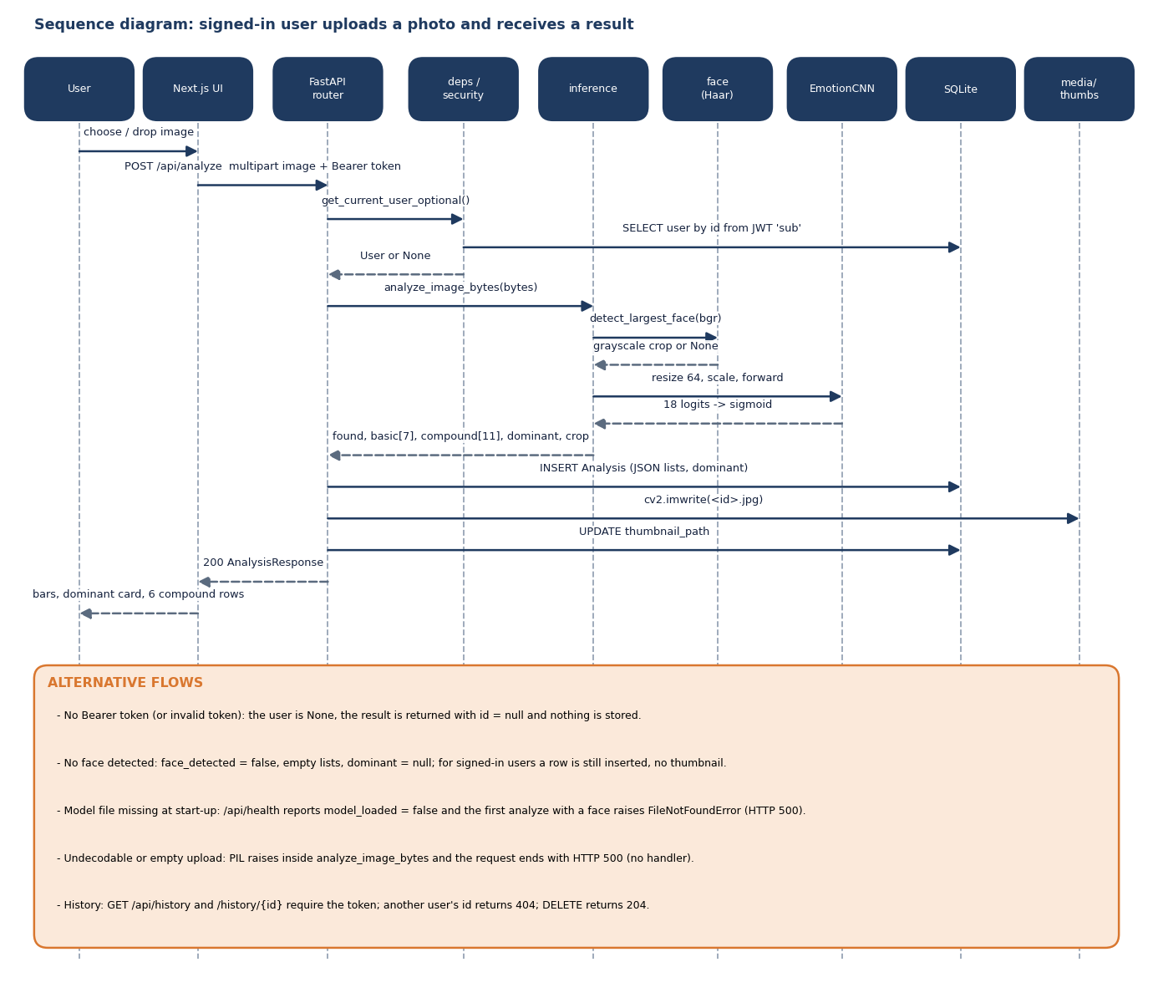
Figure 9: Sequence diagram: a signed-in user uploads a photo and receives a result.
The main flow is the analysis of one photo by a signed-in user. The router asks deps.get_current_user_optional() for the user: if the Bearer token is absent or invalid the user is None and the flow continues anonymously. analyze_image_bytes() then runs the detector and the network and returns the lists. For a signed-in user the router inserts an Analysis row, commits, writes the cropped face to media/thumbs/<id>.jpg and updates thumbnail_path, so a successful analysis costs two commits. The alternative flows at the foot of the diagram record behaviour that was verified by the tests: anonymous calls are not stored, images without a face give face_detected: false, and another user's history id gives 404.

5.6 Use-Case Design
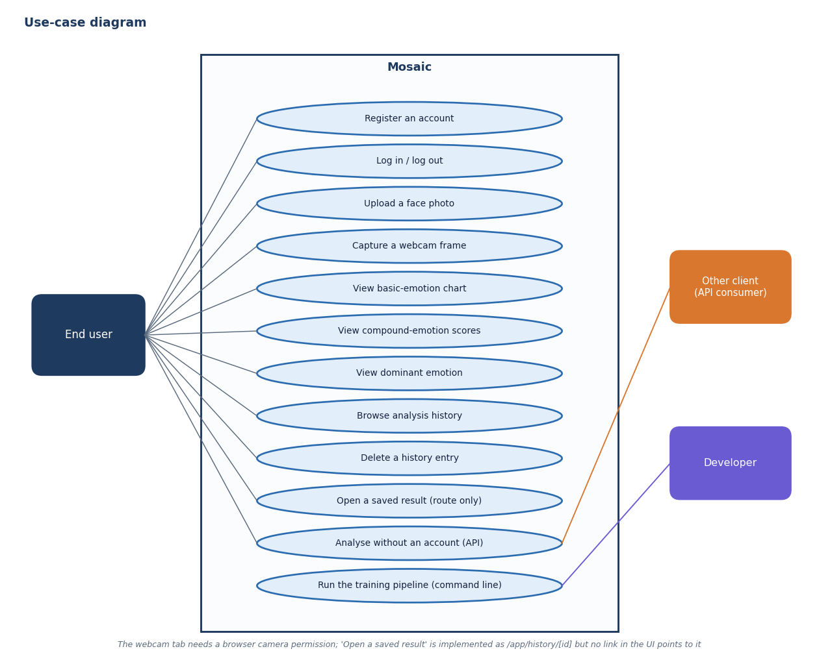
Figure 10: Use-case diagram: what the end user, an API client and the developer can do.
The end user's use cases are registration, login and logout, analysing a photo (upload or webcam), reading the three views of the result, browsing the history and deleting an entry. An opened history entry has its own route, /app/history/[id], but no element in the history page links to it; the route can be reached only by typing the address. Other API clients can analyse without an account, in which case nothing is stored. The developer's single use case is running the training pipeline. No use case needs an administrator, which is why the design has no such role.

5.7 Database Design
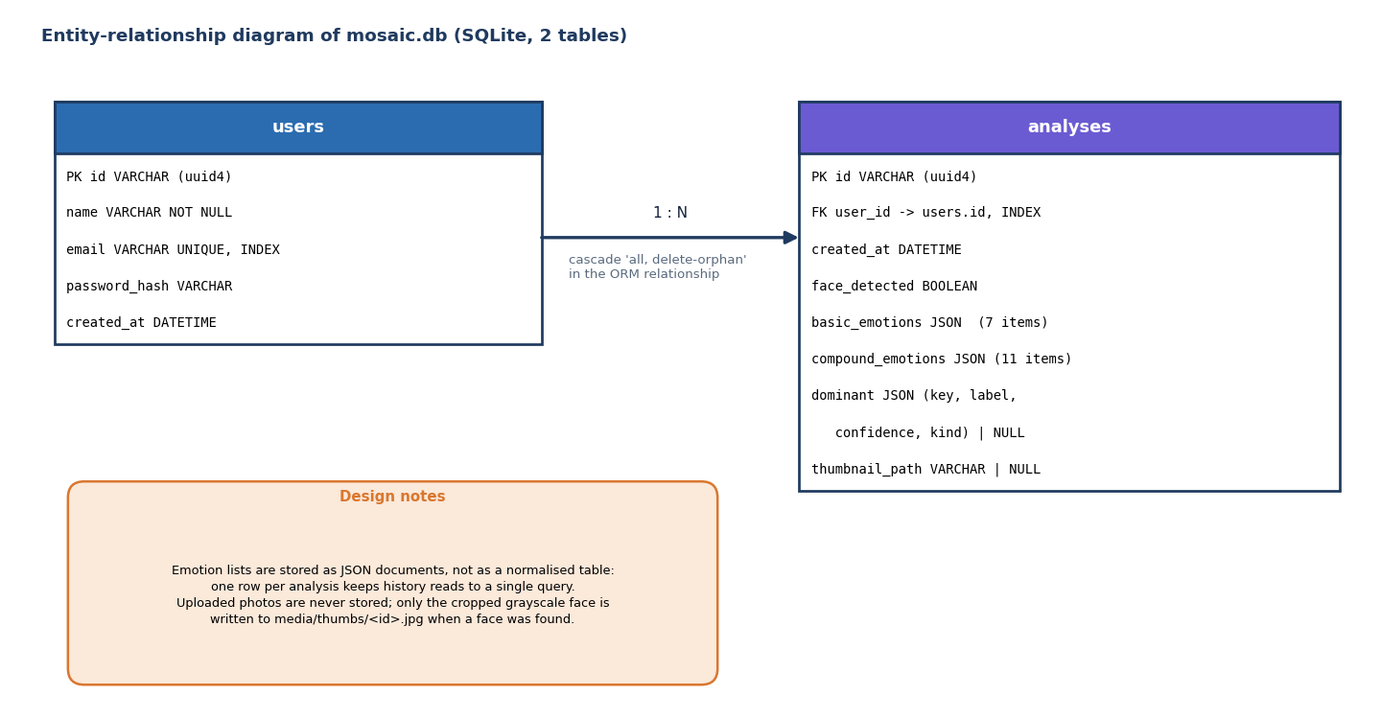
Figure 11: Entity-relationship diagram of the SQLite database: two tables joined one-to-many.
The database has two tables. User identifiers and analysis identifiers are random UUID strings. The 18 scores of an analysis are not spread across 18 columns: basic_emotions, compound_emotions and dominant are JSON columns holding the same objects the API returns (key, label, confidence, and kind for the dominant emotion). This keeps a history read to one query and lets the label set change without a migration, at the price that scores cannot be filtered or aggregated in SQL. The only declared foreign key is analyses.user_id.
Table 18: Table users
Column | Type | Constraint | Meaning
id | VARCHAR | Primary key (uuid4) | User identifier, also the JWT sub claim
name | VARCHAR | NOT NULL | Display name
email | VARCHAR | UNIQUE, INDEX, NOT NULL | Login name; format is not validated (any string is accepted)
password_hash | VARCHAR | NOT NULL | bcrypt hash through passlib
created_at | DATETIME | default UTC now | Registration time

Table 19: Table analyses
Column | Type | Constraint | Meaning
id | VARCHAR | Primary key (uuid4) | Analysis identifier, also the thumbnail file name
user_id | VARCHAR | FOREIGN KEY users.id, INDEX, NOT NULL | Owner
created_at | DATETIME | default UTC now | Time of analysis
face_detected | BOOLEAN | default false | Whether the Haar detector found a face
basic_emotions | JSON | default [] | Seven objects {key, label, confidence}, sorted by confidence
compound_emotions | JSON | default [] | Eleven objects, sorted by confidence
dominant | JSON | nullable | {key, label, confidence, kind} for the argmax of all 18; null when no face
thumbnail_path | VARCHAR | nullable | Path of the cropped grayscale face under media/thumbs/

5.8 Core Algorithms

5.8.1 Inference: analyze_image_bytes()
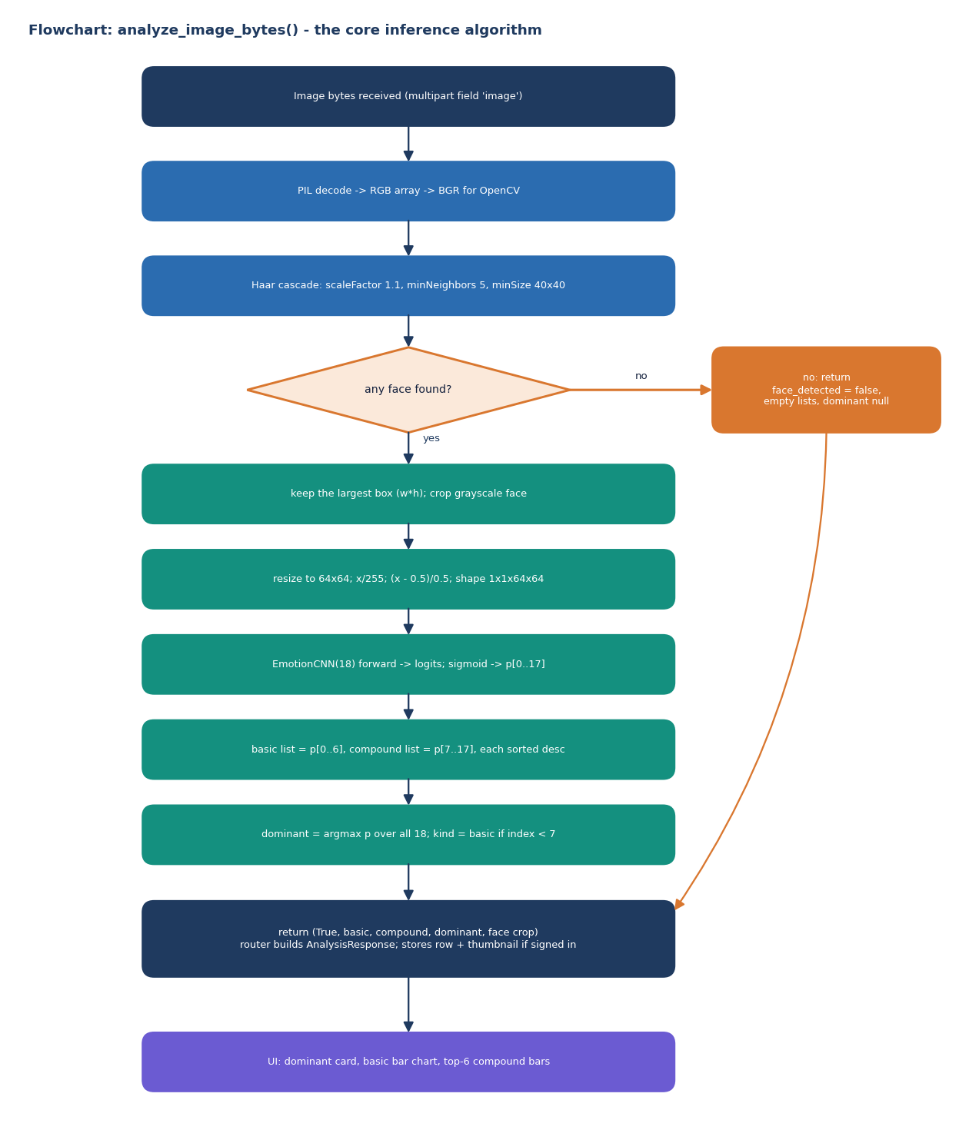
Figure 12: Flowchart of analyze_image_bytes(), the algorithm every request passes through.
The decoding step uses Pillow and converts to RGB, then to BGR for OpenCV. The Haar cascade haarcascade_frontalface_default.xml is run on the grayscale image with scale factor 1.1, five minimum neighbours and a minimum face size of 40 x 40 pixels [23]; the face with the largest width times height is kept. The crop is resized to 64 x 64, scaled, passed through the network and a sigmoid. The function has a threshold argument that is never used; the decision rule is simply the argmax. This rule has an important consequence: because a compound output must exceed every basic output to be chosen, and the compound outputs are tiny after training (Chapter 8), the dominant emotion is in practice always basic.

5.8.2 Training: three stages
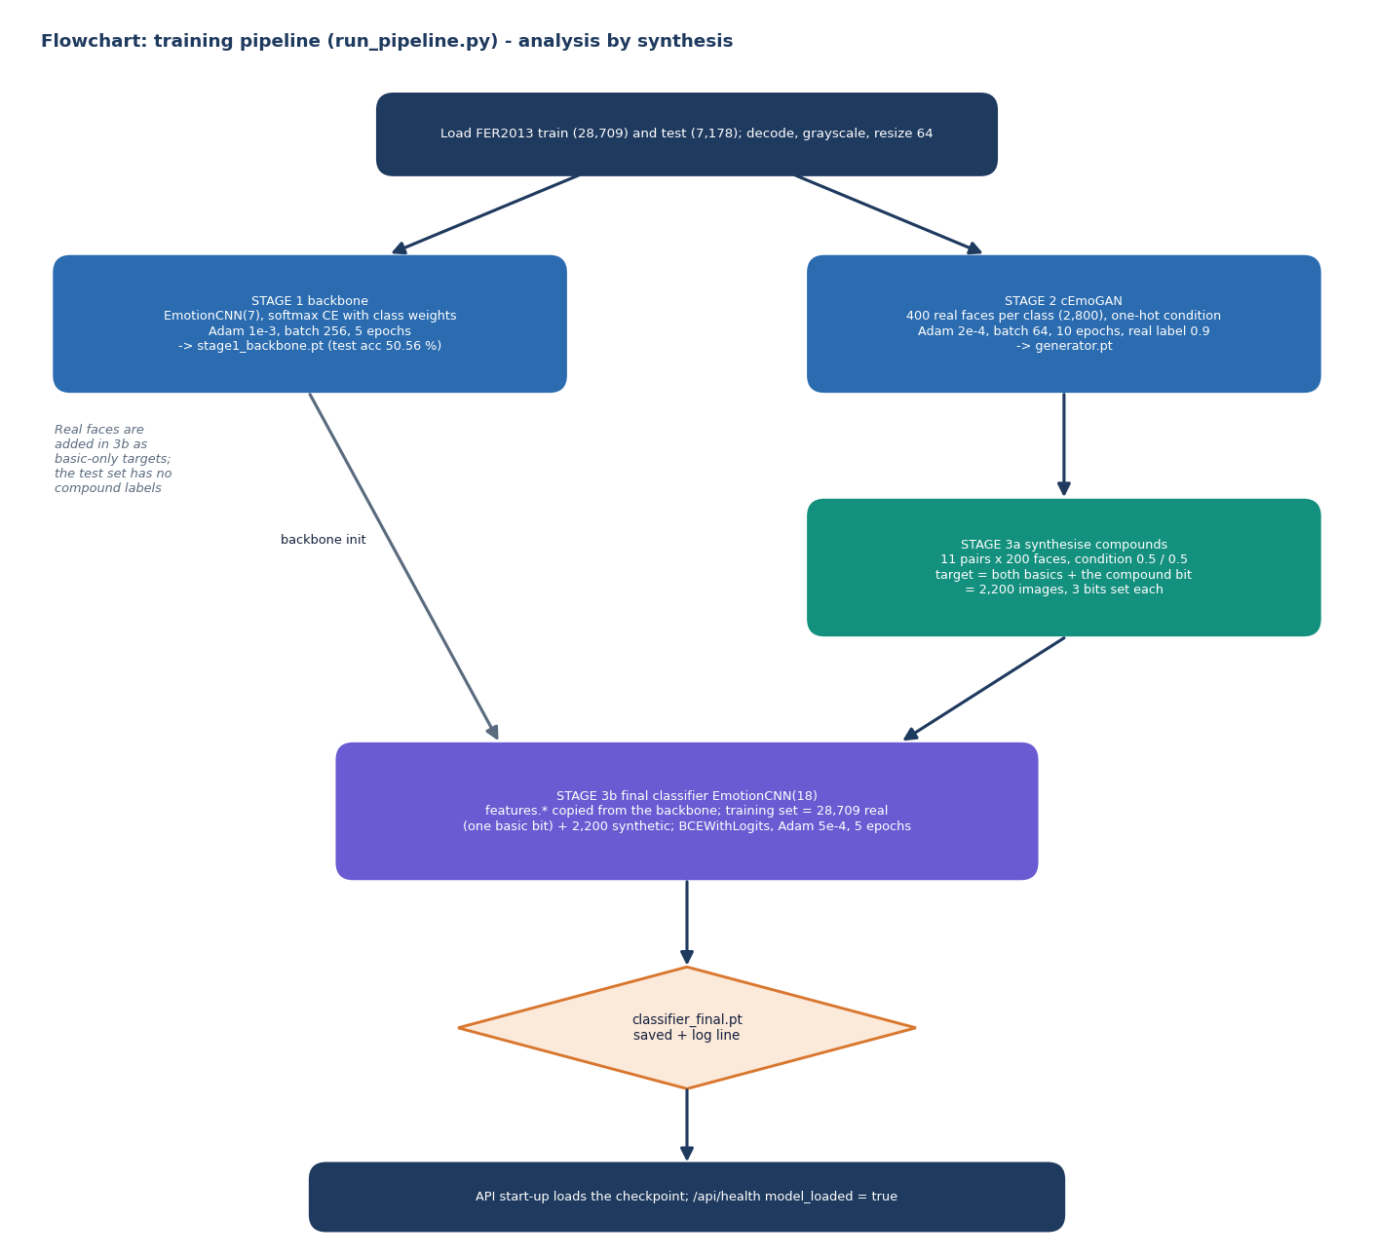
Figure 13: Flowchart of the training pipeline: backbone, cEmoGAN, synthesis and the final multi-label classifier.
Stage 1 trains the backbone with class-weighted cross-entropy and Adam [24] at a learning rate of 1e-3. Stage 2 trains the conditional GAN [17][16] with Adam at 2e-4 (beta 0.5), batch size 64 and a real-label target of 0.9 (one-sided label smoothing), on 400 faces per class. The generator input is 100 Gaussian noise values concatenated with the seven-element condition; a one-hot condition was used in training. Stage 3a builds the compound training faces by feeding the generator a condition with 0.5 on each of the two component emotions (a blend never seen in training), 200 faces per class. Stage 3b copies the convolutional weights of the backbone into the 18-output network and trains it for five epochs with binary cross-entropy and Adam at 5e-4 on the union of real and synthetic faces. The target of a real face has one basic bit set; the target of a synthetic face has the two component bits and the compound bit set.

5.9 Module Design
Table 20: Backend modules (backend/app)
Module | Responsibility | Key interfaces
main.py | Create tables, CORS, mount thumbnails, include routers, load the model at start-up | app
config.py | Paths, secret key (environment variable MOSAIC_SECRET_KEY, with a development default), token lifetime (7 days), database URL, CORS origins | constants
db.py, models.py | SQLAlchemy engine/session, User and Analysis models | get_db()
security.py, deps.py | bcrypt hashing, HS256 tokens, required and optional current user | create_access_token(), get_current_user()
schemas.py | Pydantic request and response models (password minimum 6 characters) | RegisterRequest, AnalysisResponse
routers/auth.py | Register, login, current user | /api/auth/*
routers/analyze.py | Run inference, persist analysis and thumbnail | POST /api/analyze
routers/history.py | List, read and delete a user's analyses | /api/history
routers/health.py | Report model loading state | GET /api/health
ml/taxonomy.py | The 7 + 11 labels, compound components, display labels | ALL_LABELS, COMPOUND_COMPONENTS
ml/face.py | Largest-face Haar detection | detect_largest_face()
ml/inference.py | Preprocess, forward pass, ranking, dominant emotion | analyze_image_bytes(), load_model()
ml/classifier_model.py, ml/gan_model.py | Network definitions | EmotionCNN, ConditionalGenerator, ConditionalDiscriminator
ml/dataset.py | Load FER2013 pickles, decode and resize, class weights | load_split(), class_weights()
ml/train_*.py, synthesize_compound.py, run_pipeline.py | The three training stages and the synthesis step | main()

Table 21: Front-end modules (frontend/src)
Module | Responsibility
app/page.tsx and components/landing/* | Landing page: navigation, hero with Three.js particle canvas, feature cards (GSAP), how-it-works, call to action
app/login, app/register, components/auth/* | Authentication pages and form; on success the token and user are stored and the router goes to /app
app/app/layout.tsx, DashboardShell.tsx, hooks/useAuthGuard.ts | Authenticated shell with sidebar (Analyze, History, user, log out); redirects to /login when no token is present
app/app/page.tsx, CaptureWidget.tsx | Analyse page: upload (drag and drop or file chooser) or webcam capture, loading, error and empty states
ResultsView.tsx | Dominant card, Recharts bar chart of the seven basic scores, top six compound bars; a message when no face was found
app/app/history, HistoryList.tsx | History grid with colour dot, dominant label, time and delete button; detail route for one analysis
lib/api.ts, store.ts, taxonomy.ts, emotionColors.ts | Typed API client, persisted auth store, compound components, colours

5.10 API Design
The API follows API_CONTRACT.md. All endpoints live under /api; bodies are JSON except the analyse call, which is multipart/form-data with one field named image. Errors use FastAPI's {"detail": ...} shape.
Table 22: Endpoints
Method and path | Auth | Success | Errors
POST /api/auth/register | None | 201 {token, user} | 409 duplicate e-mail; 422 invalid body or password shorter than 6
POST /api/auth/login | None | 200 {token, user} | 401 invalid credentials; 422
GET /api/auth/me | Required | 200 user | 401
POST /api/analyze | Optional | 200 analysis (id is null when not stored) | 422 no file; 500 on an undecodable file; 200 with face_detected: false when no face
GET /api/history?limit&offset | Required | 200 {items, total}, newest first | 401; 422 non-numeric limit
GET /api/history/{id} | Required | 200 analysis | 401; 404 missing or owned by another user
DELETE /api/history/{id} | Required | 204 | 401; 404
GET /api/health | None | 200 {status, model_loaded} | -
GET /api/media/thumbs/{id}.jpg | None (static) | 200 JPEG | 404

Two differences between the contract and the implementation were found while testing and are kept as they are. The contract says a photograph without a face returns HTTP 422; the implementation returns 200 with face_detected: false and empty lists, and the UI handles it. The thumbnail URL is returned as a path relative to the API (/api/media/thumbs/<id>.jpg); the contract does not say who resolves it.

5.11 User Interface Design
The interface is a dark, single-theme design with a violet-to-orange accent, a display font for headings and one colour per basic emotion (angry red, disgust green, fear purple, happy amber, sad blue, surprise pink, neutral grey). A compound emotion takes the colour of its first component. The design intentionally avoids academic wording, as the API contract requires. The screens below were captured with the production build of the real front end against the real model.
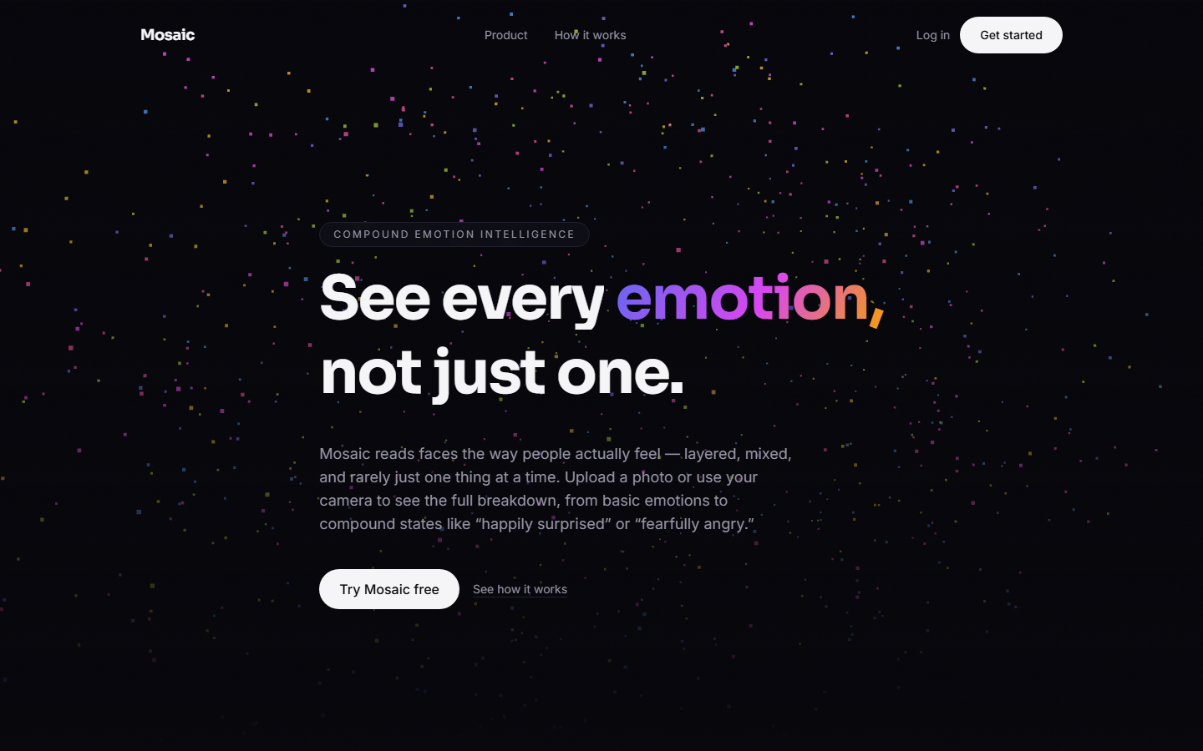
Figure 14: Landing page: hero with the animated particle canvas and the call to action.
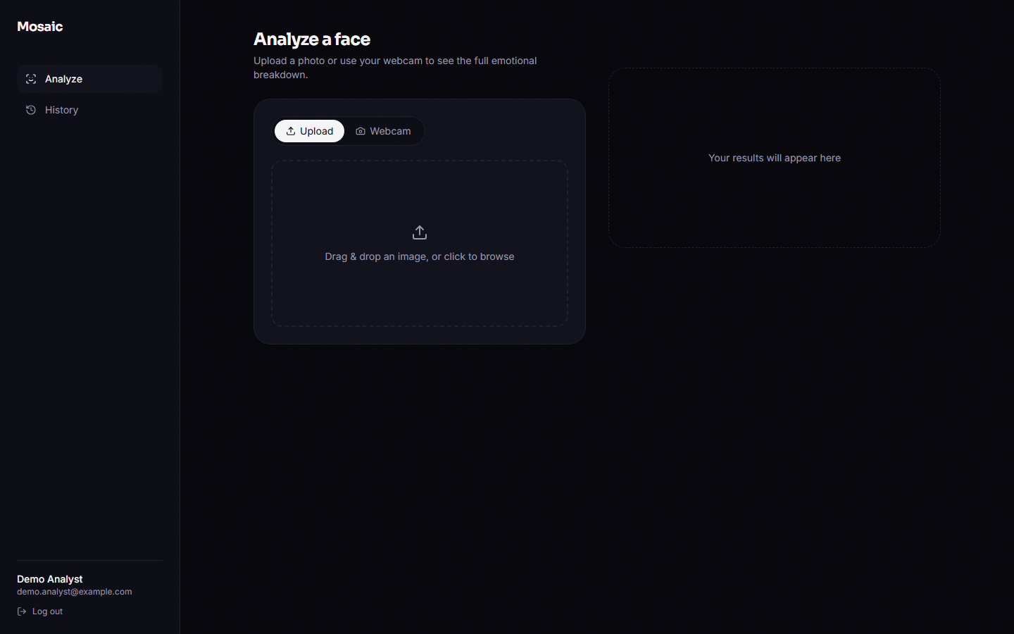
Figure 15: Analyse page before an upload: Upload and Webcam tabs, drop zone and an empty results panel.
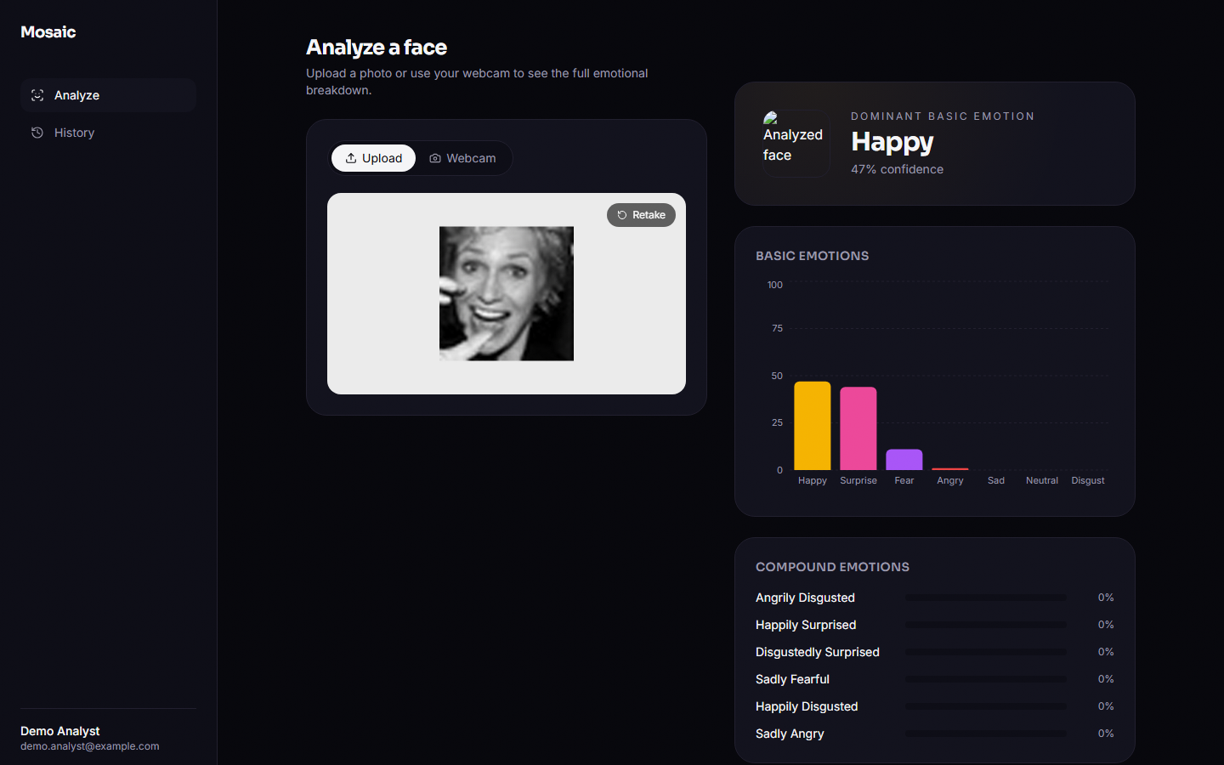
Figure 16: Analyse page after uploading a real FER2013 face: dominant card, basic-emotion chart and compound bars.
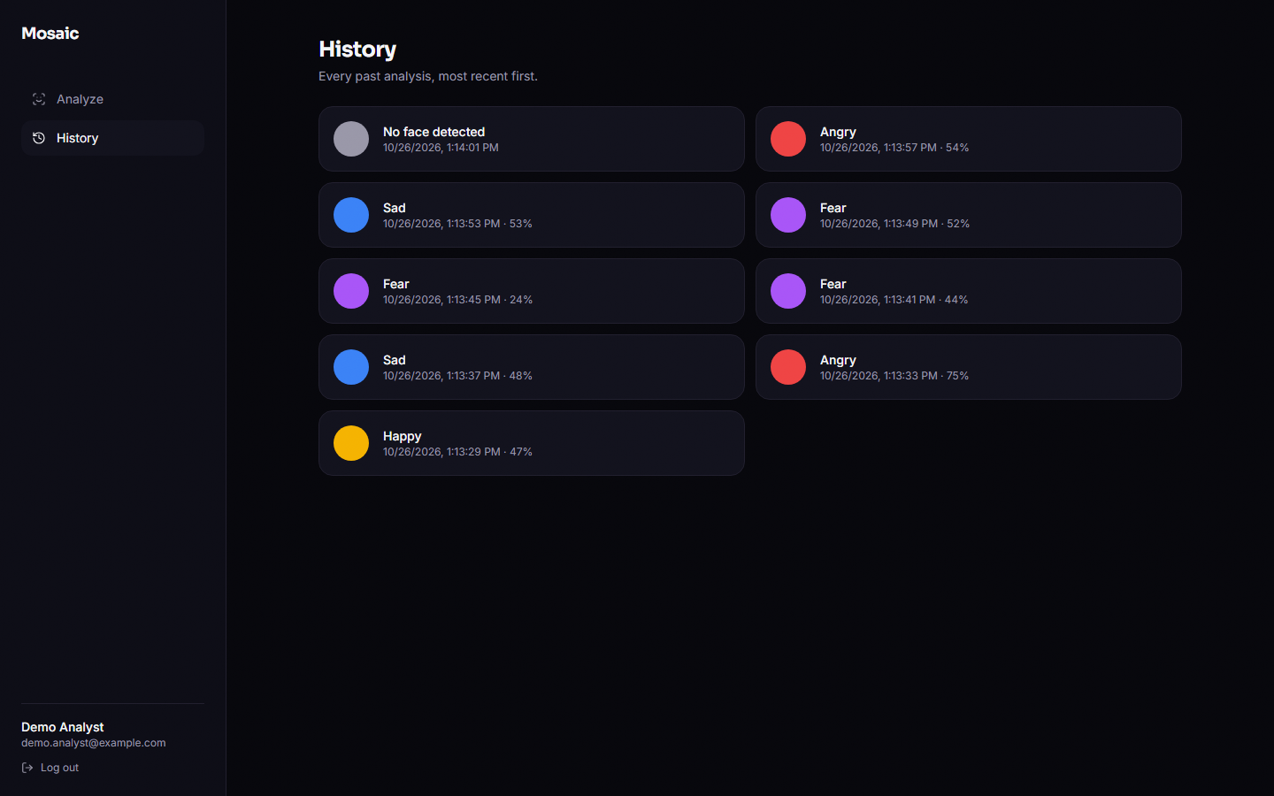
Figure 17: History page: one card per stored analysis with its dominant label, confidence and time.
The analyse page keeps the capture on the left and the results on the right on wide screens (two columns from 1024 px), and stacks them on narrow ones; the sidebar is hidden below 640 px and replaced by a header with a log-out link. The results panel animates in with Framer Motion; compound bars show only the six highest of the eleven scores. Loading, error and empty states each have their own panel.

5.11.1 Interface defects found during design review
• Thumbnail not shown. ResultsView renders result.thumbnail_url directly, a relative path that resolves against the front-end origin instead of the API origin, so the face thumbnail appears as a broken image in every result card. The helper thumbnailUrl() in lib/api.ts would fix it but is not applied there.
• History detail unreachable. /app/history/[id] renders a saved result, but the history cards do not link to it.
• Reload in development mode. In the Next.js development server a hard reload of /app redirected to /login even with a stored token, because the guard runs before the persisted store is read; the production build kept the session in the probe that was run. The screenshots were therefore taken with the production build and in-app navigation.

5.12 Design Decisions and Their Reasons
Table 23: Principal design decisions
Decision | Reason | Cost
One multi-label network with 18 sigmoid outputs | A face can carry several emotions; sigmoid outputs do not compete | No single normalised distribution; thresholds must be chosen
Initialise the final network from a softmax backbone | Faster convergence, and a separately measurable single-label baseline | The comparison with the baseline mixes extra epochs with multi-label training; a real-only control was added in Chapter 8
Condition the generator with a seven-element soft vector | Allows blended conditions such as 0.5 happy + 0.5 surprise without retraining | The generator was trained only on one-hot conditions, so blends are out of distribution
64 x 64 grayscale input | Fits CPU training and the 48 x 48 source data | Loses colour and fine detail
JSON columns for scores | One query per history read; flexible labels | No SQL filtering by score
Optional authentication on /api/analyze | Lets clients try the model without an account | Anonymous calls are not stored; the web UI does not use this path
Haar cascade for detection | Ships with OpenCV; no extra model | Misses non-frontal and very small faces; crops differ from training frames

6. METHODOLOGY AND SOFTWARE IMPLEMENTATION
This chapter explains how Mosaic is built and how it was evaluated: the overall method, the data, the preprocessing, the choice of algorithms, the formulas, the models and their training, the application, its security and its installation. Every number in it comes from the product's own training log or from the experiments in experiments/, run on the product's own modules; Chapter 8 reports what those experiments found.

6.1 Overall Methodology
The method follows the analysis-by-synthesis idea of the base paper [1]: a generative model synthesises faces that carry two emotions at once, and a multi-label recogniser is trained on real and synthetic faces together. Mosaic realises the idea at a deliberately small scale so that every stage runs on a CPU in minutes. Training is offline and has three stages that share one label order (seven basic emotions followed by eleven compound ones, 18 outputs in all); serving is online and handles one uploaded image per request. The label order is defined once in ml/taxonomy.py, and training, synthesis, inference and the API all import it, so an output index means the same thing everywhere.
1. Load the data (offline): decode the 28,709 training and 7,178 test FER2013 faces, convert to grayscale, resize from 48 by 48 to 64 by 64 pixels.
2. Stage 1, backbone: train a seven-class softmax CNN on the real faces with class-weighted cross-entropy (five epochs). It is the single-label baseline and later the initialiser of the final model.
3. Stage 2, cEmoGAN: train a conditional GAN on a class-balanced subset of 400 real faces per class (2,800 faces, ten epochs); the condition is a seven-element emotion vector.
4. Stage 3a, synthesis: for each of the eleven compound classes draw 200 noise vectors and condition the generator on its two component emotions at weight 0.5 each; label every synthetic face with both basic bits and the compound bit.
5. Stage 3b, final classifier: train the 18-output CNN with binary cross-entropy on the 28,709 real faces (one basic bit each) plus the 2,200 synthetic faces, starting from the backbone's convolutional weights (five epochs).
6. Serve: for each uploaded image, detect the largest face with a Haar cascade, crop it in grayscale, resize to 64 by 64, run the CNN, apply a sigmoid to the 18 logits, sort the basic and compound lists, and report the largest of all 18 scores as the dominant emotion.
7. Evaluate: basic-emotion accuracy and macro-F1 on the FER2013 test set against the single-label baseline, a seeded ablation with and without the synthetic faces, diagnostics of the generator and of the compound outputs, and measurements of the API.
Figure 18: Training pipeline of Mosaic: backbone, cEmoGAN, compound synthesis and the final multi-label classifier.

6.2 Dataset
The data is FER2013 [11], the 48 by 48 pixel grayscale facial-expression set collected for a 2013 machine-learning challenge, in the copy published on the Hugging Face Hub as Jeneral/fer-2013 (tagged apache-2.0 there; the original competition terms are not restated by the mirror, so the licence should be checked before redistribution). The product loads it from two pickled lists, data/train.pt and data/test.pt, whose items are a JPEG byte string and an emotion name. The split is the one shipped by the mirror: 28,709 training and 7,178 test images. There is no separate validation split; the test set is evaluated after every epoch for the log line but nothing is selected on it, because every run trains for a fixed number of epochs and keeps the last weights.
Table 24: FER2013 class counts as loaded by the product
Split | Angry | Disgust | Fear | Happy | Sad | Surprise | Neutral | Total
Train | 3,995 | 436 | 4,097 | 7,215 | 4,830 | 3,171 | 4,965 | 28,709
Test | 958 | 111 | 1,024 | 1,774 | 1,247 | 831 | 1,233 | 7,178

Two properties of the data matter for everything that follows. First, the classes are imbalanced: disgust has 436 training images (1.5 %) against 7,215 for happy, and always predicting happy would score 24.7 % on the test set. Second, FER2013 carries one basic label per image and no compound labels at all. The eleven compound outputs therefore have no real ground truth anywhere in the project: they can be trained only from synthetic faces and can be checked only against synthetic faces. The base paper used three small laboratory sets (CK+ [13], JAFFE and MUG) and built its two-emotion ground truth by morphing pairs of peak frames, which Mosaic does not do; the datasets, the label sets and the evaluation therefore differ, and Chapter 8 compares the two only qualitatively.

6.3 Preprocessing

6.3.1 Training pipeline
ml/dataset.py decodes each JPEG with Pillow into an 8-bit grayscale array, resizes it to 64 by 64 with OpenCV's default bilinear interpolation, and maps the label string to the product's own index. The mapping goes through the string, not through the dataset's integer codes, because the mirror's order (neutral before sad) differs from the product's order. Every training script then scales pixels to the range minus one to one, x = (p / 255 - 0.5) / 0.5, which matches the generator's tanh output. No augmentation (flips, crops, rotations) is applied. For the GAN, cap_per_class=400 keeps the first 400 images of each class, giving 2,800 faces and a perfectly balanced set at the cost of discarding about 90 % of the data.

6.3.2 Serving pipeline
At request time the image is decoded with Pillow, converted to RGB and then to BGR for OpenCV, and passed to detect_largest_face(), which converts to grayscale and calls CascadeClassifier.detectMultiScale with scale factor 1.1, five neighbours and a minimum size of 40 by 40 pixels [23], [29]. The detection with the largest area is cropped from the grayscale image (no margin, no alignment, no histogram equalisation) and goes through the same resize and scaling as in training. The detector's minimum size of 40 pixels is almost as large as a native 48-pixel FER2013 image, so un-enlarged FER2013 faces are not found at all; the measurements in Chapter 8 quantify this and also show that a tight Haar crop is framed differently from the training faces. This training-serving mismatch is a limitation of the design, not of the data.

6.4 Algorithm Choice and Justification
Every algorithm is the smallest one that does the job on the available hardware. The justifications below are the reasons recorded in the code and README, supplemented by the constraints of this project (a CPU-only machine, a one-hour training budget, no compound labels).
Table 25: Algorithms chosen, the reason and the alternative
Component | Choice | Why | Alternative not used
Face detection | OpenCV Haar cascade | ships with OpenCV, no extra download, fast on CPU | MTCNN or a learned detector: more robust, heavier
Recogniser | 4-block CNN, 770,130 parameters | trains in minutes on CPU; same family as the base paper's small CNN | ResNet or ViT transfer learning: stronger, needs pre-trained weights and more compute
Basic-only baseline | softmax + class-weighted cross-entropy | the standard single-label formulation; weights counter the 1.5 % disgust class | focal loss or re-sampling
Multi-label head | 18 sigmoids + BCE | a face may carry two emotions at once, so labels are not mutually exclusive | softmax over 18 classes (forces one label)
Generator | conditional DCGAN (transposed convolutions) | the condition vector lets one model produce every class, as in the base paper's cGAN part | StyleGAN or the base paper's encoder + cGAN for identity-preserving latents
Compound synthesis | 0.5 / 0.5 blend of two one-hot conditions | needs no compound training data; mirrors the base paper's multi-hot condition | morphing real pairs (base paper's ground truth)
Optimiser | Adam | robust defaults for small CNNs and GANs [24] | SGD with momentum
Regularisation | batch normalisation, dropout 0.4 | stabilise training, limit over-fitting of the 256-unit layer [25], [26] | weight decay, data augmentation

One honest difference from the base paper deserves a sentence. The base paper's central contribution is an encoder that maps a face to a latent code so that identity is kept while the label changes the expression. Mosaic's generator takes a random noise vector and a label vector only; it has no encoder and no identity-preservation mechanism, so objective 1 of the batch (identity-preserving generation) is not implemented, and the synthetic faces are random faces with a requested expression, not edited versions of a given face.

6.5 Mathematical Formulation
Notation: an image is x, the true basic class is y, there are K = 7 basic classes and L = 18 labels, n_c is the number of training images of class c, N is the training-set size and z is a noise vector with 100 elements.

6.5.1 Stage 1: weighted softmax cross-entropy
w_c = N / (K · n_c) (2)
p(c | x) = exp(s_c) / Σ_k exp(s_k), L₁ = − w_y · log p(y | x) (3)
The class weights w_c are computed from the training labels (class_weights() in ml/dataset.py). With N = 28,709 and K = 7 the weight of disgust is 9.41 and that of happy 0.57, so a disgust image counts about 16.5 times as much as a happy one in the loss.

6.5.2 Stage 3b: multi-label sigmoid and binary cross-entropy
σ(s) = 1 / (1 + e^(−s)), t ∈ {0, 1}^18 (4)
L₃ = − (1/L) Σ_j [ t_j · log σ(s_j) + (1 − t_j) · log(1 − σ(s_j)) ] (5)
A real face has exactly one basic bit set in t; a synthetic face has the two basic bits of its compound and the compound bit set (three ones). The loss is the unweighted mean over the 18 outputs (BCEWithLogitsLoss, no positive weighting), so a rare positive label contributes little unless the model can separate it. At serving time the score of label j is σ(s_j) and the dominant emotion is the arg-max over all 18 scores; the basic prediction used in the evaluation is the arg-max over the first seven. The multi-label formulation follows [27] and the base paper.

6.5.3 Stage 2: the conditional GAN objective as implemented
L_D = BCE(D(x | y), 0.9) + BCE(D(G(z | y) | y), 0) (6)
L_G = BCE(D(G(z | y) | y), 0.9) (7)
BCE(·, t) is binary cross-entropy with logits against the target t. Two details differ from the textbook minimax game [16], [17]: the real-label target is smoothed to 0.9, and the generator minimises the non-saturating loss against the same smoothed target, not against 1. D receives the image and the condition, the condition being projected to 16 values and concatenated with the 4,096 image features. Both networks use Adam with learning rate 2·10⁻⁴ and β₁ = 0.5. During training the condition y is always a one-hot vector; the blended vector used for compound synthesis never appears in training, which is the weak point of the design analysed in Chapter 8.

6.5.4 Compound condition and labels
y(a, b) = 0.5 · e_a + 0.5 · e_b, t(a, b) = e_a + e_b + e_(a·b) (8)
e_a is the one-hot vector of basic emotion a in the seven-element condition space and e_(a·b) the unit vector of the compound label in the 18-element target space. For example, happily_surprised uses the condition with 0.5 at happy and 0.5 at surprise and the target with ones at happy, surprise and happily_surprised.

6.5.5 Evaluation quantities
F1_c = 2 · P_c · R_c / (P_c + R_c), macro-F1 = (1/K) Σ_c F1_c (9)
d²(μ₁, Σ₁; μ₂, Σ₂) = ‖μ₁ − μ₂‖² + Tr(Σ₁ + Σ₂ − 2 (Σ₁ Σ₂)^(1/2)) (10)
Accuracy and macro-F1 are computed on the 7,178 test faces with scikit-learn. The second formula is the Fréchet distance between two Gaussians [21]; the project applies it to the 256-unit hidden layer of the stage-1 CNN, not to Inception features, to compare generated faces with real ones. It is a diagnostic of this project's own models and is not comparable with published FID values. The multi-label scores of the base paper (f-beta and exact-match ratio) are also computed on a synthetic hold-out set in scripts/run_experiments.py.

6.6 Model Architecture and Training

6.6.1 The recogniser
EmotionCNN has four convolution blocks that halve the resolution each time (64 → 32 → 16 → 8 → 4) while growing the channel count from 1 to 128, followed by a 256-unit hidden layer and an output layer. The same class serves as the 7-output backbone (767,303 parameters) and the 18-output final model (770,130 parameters); only the last layer differs, so the backbone's features.* weights (240,960 parameters) can initialise the final model.
Table 26: Layers of EmotionCNN with 18 outputs
# | Layer | Output shape | Parameters
1 | Conv 3×3, 1 → 32, BatchNorm, ReLU, MaxPool 2 | 32 × 32 × 32 | 384
2 | Conv 3×3, 32 → 64, BatchNorm, ReLU, MaxPool 2 | 64 × 16 × 16 | 18,624
3 | Conv 3×3, 64 → 128, BatchNorm, ReLU, MaxPool 2 | 128 × 8 × 8 | 74,112
4 | Conv 3×3, 128 → 128, BatchNorm, ReLU, MaxPool 2 | 128 × 4 × 4 | 147,840
5 | Flatten, Linear 2,048 → 256, ReLU, Dropout 0.4 | 256 | 524,544
6 | Linear 256 → 18 (7 in the stage-1 backbone) | 18 | 4,626
 | Total |  | 770,130

6.6.2 The generator and the discriminator
The generator maps the 107-element input (100 noise values plus the 7-element condition, reshaped to 1 × 1) through five transposed convolutions to a 64 by 64 image with a tanh output: 1,128,353 parameters. The discriminator has four strided convolutions (32, 64, 128, 256 channels, LeakyReLU 0.2) whose 4,096 features are concatenated with the condition projected to 16 values and mapped to one logit: 694,257 parameters. Only the generator is used afterwards.
Table 27: Layers of the conditional generator
Layer | Output shape | Parameters
ConvTranspose 4×4, 107 → 256, BatchNorm, ReLU | 256 × 4 × 4 | 438,528 + 512
ConvTranspose 4×4 stride 2, 256 → 128, BatchNorm, ReLU | 128 × 8 × 8 | 524,416 + 256
ConvTranspose 4×4 stride 2, 128 → 64, BatchNorm, ReLU | 64 × 16 × 16 | 131,136 + 128
ConvTranspose 4×4 stride 2, 64 → 32, BatchNorm, ReLU | 32 × 32 × 32 | 32,800 + 64
ConvTranspose 4×4 stride 2, 32 → 1, Tanh | 1 × 64 × 64 | 513

6.6.3 Training configuration
Table 28: Training configuration copied from the defaults of the three training scripts
Item | Stage 1 backbone | Stage 2 cEmoGAN | Stage 3 final classifier
Script | train_classifier_stage1.py | train_gan.py | train_final_classifier.py
Training images | 28,709 real | 2,800 real (400 per class) | 28,709 real + 2,200 synthetic
Targets | class index (7) | one-hot condition (7) | multi-hot (18)
Loss | weighted cross-entropy | BCE-with-logits, real label 0.9 | BCE-with-logits
Optimiser | Adam, lr 1·10⁻³ | Adam, lr 2·10⁻⁴, β = (0.5, 0.999) | Adam, lr 5·10⁻⁴
Batch size | 256 | 64 (last partial batch dropped) | 256
Epochs | 5 | 10 | 5
Initialisation | random | random | features.* from stage 1
Seeds, augmentation | not set, none | not set, none | not set, none
Device | CPU | CPU | CPU
Logged result | test accuracy 50.56 % | final losses D 0.7731, G 3.7240 | test accuracy 58.14 % (basic outputs)

The product's own training_log.txt records those three result lines. Stage 3 had not been run when the project was received (the final checkpoint was missing and the API reported that no model was loaded), so it was run for this report with the unchanged script on the shared CPU-only Windows PC used for the work: epochs took 153, 126, 129, 115 and 97 seconds (10 minutes 37 seconds in total). The scripts do not set random seeds; to make the comparisons in Chapter 8 repeatable, scripts/run_experiments.py re-trains the final classifier with explicit seeds for the with-synthetic and without-synthetic variants.

6.6.4 Evaluation protocol
• Basic emotions: accuracy, macro-F1, per-class precision, recall and F1 and the confusion matrix on the 7,178 test faces, for the stage-1 baseline and the final model (arg-max over the seven basic outputs).
• Ablation: the final classifier trained with and without the synthetic faces, same initialisation and epochs, several seeds, plus a sweep over the number of synthetic faces per compound class.
• Compound outputs: their scores on real test faces, and the multi-label metrics (micro- and macro-F1, exact-match ratio, ROC-AUC) on 1,100 freshly generated hold-out faces, with a real-data-only control. Because the hold-out comes from the same generator that produced the training faces, it measures whether the classifier learned the generator's labels, not whether it recognises real compound expressions.
• Generator: how often the stage-1 classifier reads a generated face as the requested emotion, and the Fréchet distance in its feature space.
• Serving: Haar detection rate by image size, accuracy through the serving path against direct resizing, API latency and malformed-input probes, and the automated tests.

6.7 Application Architecture
Mosaic is a two-process application: a FastAPI service [30] that wraps the models, and a Next.js console [31] that talks to it. They share nothing but the HTTP contract in API_CONTRACT.md. The service holds one loaded model in memory (loaded at start-up by load_model() and kept in a module-level variable) and keeps accounts and history in a SQLite file. No external service is called at run time.
Figure 19: Application architecture of Mosaic: browser, FastAPI service, ML modules and local files.
Table 29: Backend modules
File | Responsibility
app/main.py | creates the application, CORS middleware, mounts /api/media/thumbs, includes the four routers, loads the model on start-up (a missing checkpoint is tolerated)
app/config.py | secret key (environment variable MOSAIC_SECRET_KEY, otherwise a development default), HS256, token lifetime (7 days), SQLite URL, checkpoint and thumbnail folders, CORS origins
app/db.py, app/models.py | SQLAlchemy engine, session dependency, User and Analysis tables
app/security.py, app/deps.py | bcrypt hashing and verification, token creation and decoding, required and optional current-user dependencies
app/schemas.py | pydantic request and response models (password at least six characters)
app/routers/auth.py | register, login, me
app/routers/analyze.py | image upload, inference call, optional persistence and thumbnail
app/routers/history.py | paged list, single item, delete, all restricted to the owner
app/routers/health.py | status and whether the model is loaded
app/ml/* | taxonomy, face detection, preprocessing, CNN, GAN, dataset loading, training scripts, inference

The console is a Next.js 16 application written in TypeScript with Tailwind CSS. lib/api.ts wraps fetch and adds the Bearer token; lib/store.ts keeps the token and user in a persisted zustand store (mosaic-auth in local storage); lib/taxonomy.ts and lib/emotionColors.ts mirror the label set. The landing page uses a Three.js canvas, GSAP and Lenis smooth scrolling; the product screens are /app (upload or webcam capture and the result), /app/history and /app/history/[id]. ResultsView draws the dominant card, a Recharts bar chart of the seven basic scores and horizontal bars for the six highest compound scores; the backend still returns all eleven.

6.8 API Design
The API is JSON over HTTP with one multipart endpoint. All paths start with /api. The contract fixes the 18 label keys, so the console never reformats snake_case itself: every item carries key, a display label and a confidence between 0 and 1.
Table 30: Endpoints
Method and path | Auth | Request | Success | Errors
POST /api/auth/register | no | JSON name, email, password | 201 token + user | 409 e-mail exists; 422 short password
POST /api/auth/login | no | JSON email, password | 200 token + user | 401 invalid credentials
GET /api/auth/me | required | - | 200 user | 401
POST /api/analyze | optional | multipart field image | 200 analysis (stored when signed in) | 422 missing field; 500 undecodable file
GET /api/history | required | limit, offset | 200 items + total | 401; 422 non-numeric
GET /api/history/{id} | required | - | 200 analysis | 401; 404 not found or not owned
DELETE /api/history/{id} | required | - | 204 | 401; 404
GET /api/health | no | - | 200 status, model_loaded | -

Real responses captured from the running service follow. Registration returns the user and a signed token (shortened here):
POST /api/auth/register {"name":"Doc Sample","email":"ch6_87424a@example.com","password":"sample-pass-1"}
201 {"token":"eyJhbGciOiJIUzI1NiIsInR5cCI6Ik...",
"user":{"id":"12775519-0a87-4d43-9550-88957a261c21","name":"Doc Sample",
"email":"ch6_87424a@example.com","created_at":"2026-10-26T13:45:36.734980"}}

Analysing a face with a Bearer token returns all seven basic and eleven compound scores sorted by confidence (only the top three of each list are shown), the dominant emotion and the thumbnail path; the row is stored and the cropped face is written to media/thumbs:
POST /api/analyze (multipart image=happy_01.jpg, Authorization: Bearer ...)
200 {"id":"698f315f-dedd-498b-922d-1492cb523479","created_at":"2026-10-26T13:45:36.767207","face_detected":true,
"basic_emotions":[{"key":"happy","label":"Happy","confidence":0.4733},
{"key":"surprise","label":"Surprise","confidence":0.4379},
{"key":"fear","label":"Fear","confidence":0.1133}, ... 4 more],
"compound_emotions":[{"key":"angrily_disgusted","label":"Angrily Disgusted","confidence":1.9e-05},
{"key":"happily_surprised","label":"Happily Surprised","confidence":1.6e-05}, ... 9 more],
"dominant":{"key":"happy","label":"Happy","confidence":0.4733,"kind":"basic"},
"thumbnail_url":"/api/media/thumbs/698f315f-dedd-498b-922d-1492cb523479.jpg"}

The compound confidences in this real response, of the order of 10⁻⁵, are typical of real faces and are discussed in Chapter 8. When no face is found the service still answers 200:
API_CONTRACT.md says that a missing face should return 422; the implementation returns 200 with face_detected false, and the console handles it by showing the message No face was detected in that image. Errors otherwise use FastAPI's standard {"detail": ...} body, for example 401 {"detail":"Not authenticated"} and 409 {"detail":"Email already registered"}.

6.9 Security and Error Handling
Table 31: Security measures and what they do not cover
Area | Implementation | Gap or caveat
Passwords | bcrypt through passlib; minimum six characters | no complexity rule; bcrypt must stay at 4.0.1 (version 5 breaks passlib)
Sessions | HS256 JWT with sub and exp, 7-day lifetime; tampered, expired and foreign-key tokens are rejected as 401 | no refresh or revocation; the token lives in browser local storage
Signing key | read from MOSAIC_SECRET_KEY | a development default is used when the variable is unset and must be replaced in any deployment
Authorisation | history queries filter on user_id; another user's id gives 404 | -
Optional auth | /api/analyze works without a token and then stores nothing | unauthenticated users can consume CPU; no rate limit
SQL injection | all queries go through the SQLAlchemy ORM with bound parameters | -
CORS | only http://localhost:3000 and http://127.0.0.1:3000 are admitted | the list is hard-coded in config.py
Uploads | bytes are decoded in memory; the original photo is never written to disk | no size limit and no content-type check
E-mail | stored as a plain string | not validated: a value such as not-an-email-ab12 is accepted
Transport | plain HTTP in development | no TLS configuration is provided

Error handling is minimal and is described here exactly as it behaves. A request without a valid token to a protected route returns 401; an unknown route 404; a wrong method 405; a malformed body or a missing field 422. If no face is detected the response is a normal 200 (see above). If the uploaded bytes are not a decodable image (a text file, an empty file or a truncated JPEG), Pillow raises an exception inside analyze_image_bytes() and the request ends in HTTP 500; there is no handler. If the checkpoint file is missing, start-up succeeds, /api/health reports model_loaded: false, and the first request that contains a face raises FileNotFoundError (HTTP 500). The unused threshold parameter of analyze_image_bytes() has no effect.

6.10 Installation and Execution
The code defaults are port 8000 for the API and port 3000 for the console. The console reads the API address from the build-time variable NEXT_PUBLIC_API_URL (default http://localhost:8000/api). The backend needs Python 3.10 or newer and the packages of requirements.txt (FastAPI, SQLAlchemy, python-jose, passlib with bcrypt==4.0.1, PyTorch, OpenCV, Pillow, NumPy, pandas); the console needs Node.js and npm install. The sequence is: create a virtual environment, install the requirements, run python -m app.ml.run_pipeline once (the three training stages, about 30 to 60 minutes on a CPU, writing the checkpoints and the training log), start uvicorn app.main:app --port 8000, then npm run dev in frontend/. For the measurements and screenshots in this report port 8000 was in use by another program, so the API ran on port 8116 and the console was a production build (npm run build, npm start) with NEXT_PUBLIC_API_URL set accordingly. The repository contains no run.bat, setup.bat or .env.example; Appendix B lists the steps in full.
Automated checks live in backend/tests: 28 tests, 0 failures (unit tests for the taxonomy, security helpers, network shapes, preprocessing and synthesis labels, and API tests with a temporary database that cover registration, login, analysis, history privacy and two characterised defects). On this machine, over 127.0.0.1, an anonymous analysis of a detected face takes 19 ms (median) and 26 ms (95th percentile), and a login about 219 ms, dominated by bcrypt.

7. SYSTEM TESTING

7.1 Testing strategy
Mosaic was handed over without any automated test. The documentation run added four kinds of evidence, each answering a different question. (1) A pytest suite in backend/tests checks the code in isolation and through FastAPI's TestClient against a temporary SQLite database (28 tests). (2) scripts/measure_api.py sends 24 malformed or hostile requests to the running service over real HTTP and times the main endpoints. (3) scripts/run_experiments.py measures the model itself (Chapter 8), including a face-detector study and a seeded ablation. (4) scripts/capture_screens.py drives the production build of the Next.js console in Chrome with real FER2013 faces and photographs every screen.
The strategy follows the risk in the design. The model cannot be unit-tested for 'correct emotion', because the data has no compound ground truth, so model quality is treated as a measurement (Chapter 8) and testing concentrates on what can be checked exactly: label bookkeeping, tensor shapes, authentication, access control, the request/response contract and behaviour on bad input. Where a test exposed a defect the product was not changed; the test was written to describe the behaviour that exists (a characterisation test) and the defect is listed in Section 7.7 and in Chapter 8.
Table 32: Test activities and where their evidence is recorded.
Activity | Tool and location | Volume | Section
Unit tests | pytest, backend/tests/test_units.py | 14 tests | 7.3
Integration tests (API + database + model) | pytest + TestClient, backend/tests/test_api.py | 14 tests | 7.4
Functional walk-through of the console | Playwright + Chrome, scripts/capture_screens.py | 19 screen captures | 7.5
Security and abuse probes | scripts/measure_api.py | 24 probes | 7.6
Validation and edge cases | scripts/run_experiments.py eval (Haar study), probes | 1,000 faces per scale | 7.7
Performance | scripts/measure_api.py | 8 request types, 10-100 calls each | 7.8

7.2 Test environment
All tests ran on one Windows 11 Pro machine with an Intel Core i5-12500 (6 cores, 12 threads), 15.7 GB of RAM and no GPU. Python was 3.11.9. The backend ran in a virtual environment that inherits the system packages (PyTorch 2.14.1 CPU, FastAPI 0.143.3, Pydantic 2.14.1, OpenCV 4.11, pytest 8.2.0) and pins bcrypt==4.0.1; these are newer than the versions in requirements.txt (FastAPI 0.115.0, PyTorch 2.4.1), so the suite doubles as a check that the code runs on current libraries. The pin on bcrypt matters: with the system's bcrypt 5.0.0 the first test run failed with five errors, because passlib 1.7.4 cannot hash with bcrypt 5. The front end was the production build (next build, then next start on port 3000) of Next.js 16.3.6, pointed at the API on port 8116 because port 8000 was occupied by another program.
Other programs kept the processor busy during the measurements, so every timing in Section 7.8 is an upper bound on what an idle machine would give. The checkpoint under test is classifier_final.pt, trained during the documentation run with the unchanged training script (it was missing from the delivered folder).

7.3 Unit testing
test_units.py holds 14 tests. They need no network, no database and (apart from one that builds a random generator) no trained weights, and they ran in a fraction of a second.
Table 33: Unit tests by area.
Area | File | Tests | What is checked
Taxonomy | test_units.py | 4 | 7 basic + 11 compound = 18 unique labels in a fixed order; every compound has two distinct valid components; no two compounds share a pair; display_label title-cases keys.
Security primitives | test_units.py | 4 | bcrypt hash differs from the password and verifies only the right one; a JWT round-trips; a tampered, expired or wrongly signed token decodes to nothing.
Model and pre-processing | test_units.py | 6 | Rarer classes get larger loss weights; the CNN returns (N, 7) and (N, 18); the generator returns 1x64x64 images in [-1, 1] and the discriminator one logit; a white face scales to +1.0; a flat grey image has no face; synthesised compound targets have exactly three bits set (two basic, one compound).

Two of these deserve a comment. The class-weight test confirms the inverse-frequency rule used by the stage-1 trainer: with 436 disgust and 7,215 happy training faces the weight of disgust is about 9.4, against 0.57 for happy. The synthesis test pins down the labelling convention of the whole method: a synthetic 'happily surprised' face is trained with three positive outputs (happy, surprise and happily surprised), exactly as the base paper [1] gives each generated image two basic labels, with Mosaic adding a third bit for the compound class.

7.4 Integration testing
test_api.py holds 14 tests that start the real FastAPI application (including the start-up hook that loads the checkpoint) and replace only the database with a temporary file. They therefore exercise routers, dependencies, JWT handling, the ORM, the Haar detector, the CNN, the thumbnail writer and the pydantic response models together. The face fixture is a real FER2013 test image enlarged threefold, because the detector cannot see a native 48-pixel face (Section 7.7).
Table 34: Integration tests by area.
Area | File | Tests | What is checked
Service and accounts | test_api.py | 8 | Health, registration, login and /me; 409 on a duplicate e-mail; 422 on a five-character password; 401 on a wrong password, a missing or a junk token; history needs a token.
Analysis and history | test_api.py | 6 | An anonymous analysis returns 7 + 11 sorted scores and is not stored; a signed-in one is stored with a thumbnail, listed, read and deleted; another user gets 404; a flat image returns 200 with face_detected false; a missing file field is 422; an undecodable file is HTTP 500 (a characterised defect).

All 28 tests passed in 3.6 s (0 failures, 0 errors, 0 skipped). Two of them pass because the product misbehaves: test_no_face_returns_200_with_empty_result records that API_CONTRACT.md promises HTTP 422 for an image without a face while the code answers 200 with face_detected: false, and test_non_image_upload_is_unhandled_500 records that an undecodable upload ends in an internal server error. If either defect is fixed, the corresponding test must be updated deliberately.

7.4.1 A defect found by the first run
The first execution of the suite used the system's bcrypt 5.0.0 and produced five failures (password hashing and every test that registers a user). The cause is the known incompatibility between passlib 1.7.4 and bcrypt 5. requirements.txt already pins bcrypt==4.0.1 for this reason; the failure is therefore a reminder that the pin is load-bearing, not a code defect.

7.5 Functional testing: a walk-through with real data
The functional check is a scripted walk-through of the production console. The script registers a user, then uploads seven real FER2013 test faces (one per basic class, enlarged fivefold so that the Haar detector can find them) and two faces generated by the project's own cEmoGAN, uploads an un-enlarged 48-pixel face to provoke the no-face path, opens the history list and one history entry, and finally opens the Webcam tab. Every screen was captured at 1440 x 900 (Chapter 8 shows the key ones, Appendix C the rest).
Table 35: Functional test cases and observed behaviour.
No. | Case | Expected | Observed
F1 | Open the landing page | Hero, features and how-it-works sections render | Passed (screens 01-03)
F2 | Register with name, e-mail, password | Account created, redirect to /app | Passed (screens 05-07)
F3 | Log-in page renders | E-mail and password fields | Passed (screen 04)
F4 | Upload a face photo | Dominant card, basic chart, compound rows | Passed for 7 of 7 basic-class faces and 2 of 2 generated faces (screens 08-15)
F5 | Dominant label matches the face | Same as the dataset label | 4 of the 7 real faces (happy, sad, angry, fear); neutral -> Fear, disgust -> Angry, surprise -> Fear. A sample of seven, not a statistic
F6 | Face thumbnail on the result card | Cropped face next to the label | FAILED: broken image icon with alt text (the relative /api/media/thumbs/... URL resolves against the UI origin)
F7 | Image without a detectable face | Clear message | Passed: 'No face was detected in that image' (screen 16)
F8 | History list | One row per analysis, newest first | Passed (screen 17)
F9 | Open a history entry | Reachable from the list | FAILED as a user path: the route exists but nothing links to it; opened by typing its address (screen 18)
F10 | Webcam capture | Camera frame analysed | Not exercised: the headless browser has no camera; only the tab was opened (screen 19)
F11 | Reload a protected page | Stays signed in | FAILED in development mode (redirect to /login); in the production build the page also redirected when opened by address, so the check was done through in-app navigation
F12 | Delete a history entry | Entry removed | Passed through the API (integration test); not clicked in the UI walk-through

F6, F9 and F11 are front-end defects. They do not affect any measured number, but a user would notice the broken thumbnail on every result.

7.6 Security testing
scripts/measure_api.py sends 24 probes and then checks that the service still answers /api/health (it did). The probe table lists the tolerated outcomes; for the three undecodable-upload probes and the e-mail probe the tolerated set deliberately included the defective answer, so the headline '24 of 24 as expected' means 'no crash and no surprise', not 'no defect'. The real findings are in the last column.
Table 36: Probes sent to the running API (127.0.0.1) and what came back.
Probe | Tolerated | Status | Verdict
register duplicate email -> 409 | 409 | 409 | as expected
register 5-char password -> 422 | 422 | 422 | as expected
register missing field -> 422 | 422 | 422 | as expected
register with e-mail 'not-an-email' accepted? | 201/422 | 201 | DEFECT: e-mail not validated
login wrong password -> 401 | 401 | 401 | as expected
login SQL-looking e-mail -> 401 | 401 | 401 | as expected
malformed JSON -> 422 | 422 | 422 | as expected
/me without token -> 401 | 401 | 401 | as expected
/me tampered token -> 401 | 401 | 401 | as expected
history without token -> 401 | 401 | 401 | as expected
history item of another user -> 404 | 404 | 404 | as expected
delete item of another user -> 404 | 404 | 404 | as expected
history limit=-5 | 200/422/500 | 200 | accepted (SQLite treats a negative limit as no limit)
history limit=100000 | 200 | 200 | as expected
history limit=abc -> 422 | 422 | 422 | as expected
analyze without file -> 422 | 422 | 422 | as expected
analyze with a text file | 200/400/415/422/500 | 500 | DEFECT: unhandled exception
analyze with an empty file | 200/400/415/422/500 | 500 | DEFECT: unhandled exception
analyze with truncated JPEG | 200/400/415/422/500 | 500 | DEFECT: unhandled exception
analyze 6000x6000 JPEG (decode cost) | 200 | 200 | accepted: no size limit
path traversal in thumbnail URL | 400/404 | 404 | as expected
unknown endpoint -> 404 | 404 | 404 | as expected
wrong method on /api/health -> 405 | 405 | 405 | as expected
CORS preflight from an unlisted origin | 200/400 | 400 | as expected

What the probes and the tests establish:
• Passwords are stored as bcrypt hashes and never returned; a SQL-looking e-mail is just an unknown user (401), because all queries go through the ORM.
• Tokens: a tampered token, an expired token and a token signed with another key are all rejected; a request without a token is rejected on every protected route.
• Isolation: user B reading or deleting user A's history entry gets 404, and A's history is empty for B.
• CORS: the listed origin gets Access-Control-Allow-Origin: http://localhost:3000; an unlisted origin is refused with 400 'Disallowed CORS origin'.
• Path traversal in the thumbnail route returns 404.
• Weaknesses found: e-mail addresses are not validated (any string registers); passwords need only six characters; there is no rate limit on login or on analysis; uploads have no size limit (a 6000 x 6000 JPEG is decoded in full); the JWT secret falls back to a fixed development string when MOSAIC_SECRET_KEY is not set; the token is kept in browser local storage; traffic is plain HTTP in development.
These are findings of a black-box probe and a code reading, not a penetration test. They are acceptable for a local demonstration and would have to be closed before a public deployment.

7.7 Validation and edge cases

7.7.1 The face detector on FER2013 faces
The product looks for a face with OpenCV's Haar cascade (scale factor 1.1, five neighbours, minimum size 40 x 40 pixels) [23]. FER2013 images are 48 x 48 pixels and already cropped, so a face fills almost the whole image and is barely larger than the minimum window. On 1,000 random test faces the detector found a face in 0.0 % of the native images, 54.0 % after a bicubic 2x enlargement, 56.5 % at 3x, 56.1 % at 4x and 58.6 % at 6x. More than four in ten faces are therefore never classified, whatever the scale, which is a property of the detector on this kind of image (low resolution, harsh crops, occlusions, strong expressions such as open mouths), not of the CNN.
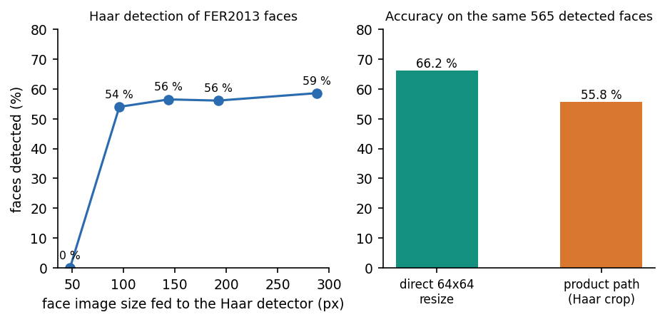
Figure 20: Haar detection rate against image size (left) and accuracy of the final model on the same faces through the product path and by direct resizing (right).
The second panel measures a second effect. On the 565 faces that were detected at 3x, the final classifier is 66.2 % accurate when the 48-pixel image is simply resized to 64 x 64 (how it was trained) but only 55.8 % accurate when the product's own path is used (Haar crop of the enlarged image, then resize). The Haar box cuts the face tighter than the dataset's crop, so the network sees a different framing from the one it learned. This train/serve mismatch costs about ten points of accuracy and is not visible in any number the training script prints.

7.7.2 Other edge cases
• No face: the service answers 200 with face_detected: false, empty lists and dominant: null; for a signed-in user a history row is still written (without a thumbnail), so history lists such rows as 'No face detected'.
• Undecodable input: a text file, an empty file and a truncated JPEG each end in HTTP 500 (3 probes), because Pillow's exception is not caught.
• Large input: a 2000 x 1500 JPEG with no face takes about 61 ms; a 6000 x 6000 JPEG is accepted.
• Several faces: only the largest detected box is analysed; the others are ignored (by design in face.py).
• Model file missing: /api/health reports model_loaded: false and an analysis that finds a face raises FileNotFoundError (HTTP 500); this is exactly the state the delivered folder was in.
• Unused parameter: analyze_image_bytes accepts a threshold argument that is never read.

7.8 Performance testing
Latency was measured over real HTTP on 127.0.0.1 (the name localhost adds about two seconds per call on this machine because of an IPv6 fall-back). Each endpoint was called 10-100 times in sequence by a single client; there was no concurrent load, so these are service times, not capacity figures.
Table 37: Latency of the Mosaic API (milliseconds).
Request | n | p50 | p95 | max
GET /api/health | 100 | 1.7 | 3.1 | 6.5
POST /api/auth/login (bcrypt) | 20 | 219.2 | 239.9 | 298.2
GET /api/auth/me | 100 | 3.0 | 4.7 | 5.9
POST /api/analyze anonymous (face) | 60 | 19.3 | 26.2 | 36.5
POST /api/analyze authenticated (face, persisted) | 60 | 27.8 | 36.0 | 45.7
POST /api/analyze (no face found) | 40 | 2.4 | 3.5 | 4.1
GET /api/history?limit=20 | 60 | 6.6 | 11.3 | 14.0
POST /api/analyze (2000x1500 JPEG, no face) | 10 | 61.3 | 64.7 | 75.4

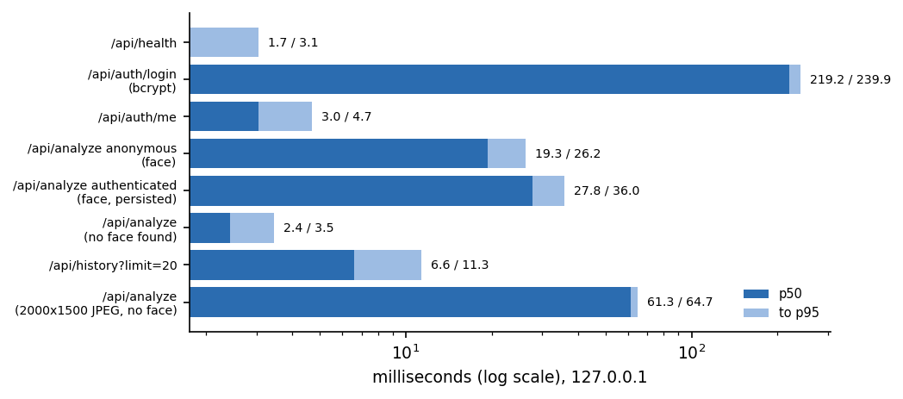
Figure 21: Median and 95th-percentile latency of each measured request (log scale).
Classification is cheap: an anonymous analysis of a face takes 19.3 ms at the median, and 27.8 ms when the user is signed in, the extra 8.4 ms being the database insert, the thumbnail write and the update. A photo without a face is answered in 2.4 ms because the CNN is skipped, and the largest image tested (61 ms) is dominated by decoding. Login costs 219 ms, which is bcrypt's deliberate work factor. Health and /me take under 4 ms. Model start-up (loading a 770,130-parameter network) happens once, when uvicorn starts.
Training cost is a different matter: on this CPU one 5-epoch classifier run took 8-9 minutes when the machine was shared (mean 8.5 minutes over 8 runs), and the shipped final-stage run took 10 minutes 37 seconds.

7.9 User acceptance
No user-acceptance test with real users was carried out. There was no pilot group, no questionnaire and no usability session, and no claim about satisfaction or usability is made anywhere in this report. The nearest substitute is the scripted walk-through of Section 7.5, which shows that a new user can register, upload a photo and read a result without any step that the interface does not offer, with the exceptions listed there.

7.10 The limits of the testing done
• One machine, one browser, one session: Windows 11, Chrome (headless, 1440 x 900), a single sequential client. No mobile or tablet layouts, no other browsers, no accessibility audit.
• No load or soak test: concurrency, memory growth and SQLite locking under many users were not measured.
• Front end: there are no component or end-to-end test files in the repository; the evidence is the successful TypeScript compile in next build and the screen walk-through.
• Webcam path untested (no camera); the same upload route would be used, with a JPEG captured from the video element.
• Model correctness is measured, not tested: the 7,178 FER2013 test faces carry basic labels only, so the compound outputs have no real ground truth (Chapter 8).
• Test data is the training distribution: every face used in a test or screenshot comes from FER2013 or from the project's own generator; no photograph of a person outside the dataset was used.
• Characterisation tests freeze defects: two of the 28 tests pass only while two known defects remain.

8. RESULTS AND OUTPUT SCREENS

8.1 What was measured and how
Five sets of measurements are reported. (1) The model the product serves, classifier_final.pt, on the FER2013 test set (7,178 real faces, seven basic labels), compared with the single-label stage-1 backbone that is the 'single-label baseline' of objective 4. (2) A seeded ablation that retrains the final stage with and without the synthetic faces (3 seeds each). (3) The behaviour of the eleven compound outputs on real faces and on freshly generated compound faces. (4) The quality of the conditional GAN. (5) The serving path: face detection and the output screens of the running application.
The data is the FER2013 partition shipped by the Hugging Face mirror Jeneral/fer-2013: 28,709 training and 7,178 test faces of 48 x 48 pixels with seven labels [11]. The product's training script prints the test accuracy after every epoch, so the test set doubles as a validation set; it is never used to choose a model or a threshold in this work, and all runs use the training script's fixed hyper-parameters. Disgust is rare (436 training and 111 test faces), so per-class figures for it are noisy. The majority-class rate on the test set is 24.71 % (always answering 'happy').
All numbers come from experiments/**/metrics.json, written by scripts/run_experiments.py and scripts/measure_api.py, and are copied into docs/REPORT_FACTS.md. The hardware was an Intel Core i5-12500 with 15.7 GB of RAM and no GPU, shared with other jobs. FER2013 contains no compound-emotion labels, so no accuracy for compound emotions on real faces can be reported; Section 8.5 says what can and cannot be measured instead.

8.2 Output screens
The screens below were captured from the production build of the console with a signed-in demo account and real data. The uploaded faces are FER2013 test images, enlarged fivefold onto a grey 640 x 360 canvas so that the face detector can find them; two further uploads are faces synthesised by the project's cEmoGAN. The seven real faces were the first detectable face of each class in a random order, a small illustration and not a sample from which an accuracy could be estimated.
Figure 22: Result for a happy face: the card names Happy (47 % confidence); the bar chart shows Surprise (44 %) as the runner-up; every compound bar reads 0 %. The thumbnail is a broken image (defect F6, Chapter 7). | 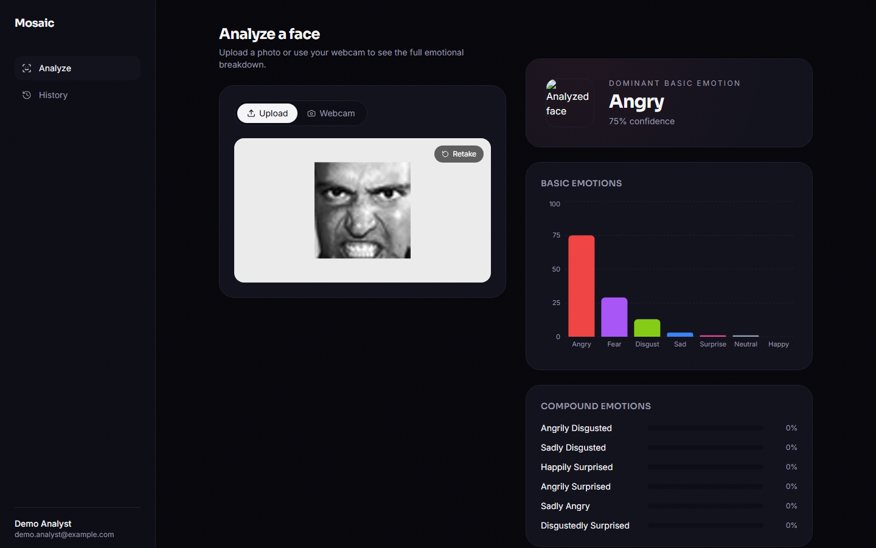  Figure 23: Result for an angry face: Angry is dominant with 75 % confidence, the highest of the seven samples.

The first two screens show the interface working as designed. The dominant card gives the highest of the 18 sigmoid outputs, the bar chart lists the seven basic emotions sorted by confidence, and the lower panel lists the six strongest compound emotions. Because the sigmoid outputs are independent, the basic confidences do not sum to one: for the happy face Happy and Surprise together exceed 90 %, which is what a multi-label model is expected to do. What is not as intended is the compound panel, where the highest compound probability averages 0.00019 over the real test set (Section 8.5).
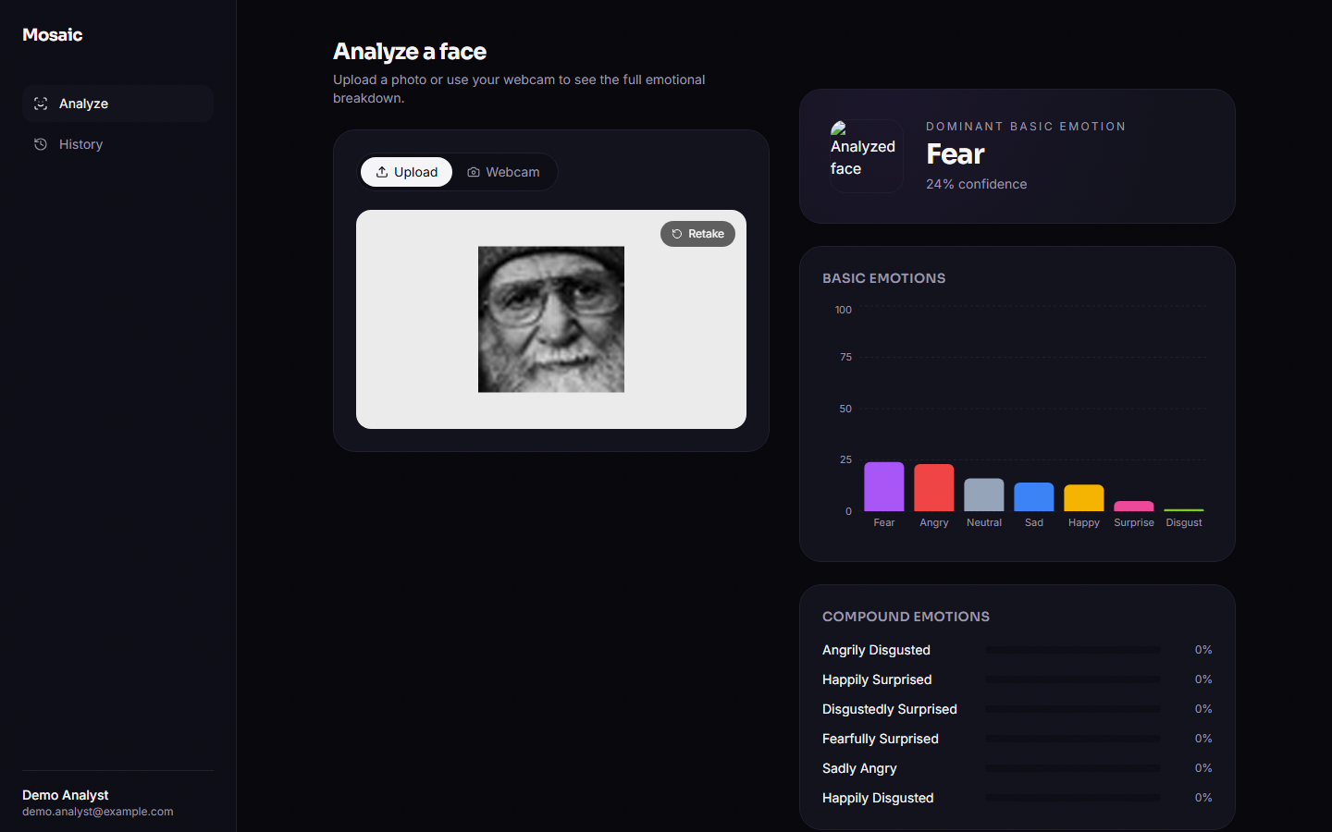  Figure 24: A neutral face read as Fear (24 % confidence, the lowest of the samples): a low-confidence error, typical of the confusion between neutral, sad and fear. | 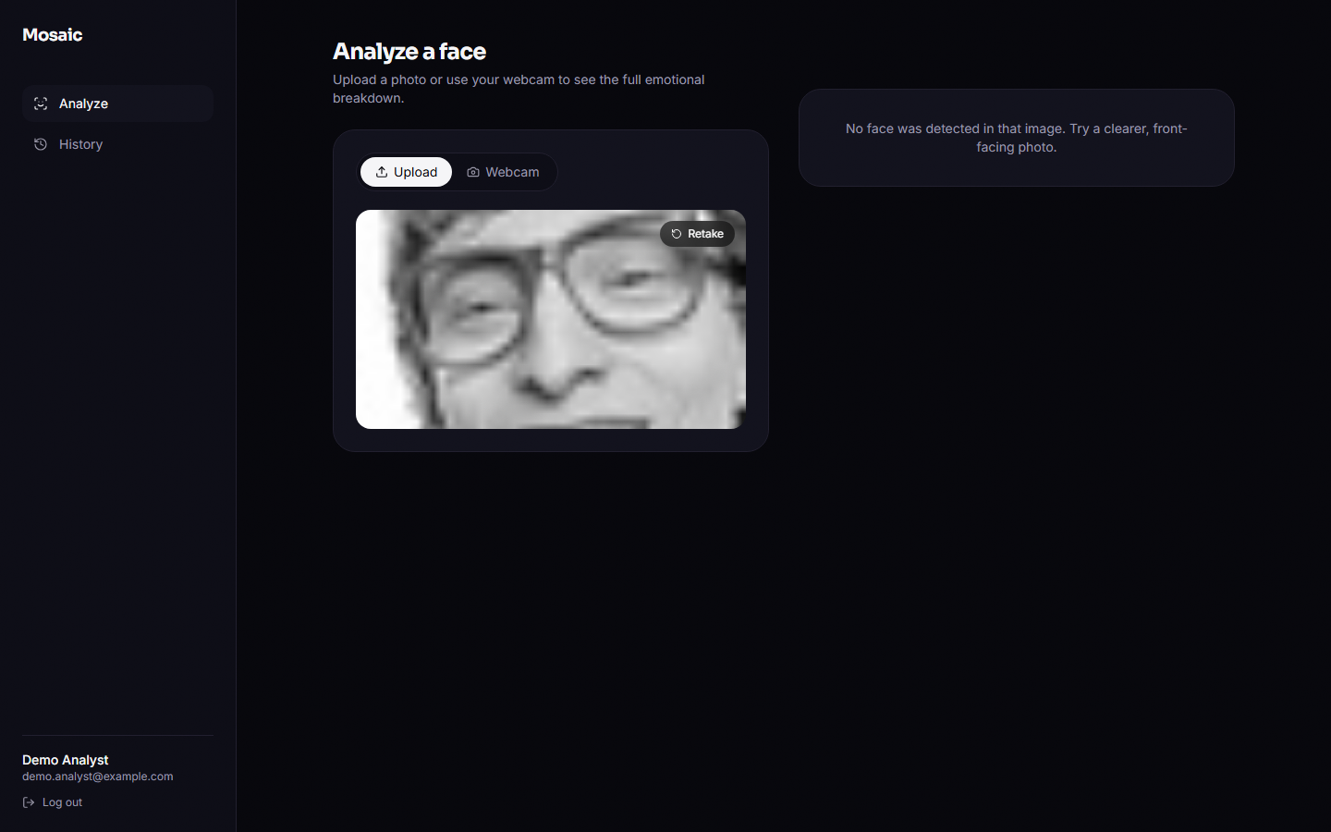  Figure 25: A native 48 x 48 face: the Haar detector finds nothing, the API answers 200 with face_detected false and the console shows 'No face was detected in that image'.

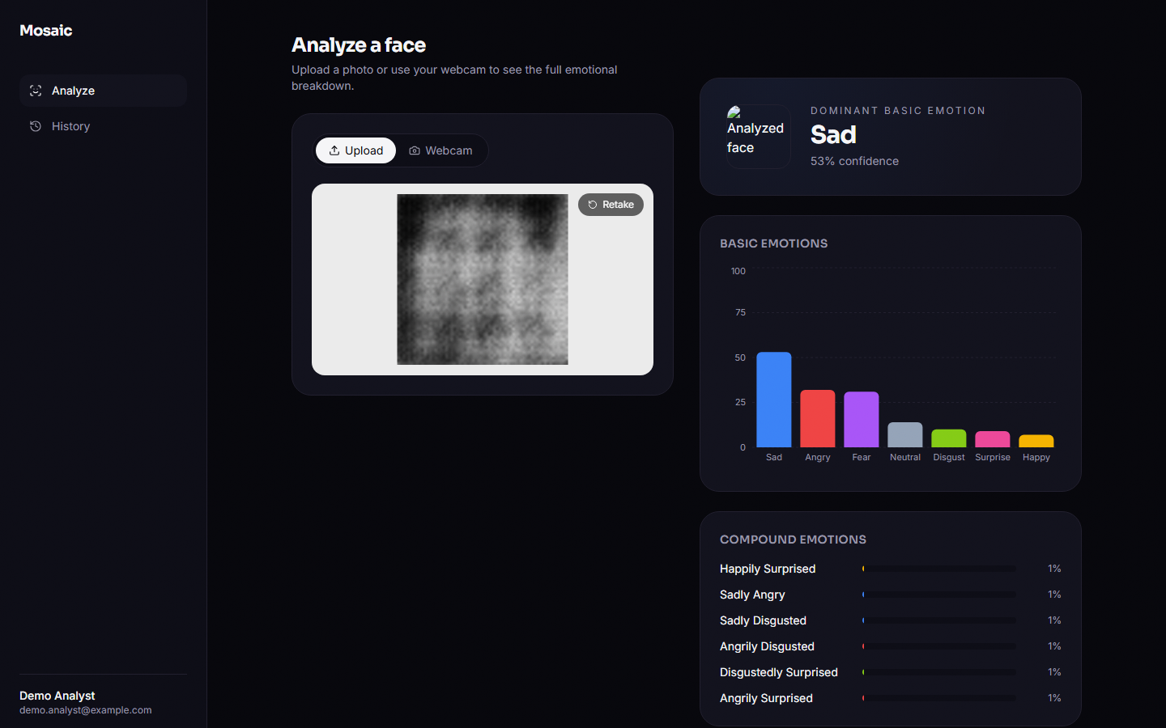  Figure 26: A face synthesised by the cEmoGAN under the condition 'happily surprised'. The image is a blurred blob, classified Sad (53 %); the happily-surprised bar shows 1 %. | Figure 27: History page: one card per analysis, newest first, with the dominant label, confidence and time; the entry without a face is listed as 'No face detected'.

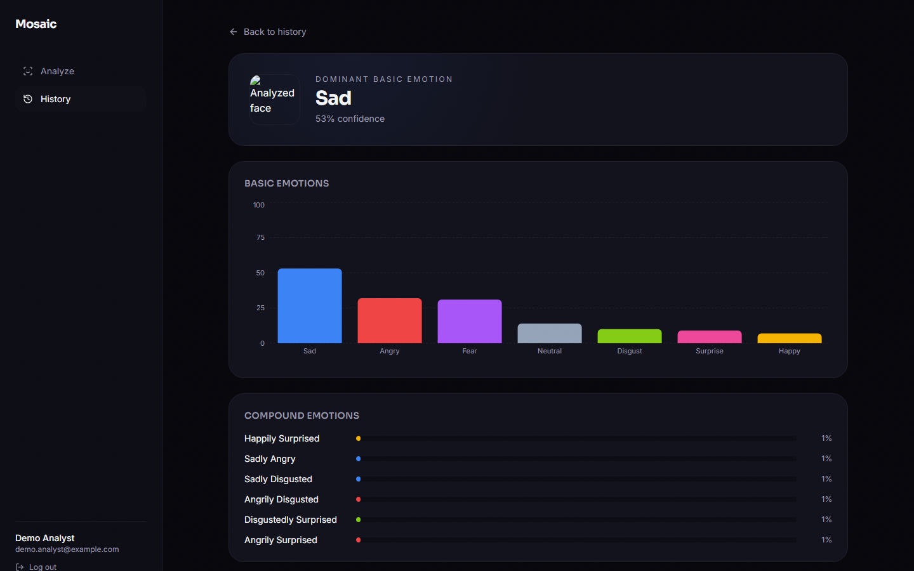
Figure 28: History detail route /app/history/[id], opened by typing its address because no link leads to it; it re-renders the stored result.
Table 38: The seven real faces of the walk-through (dominant label returned by the running API).
Sample | True label | Dominant label | Confidence | Outcome
happy_01.jpg | Happy | Happy | 47 % | correct
neutral_02.jpg | Neutral | Fear | 24 % | wrong
sad_03.jpg | Sad | Sad | 48 % | correct
angry_04.jpg | Angry | Angry | 75 % | correct
fear_05.jpg | Fear | Fear | 44 % | correct
disgust_06.jpg | Disgust | Angry | 48 % | wrong
surprise_07.jpg | Surprise | Fear | 52 % | wrong

A real API response (anonymous call, so id is null and nothing is stored) for the first sample, abridged to the first three entries of each list:
POST /api/analyze (multipart field "image" = happy_01.jpg)
200 OK
{ "id": null, "face_detected": true,
"basic_emotions": [ {"key":"happy","label":"Happy","confidence":0.4733},
{"key":"surprise","label":"Surprise","confidence":0.438},
{"key":"fear","label":"Fear","confidence":0.113}, ... 7 items ],
"compound_emotions": [ {"key":"angrily_disgusted","label":"Angrily Disgusted","confidence":0.0000}, ... 11 items ],
"dominant": {"key":"happy","label":"Happy","confidence":0.4733,"kind":"basic"},
"thumbnail_url": null }

POST /api/analyze (native 48x48 face)
200 OK { "id": null, "face_detected": false, "basic_emotions": [], "compound_emotions": [], "dominant": null, "thumbnail_url": null }

8.3 Basic-emotion recognition
Table 39: Seven-class results on the FER2013 test set (7,178 faces).
Model | Accuracy | Macro-F1 | Weighted-F1
Single-label baseline: stage-1 softmax CNN, 5 epochs | 50.56 % | 0.4735 | 0.5081
Final 18-output multi-label CNN (shipped), argmax over the seven basic outputs | 58.14 % | 0.5381 | 0.5872
Majority class ('happy') for reference | 24.71 % | - | -

The shipped multi-label model reaches 58.14 % accuracy and 0.538 macro-F1, against 50.56 % and 0.473 for the single-label baseline: 7.6 points of accuracy and 0.065 of macro-F1 in favour of the final model, on 770,130 parameters. Both are far above the majority rate, and both are in the range of a small CNN on this noisy dataset: the lightweight CNN of a recent comparative study reaches 51.6 % on FER-2013, ahead of HOG with an SVM (44.0 %) and LBP with logistic regression (25.0 %) [6]. That study uses its own split and training schedule, so the comparison is indicative only.
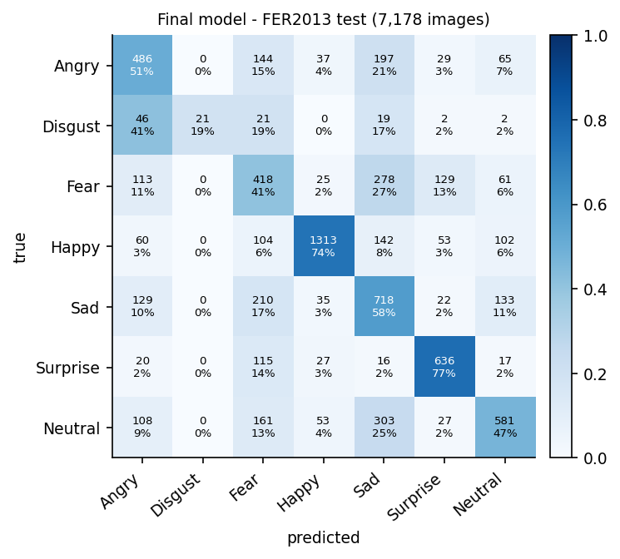
Figure 29: Normalised confusion matrix of the final model on the FER2013 test set (counts and row percentages).
Table 40: Per-class results of the final model, with the baseline's F1 for comparison.
Class | Baseline F1 | Final precision | Final recall | Final F1 | Test faces
Angry | 0.386 | 0.505 | 0.507 | 0.506 | 958
Disgust | 0.370 | 1.000 | 0.189 | 0.318 | 111
Fear | 0.232 | 0.356 | 0.408 | 0.381 | 1024
Happy | 0.744 | 0.881 | 0.740 | 0.805 | 1774
Sad | 0.394 | 0.429 | 0.576 | 0.492 | 1247
Surprise | 0.690 | 0.708 | 0.765 | 0.736 | 831
Neutral | 0.497 | 0.605 | 0.471 | 0.530 | 1233

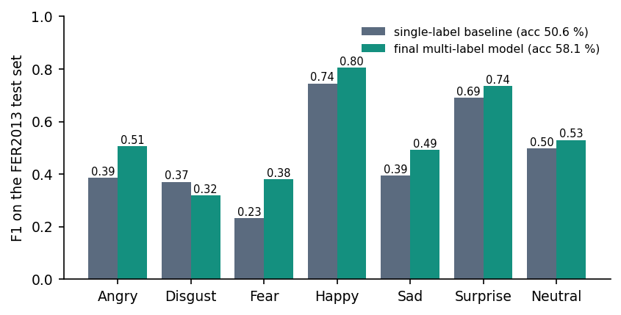
Figure 30: Per-class F1 of the single-label baseline and of the final multi-label model.
Happy (0.80) and surprise (0.74) are recognised best; angry, neutral and sad sit around 0.5; fear is weak (0.38). Disgust is the extreme case: precision is 1.00 but recall only 0.19, because the model predicts it 21 times in 111 true cases and almost always (and correctly) when it does; 41 % of disgust faces are read as angry. The two-way confusions that dominate the matrix are fear with sad (27 % of fear faces are read as sad, 17 % of sad faces as fear) and neutral with sad (25 % of neutral faces read as sad). The baseline had a different error profile, with much better disgust recall (0.56) at the price of low precision; a plausible reason is that the stage-1 softmax loss is class-weighted while the final model's binary cross-entropy is not, but this was not isolated.
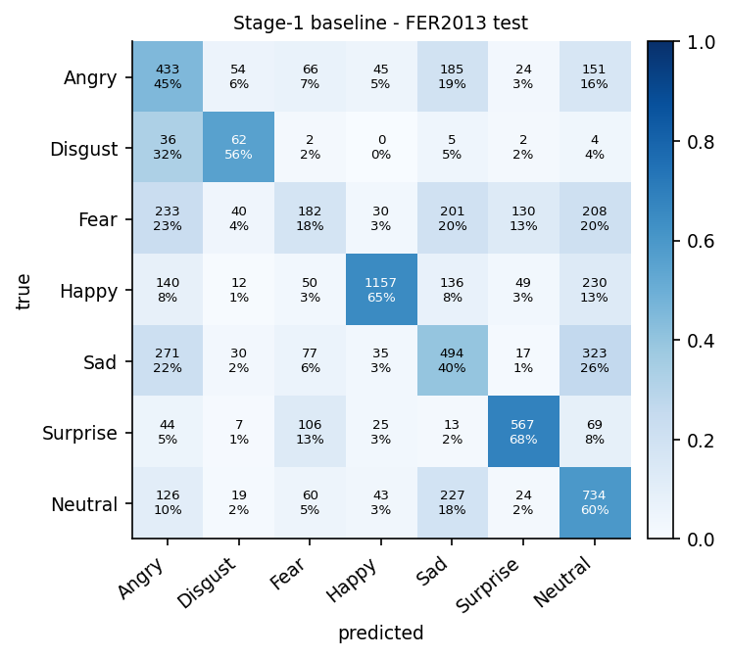
Figure 31: Normalised confusion matrix of the single-label baseline, for comparison with the final model.

8.4 Does the synthetic data help? A seeded ablation
The 'multi-label beats single-label' result of Section 8.3 has two possible causes: the synthetic compound faces, or simply the five extra epochs of training on top of the stage-1 weights. To separate them, the final stage was retrained from the same backbone with the same hyper-parameters, with 200 synthetic faces per compound class (the product recipe) and without any synthetic data (the compound targets are then always zero), for 3 seeds each. Both variants have 18 outputs; only the training set differs.
Table 41: Final-stage retraining with and without the synthetic faces (FER2013 test set, seven basic labels).
Run | Real only: accuracy | Real only: macro-F1 | Real + synthetic: accuracy | Real + synthetic: macro-F1
seed 1 | 58.32 % | 0.5472 | 58.28 % | 0.5257
seed 2 | 56.42 % | 0.5372 | 59.42 % | 0.5411
seed 3 | 59.57 % | 0.5555 | 58.89 % | 0.5383
mean ± std | 58.10 ± 1.59 % | 54.67 ± 0.92 | 58.86 ± 0.57 % | 53.51 ± 0.82

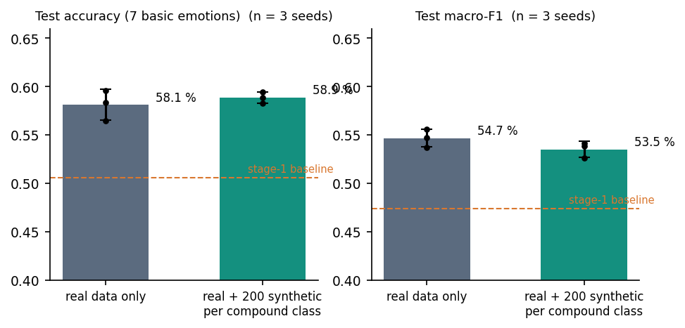
Figure 32: Ablation over seeds: test accuracy and macro-F1 with and without synthetic compound faces; dots are single seeds, bars the mean.
With synthetic data the mean accuracy is 58.86 % against 58.10 % without, a difference of 0.76 points that is smaller than the seed-to-seed spread of the real-only runs (standard deviation 1.59 points) (Welch t = 0.78, p = 0.50, n = 3 per group). Macro-F1 is lower with synthetic data (0.535 against 0.547, p = 0.18). With three seeds the test has little power, so the honest conclusion is no detectable effect of the synthetic data on basic-emotion recognition; the improvement from 50.56 % to about 58 % is reproduced by the real-only control and is therefore attributable to the additional training, not to the generated faces. This is consistent with the generator's quality (Section 8.6): 2,200 blurred images among 30,909 cannot be expected to change what the network learns about real faces.
Table 42: Effect of the number of synthetic faces per compound class (seed 1).
Synthetic per class | Accuracy | Macro-F1 | Mean top compound probability on real faces
0 | 58.32 % | 0.5472 | 0.00007
50 | 57.77 % | 0.5151 | 0.00012
200 | 58.28 % | 0.5257 | 0.00023
800 | 58.41 % | 0.5593 | 0.00014

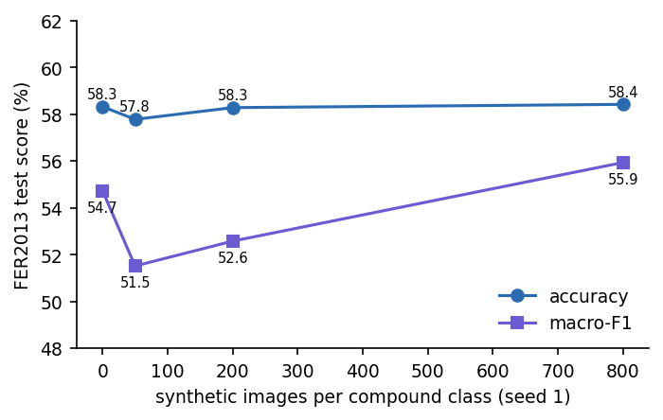
Figure 33: Accuracy and macro-F1 against the number of synthetic faces per compound class (single seed).
The sweep uses one seed per point, so differences of one or two points are within the seed noise shown above; the table is a check that the number of synthetic faces chosen by the product (200) is not an unlucky value, not a tuning result.

8.5 Compound emotions

8.5.1 On real faces
On the 7,178 real test faces the largest compound probability averages 0.00019. No face has any compound output at or above 0.3 (0.00 %) or 0.5 (0.00 %), and the dominant label, the maximum of all 18 outputs, is a compound label for 0.00 % of faces. The compound scores also carry no information about the face: the mean score is 0.000091 when the true basic emotion is one of the two components of the compound and 0.000091 when it is not, and the top-ranked compound contains the true basic label for 19.43 % of faces, below the 25.38 % that a random compound would achieve. In short, on real faces the shipped product is a seven-class recogniser whose compound panel always reads about zero (screens 08, 09 and 12).

8.5.2 On synthetic compound faces
Real compound ground truth is unavailable, so the only labelled compound data are the faces the project's own generator produces. A hold-out of 1,100 fresh generated faces (100 per compound class, a seed not used in training) carries the training-style labels (two basic bits and one compound bit). This is a weak test, because the labels are defined by the generator's own condition, and it is the same kind of evaluation as the base paper's (Section 8.7). The multi-label scores at several thresholds are:
Table 43: Final model on the synthetic hold-out, over all 18 labels.
Threshold | Micro-F1 | Macro-F1 | Exact-match ratio | Compound recall | Compound ROC-AUC (macro)
0.05 | 0.301 | 0.265 | 0.000 | 96.6 % | 0.497
0.1 | 0.442 | 0.175 | 0.000 | 1.3 % | 0.497
0.2 | 0.453 | 0.150 | 0.000 | 0.0 % | 0.497
0.3 | 0.401 | 0.116 | 0.000 | 0.0 % | 0.497
0.5 | 0.110 | 0.025 | 0.000 | 0.0 % | 0.497

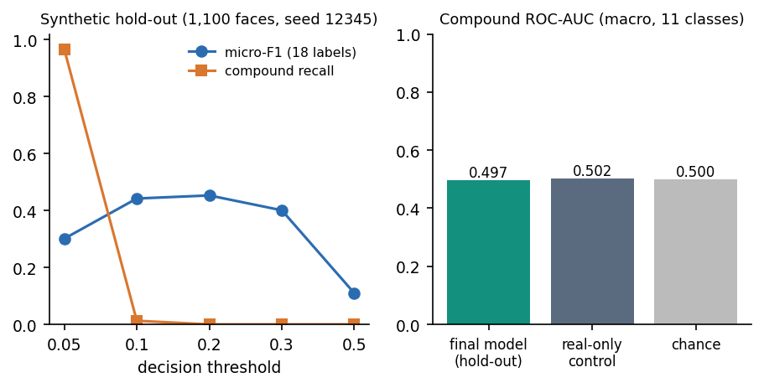
Figure 34: Synthetic hold-out: micro-F1 and compound recall against the decision threshold (left) and compound ROC-AUC compared with the real-only control and with chance (right).
Micro-F1 peaks at 0.453 at threshold 0.2, and that figure is almost entirely the basic bits; the exact-match ratio is 0.000 at every threshold tried, i.e. the model never reproduces a full three-bit label set. Compound recall is 97 % at 0.05 only because nearly every output exceeds that low threshold; at 0.1 it falls to 1.3 %. The macro ROC-AUC of the eleven compound outputs is 0.497, which is chance level: the model cannot say which compound class a generated face was synthesised for. The real-only control scores 0.502, so the synthetic training changed the compound outputs on generated faces (mean probability 0.069 against 0.00008) without teaching it to discriminate between them. The dominant label is the correct compound for 0.00 % of generated faces.
What the network appears to have learned from the synthetic data is to detect that an image looks generated (and to raise all compound outputs a little for it), not to tell compounds apart. Two causes are visible in the data: the 2,200 synthetic faces are 7 % of the training set and each compound bit is positive in only 0.65 % of rows, so binary cross-entropy is minimised by predicting small probabilities everywhere; and the generator does not produce distinguishable faces for different conditions (Section 8.6).

8.6 Quality of the conditional GAN
The generator (1,128,353 parameters) was trained for 10 epochs on 2,800 faces (400 per class) with final discriminator and generator losses of 0.773 and 3.724 (training log). Its images are shown against real faces in the next three figures; the first two grids have one row per basic emotion in the order angry, disgust, fear, happy, sad, surprise, neutral, and the third has one row per compound class in taxonomy order, starting with happily surprised.
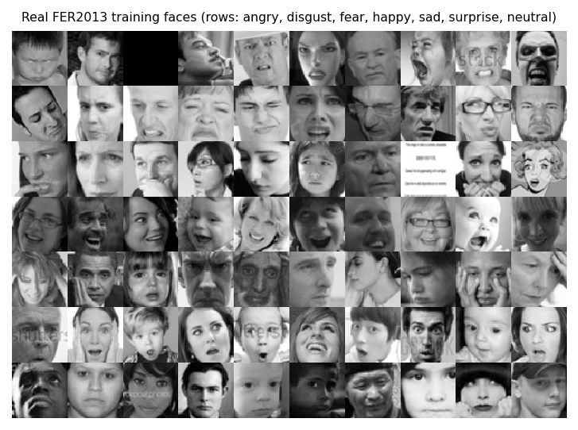  Figure 35: Real FER2013 training faces, one row per basic emotion. | 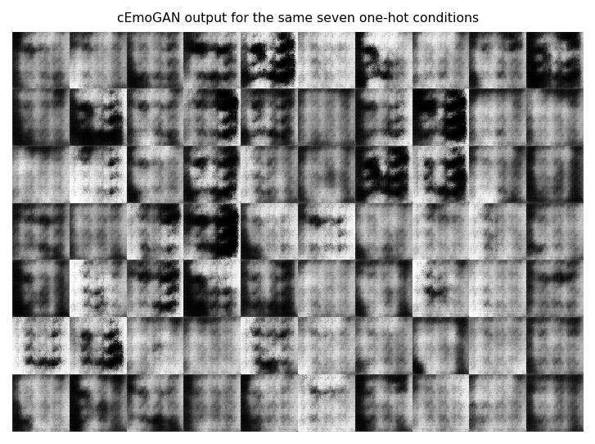  Figure 36: Generator output for the same seven one-hot conditions: blurred, low-contrast face-like patterns.

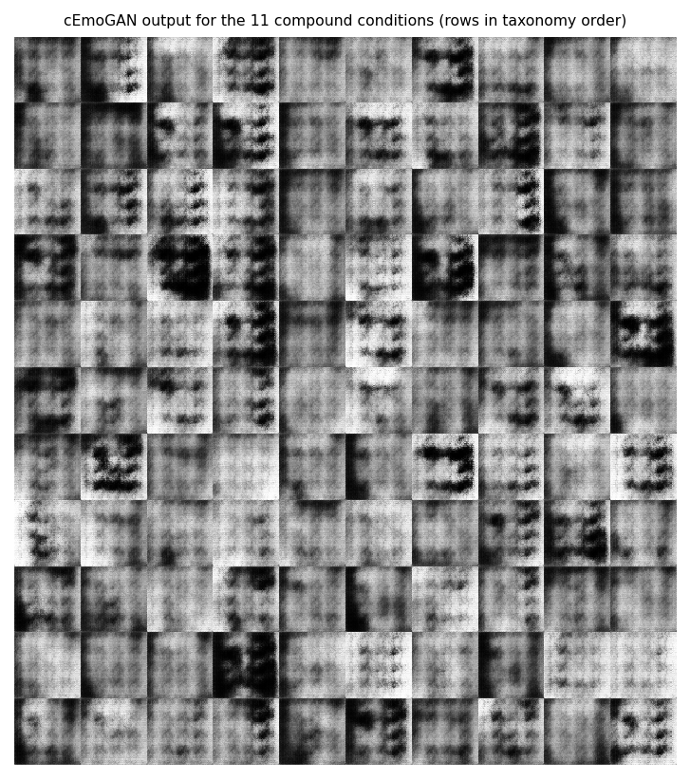
Figure 37: Generator output for the eleven compound conditions (0.5 / 0.5 on the two component emotions).
Visually the output is not photographic: faces are blurred, with eyes and mouth as dark patches and mottled backgrounds. Two measurements make this objective. First, does the generator obey its condition? The stage-1 classifier reads the intended emotion on 15.0 % of 500 generated faces per class on average, against 14.3 % by chance; the per-class values range from 0.0 % to 45.2 %, which means that the classifier agrees with the condition only for angry, fear and sad and almost never for happy, surprise, disgust or neutral. For the compound conditions the classifier's top class lies in the intended pair for 33.5 % of faces (chance 28.6 %) and its top two classes equal the pair for 8.3 % (chance 4.8 %); the best pairs are sadly fearful and sadly angry (70 % and 70 %), while happily surprised (0 %), happily disgusted (1 %) and disgustedly surprised (1 %) are essentially never recognised.
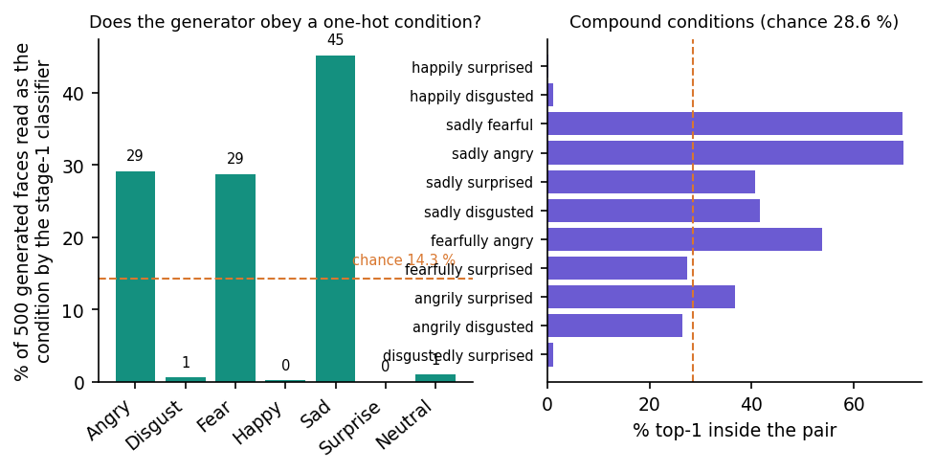
Figure 38: Condition fidelity of the generator, judged by the stage-1 classifier: one-hot conditions (left) and compound conditions (right).
Second, how far are generated faces from real ones? The Fréchet distance between 2,800 generated faces and 2,800 real training faces, computed in the 256-dimensional feature space of the stage-1 CNN, is 171.0 for the one-hot conditions and 170.2 for the compound conditions, against 14.5 for real test faces measured the same way. This is not an Inception-based FID [21] and its values are not comparable with published FIDs; it only says that generated faces are roughly 12 times further from the real distribution than a real held-out face is. The pixel-wise standard deviation within a class is 53.0 for generated and 60.2 for real faces, so the generator has not collapsed to a single image, but in the grids the variation looks mostly like changes in brightness and blur rather than in facial structure.
The base paper's generator adds an encoder that keeps a face's identity while the label changes, and reports that 94-99 % of generated images keep an identity similarity above 0.7 [1]. Mosaic's generator has no encoder and no identity input: the latent vector is random noise, so identity preservation, the core of objective 1, is neither implemented nor measured.

8.7 Comparison with the base paper and related work
The base paper [1] reports, for its recogniser trained on cEmoGAN images, f-beta scores of 0.99, 0.99 and 0.80 and exact-match ratios of 100 %, 99 % and 68.7 % on CK+, JAFFE and MUG, against 0.45, 0.60 and 0.51 f-beta for an EfficientNet-B0 baseline. These numbers cannot be compared with Mosaic's, for four reasons, stated here as plainly as possible:
1. Different data. The base paper uses three laboratory datasets (CK+, JAFFE, MUG) and, for MUG at least, builds two-emotion ground truth by morphing peak frames; Mosaic uses FER2013, 36,000 uncontrolled web faces at 48 x 48 pixels with basic labels only.
2. Different test images. The base paper scores its recogniser on a 30 % split of 15,000 images produced by the same generator that produced its training images; Mosaic's basic-emotion figures are on real held-out photographs, and its only compound figures are on a generated hold-out.
3. Different labels. The base paper's compound classes have morphed ground truth; Mosaic has none for real faces.
4. Different resources. The base paper trained on an Intel i9-9900K with an NVIDIA RTX A6000; Mosaic's generator was trained for ten epochs on a CPU.
The one place where the two evaluations are of the same kind is the generated hold-out. There the base paper obtains exact-match ratios of 68.7-100 % and Mosaic obtains 0.000 at every threshold (best micro-F1 0.453) and chance-level compound ROC-AUC: the reproduction of the idea (generate compound faces, train a multi-label CNN on them) did not reproduce the result. The reasons are the generator's weakness (Section 8.6), the very small share of synthetic data, and the absence of the encoder.
Table 44: Mosaic against the base paper and the related results quoted in this report.
Work | Data and labels | Test images | Reported result | Comparable with Mosaic?
Khine et al. [1] | CK+, JAFFE, MUG; morphed compound labels | Generated by their cEmoGANs | f-beta 0.99 / 0.99 / 0.80; EMR 100 / 99 / 68.7 % | No (different data and test images)
Galkaduwa [6] | FER-2013, 7 basic labels | FER-2013 test split | CNN 51.6 %, HOG+SVM 44.0 %, LBP 25.0 % | Loosely (same dataset, own split)
Liu et al. [7] | RAF-DB compound, 7 classes, real labels | RAF-DB validation | Accuracy 60.4-64.3 %, F1 51.5-55.4 % | No (real compound labels, other data)
Mosaic baseline | FER2013, 7 basic labels | FER2013 test (7,178) | 50.6 %, macro-F1 0.473 | -
Mosaic final model | FER2013, 7 basic labels | FER2013 test (7,178) | 58.1 %, macro-F1 0.538 | -
Mosaic compound outputs | Synthetic compound labels only | Generated hold-out (1,100) | EMR 0.000; compound AUC 0.50 | Same kind as the base paper's; far lower

8.8 Face detection and the serving path
The product does not classify the uploaded image directly: a Haar cascade must first find a face. On enlarged FER2013 faces it succeeds for 56 % of images (3x) and for none of the native 48-pixel images; on the 565 detected faces the final model scores 55.8 % through the product path, against 66.2 % when the same images are resized directly (Figure in Chapter 7). A real user's photograph is larger and sharper than a FER2013 face, so the detection rate on such photographs would probably be higher, but this was not measured: no photograph from outside the dataset was used.
End-to-end the API answers an analysis in 19 ms at the median (Chapter 7), so the cost of classification is negligible against the cost of getting a usable face into the network.

8.9 Success and failure analysis

8.9.1 What worked
• A complete application: registration, token authentication, upload and webcam capture, a seven-bar basic chart, a compound panel, a dominant card, per-user history with thumbnails, all running locally, 28 automated tests passing.
• Basic-emotion recognition at 58.1 % accuracy, with happy and surprise recognised well (F1 0.80 and 0.74).
• Fast serving: 19 ms median per analysis on a CPU.
• A reproducible measurement set: every number in this chapter is regenerated by two scripts from the stored checkpoints and the dataset.

8.9.2 What failed
• Compound emotions: inert on real faces (maximum compound probability 0.00019) and at chance level on generated faces (ROC-AUC 0.50); the dominant label is never a compound.
• The generator does not follow its condition (15 % against 14 % chance) and produces blurred faces.
• Disgust is recalled for only 19 % of faces and fear confused with sad; neutral is often read as sad or fear (screen 12).
• Face detection misses 44 % of enlarged faces, and the crop it produces lowers accuracy by about 10 points.
• Interface defects: broken thumbnail on every result card, unreachable history-detail page, redirect to the login page on a hard reload, no-face answered 200 where the contract says 422, undecodable uploads answered 500.

8.10 Limitations of these results
• Single dataset: FER2013 only; no other basic-emotion dataset and no compound dataset was available (RAF-DB, which has compound labels, was not available to this project).
• No compound ground truth on real faces, hence no accuracy for the product's headline feature.
• Few seeds: 3 seeds per ablation arm; differences below about 2 points cannot be resolved.
• The test set doubles as validation in the training scripts' printout; it was not used for selection here, but there is no separate validation split.
• Short training: five epochs per stage and a ten-epoch GAN on a CPU; longer training might change both the basic accuracy and the generator, but this was not tried.
• FER2013 label noise: the labels of FER2013 are noisy, so the attainable accuracy is well below 100 %; no human-accuracy figure was measured here.
• No real-world photographs and no users: the walk-through uses dataset faces and generated faces only.

8.11 Objectives versus outcomes
Table 45: The five objectives of the batch and what was measured.
No. | Objective | Outcome | Evidence
1 | Generate identity-preserving facial images with complex emotions using cEmoGANs | Not achieved. A conditional GAN exists and was trained, but it has no identity encoder and does not obey its condition | 15 % condition accuracy (chance 14 %); Fréchet distance 171 vs 14
2 | Enlarge the complex-emotion dataset with generated images | Partly. 2,200 synthetic compound images were produced and added to the training set, but they are not distinguishable by class and carry no real labels | Compound ROC-AUC 0.50; no effect on basic accuracy (58.1 % real-only against 58.9 % with synthetic faces)
3 | Train a CNN multi-label classifier for basic and complex emotions | Implemented; basic emotions work, compound outputs are inert | 58.1 % basic accuracy; maximum compound probability 0.00019 on real faces
4 | Evaluate recognition performance against single-label baselines | Done, with caveats. The multi-label model beats the single-label baseline, but a real-only control shows that the extra epochs, not the synthetic images, explain the gain | 50.6 % -> 58.1 %; ablation 58.1 % real-only against 58.9 % with synthetic faces
5 | Provide an interface for emotion recognition from uploaded images | Achieved (with the front-end defects of Chapter 7) | 19 captured screens; 28 tests pass; median analysis 19 ms

8.12 Summary of findings
1. Mosaic recognises the seven basic emotions at 58.1 % accuracy (macro-F1 0.538) on 7,178 real FER2013 faces, 7.6 points above its single-label baseline.
2. The gain comes from additional training, not from the generated faces: real-only retraining scores 58.1 % (± 1.6) and retraining with synthetic faces 58.9 % (± 0.6).
3. The compound-emotion output, the purpose of the project, is not functional: it is zero on real faces and cannot rank compound classes on synthetic ones.
4. The conditional GAN is under-trained and ignores most of its condition; identity preservation was not implemented.
5. The application around the model works and is fast, with a short list of front-end and API defects documented in Chapter 7.
6. A faithful reproduction of the base paper's result would need an identity-preserving generator trained far longer on a laboratory dataset, a real compound test set, and a larger share of compound data in training; these are taken up in Chapter 10.

9. CONCLUSION

9.1 Summary of the work
The batch asked for a system that generates realistic complex-emotion data and recognises several emotions in a single face. The project delivered Mosaic: a face detector, a conditional GAN, synthesis of 2,200 compound-labelled faces, an 18-output multi-label CNN, a FastAPI service with accounts and history, and a Next.js console, backed by 28 passing tests and 24 of 24 expected probe results.
In the documentation phase the product was measured more strictly than it had been built. The final classifier reaches 58.14 % accuracy on 7,178 real FER2013 test faces, against 50.56 % for the single-label baseline. A control trained without synthetic images scores 58.10 ± 1.59 % against 58.86 ± 0.57 % with them, so the generated faces do not account for the gain. The compound outputs are inert on real faces (mean maximum 0.00019) and at chance on synthetic faces (ROC-AUC 0.497). The engineering works as designed; the central scientific claim of the batch, that generated complex expressions teach a classifier to recognise complex emotions, was not reproduced at this scale.

9.2 Objectives achieved and not achieved
Table 46: Batch objectives against the outcome
Objective | Status | Evidence
1. Generate identity-preserving facial images with complex emotions using cEmoGANs | Not achieved | A conditional GAN (1,128,353 parameters) was trained for 10 epochs on 2,800 faces, but the code has no encoder and no identity term, and the generator does not obey its condition: the stage-1 classifier reads the intended emotion on 15.0 % of one-hot generated faces (chance 14.3 %) and the Fréchet distance in feature space is 171.0 against 14.5 for real test faces. Identity preservation was not measured.
2. Enlarge the complex-emotion dataset with generated images | Nominal only | 2,200 synthetic images (200 per compound class, 7.1 % of the 30,909 training images) were added with three target bits each. They carry no verified compound content, so the dataset is larger but not richer in complex emotions.
3. Train a CNN multi-label classifier for basic and complex emotions | Implemented; compound outputs inert | 18 sigmoid outputs, 770,130 parameters, basic accuracy 58.14 %. On 7,178 real test faces the largest compound probability averages 0.00019 and none reaches 0.3; on 1,100 synthetic hold-out faces the compound ROC-AUC is 0.497 (chance 0.5).
4. Evaluate recognition performance against single-label baselines | Done; the gain is not due to the GAN | Final model 58.14 % against the single-label baseline 50.56 %, but a control trained the same way without synthetic images scores 58.10 ± 1.59 % (mean ± std over 3 seeds) against 58.86 ± 0.57 % with them. The gain over the baseline comes from five further epochs, not from the generated faces.
5. Provide an interface for emotion recognition from uploaded images | Achieved, with defects | Next.js console (landing, register, login, analyse by upload or webcam, history) over a FastAPI service; 28 automated tests pass, 24 of 24 malformed-input probes behave as expected, analysis takes a median of 19.3 ms. Defects: broken thumbnail image, unreachable history-detail page, HTTP 500 on undecodable uploads, 200 instead of 422 when no face is found.

The statuses are strict. 'Nominal' means the step ran but produced nothing of the quality the objective requires; 'inert' means the outputs exist but carry no signal in the measurements.

9.3 Key findings
1. Extra training with a multi-label head beats the single-label baseline. Accuracy rises from 50.56 % to 58.14 % (+7.58 points) and macro-F1 from 0.473 to 0.538 on the 7,178 FER2013 test faces (always predicting 'happy' scores 24.7 %). Per-class F1 is highest for happy (0.805) and surprise (0.736) and lowest for fear (0.381) and disgust, which has 436 training images and a recall of 18.9 %.
2. The generated faces do not explain that gain. Over 3 seeds the same recipe without synthetic images scores 58.10 ± 1.59 % accuracy and 54.67 ± 0.92 % macro-F1; with 200 synthetic faces per compound class it scores 58.86 ± 0.57 % and 53.51 ± 0.82 % (+0.76 and -1.16 points). Both differences are within the seed-to-seed spread. A single-seed sweep of the number of synthetic faces per compound class gives 57.77 % accuracy and 0.515 macro-F1 at 50, 58.28 % accuracy and 0.526 macro-F1 at 200 and 58.41 % accuracy and 0.559 macro-F1 at 800 (seed 1 throughout), so no dose-response is visible.
3. Compound outputs are inert on real faces. On 7,178 real test faces the largest compound probability averages 0.00019; 0.00 % of the faces have any compound output at or above 0.3, and the argmax rule that picks the dominant emotion chooses a compound label for 0.00 % of them. The score of a compound does not depend on whether the true basic label is one of its components, and the top compound contains the true label 19.4 % of the time against a chance level of 25.4 %.
4. Compound outputs cannot rank the synthetic classes either. On the synthetic hold-out the macro ROC-AUC is 0.497 for the shipped model (mean 0.507 over the retrained models) and 0.502 for the real-only control; no threshold gives an exact match. The compound head did learn that generated faces differ from real ones (mean compound probability 0.069 on synthetic compounds against 0.00008 for the control) but not which compound each one is.
5. The generator does not follow its condition. The stage-1 classifier recognises the intended basic emotion on 15.0 % of generated faces (chance 14.3 %); for compound conditions its top-two labels equal the requested pair 8.3 % of the time against 4.8 % by chance. Ten epochs on 2,800 faces were not enough to produce usable faces.
6. The serving path does not match the training data. Haar detection finds 0 % of native 48x48 FER2013 faces and 56.5 % after a threefold upscale. On the 565 faces it does find, accuracy through the product path is 55.8 % against 66.2 % when the same images are resized directly.
7. The software is tested and fast. 28 pytest tests pass; 24 of 24 malformed-input probes behave as expected (two documented defects aside); analysis takes a median of 19.3 ms anonymously and 27.8 ms when the result is stored, and a bcrypt login takes about 219 ms.
8. Scores are not comparable with the base paper. The base paper [1] reports f-beta 0.99, 0.99 and 0.80 on CK+, JAFFE and MUG, measured on 15,000 images produced by its own generator. Mosaic is scored on real, uncontrolled FER2013 faces for basic emotions and on its own synthetic faces for compounds, so neither number supports a claim of better or worse.
The two findings that most change how the system should be read are the seeded comparison with and without synthetic faces (Figure in Section 8.4) and the behaviour of the compound outputs on the synthetic hold-out (Figure in Section 8.5).

9.4 Practical applications
As built, Mosaic is a teaching and prototyping platform for affective computing: it shows the full path from a photo to a stored, explained result, and it makes the pitfalls of synthetic augmentation visible with real numbers. The basic-emotion output (58 % accuracy over seven classes, strongest for happy and surprise) could support exploratory interfaces, such as classroom or human-computer-interaction demonstrations, where errors are tolerable. The intended use cases (well-being applications, driver monitoring, customer-experience analysis) would need far higher accuracy, validated compound labels, consent handling and fairness testing first; Mosaic is not suitable for them as it stands.

9.5 Known limitations
The limitations are listed in full in Chapter 1, Chapter 8 and the Scope and Limitations document. The ones that matter most for reading the results are:
• No identity preservation and a weak generator.
• Compound emotions have no real ground truth.
• Synthetic labels are assumptions.
• Small, noisy, imbalanced training data.
• Short training on a CPU.
• Training and serving framing differ.

10. FUTURE SCOPE

10.1 Improvements to the existing system
The improvements below follow directly from the measurements; the first three would change the headline results.
1. Make the generator work first. Train the conditional GAN for far more than 10 epochs on more than 2,800 faces, add an identity encoder and a reconstruction or identity loss as in the base paper [1], widen the networks, and verify with a condition-fidelity test (target well above 15.0 %) and a Fréchet distance close to the real-versus-real reference of 14.5 before any synthetic face is used for training.
2. Use real compound labels. Evaluate and fine-tune on RAF-DB compound faces [12] or the C-EXPR-DB set used in ABAW7 [7] (both need a licence); only then can the compound outputs be scored on real faces.
3. Rebalance the loss for compound labels. Positive-weight or oversample the compound-positive rows, use focal loss, and calibrate per-label thresholds on a validation set instead of taking an argmax over all 18 outputs.
4. Match the training and serving framing. Replace the Haar cascade by a landmark-based detector with alignment, train on the same crops used at serving time, and re-measure the drop from 66.2 % to 55.8 %.
5. Train longer with augmentation and a schedule. The baseline reaches only 50.56 % after five epochs; a deeper backbone, flips, crops and a cosine schedule are standard remedies on FER2013.
6. Evaluate generated faces properly. Report, for every synthetic-data experiment, a real-only control with several seeds, a held-out real test set, and the condition-fidelity score of the generator. In this work the control scored 58.10 ± 1.59 % against 58.86 ± 0.57 % with synthetic faces, a difference that a single run could easily have presented as a gain.
7. Scale the synthetic set deliberately. Once generated faces pass the fidelity test, sweep the number per class over a wide range (the 50 and 800 runs here were a first step), and mix real and synthetic rows with a ratio chosen on validation data rather than a fixed 200 per class.
8. Fix the defects found in this work. Resolve the thumbnail URL against the API origin, link the history list to the detail page, return 422 for no face and 400 for undecodable files, validate e-mail addresses, read the persisted token before the route guard runs, and add .env.example, setup.bat and run.bat.
The order matters. Until the generator follows its condition, adding more synthetic faces cannot help, and until real compound labels are used, no change to the compound head can be verified. A realistic plan is therefore: repair the generator and its test, obtain a licensed compound dataset, retrain with weighted loss and calibrated thresholds, and only then change the serving path.

10.2 Additional features
The features below extend what a user can do with an emotion estimate. None of them requires changing the data model beyond adding columns or a second table.
• Several faces per image with a bounding box and result for each face, and video or webcam streaming with temporal smoothing.
• Intensity and valence-arousal outputs alongside the categorical labels, using AffectNet-style annotations.
• Explanations: class-activation maps or saliency overlays so that a user can see which facial regions drive a prediction, as the base paper suggests for future interpretability work [1].
• Export and sharing: CSV or PDF export of the history, with an option to delete all stored thumbnails.
• Consent and privacy controls: an explicit consent screen, optional thumbnail storage and a data-retention setting.
• Multimodal cues: combine the face with voice or text, as surveyed for multimodal emotion recognition [8].

10.3 Scalability and deployment
Mosaic is a single-machine demonstration. The measured median analysis time is small, so the first scaling concern is operational rather than computational: security, storage and observability.
• Server-side hardening: a production ASGI setup, a secret key from the environment, rate limiting, token refresh and revocation, and HTTPS.
• Database: move from SQLite to PostgreSQL if several users or instances are needed, and normalise the score arrays if queries over scores become useful.
• Packaging: a Docker image for the API and the UI, and a CI job that runs the 28 tests and a smoke analysis.
• Acceleration: export the 770,130-parameter CNN to ONNX or run it on a GPU for batch workloads; at the measured median of about 19 ms per image a CPU is already adequate for light use.
• Monitoring: log latency, the share of requests without a face and the distribution of predicted emotions to detect drift.

10.4 Further research
The work also raises research questions that go beyond this implementation. Each can be tested with the measurement tools already in scripts/run_experiments.py: the seeded control, the synthetic hold-out and the conditional-fidelity check.
• Diffusion and StyleGAN-class generators [19], [20] for expression synthesis with identity control, compared with cEmoGANs on real compound recognition.
• Label-efficient compound learning: learn compound emotions as compositions of action units or of basic-emotion embeddings so that few real compound labels are needed.
• Evaluation of synthetic data: a standard protocol (real-only control, several seeds, a real compound test set, a conditional-fidelity check) for papers that claim gains from generated faces, since the base paper scores on its own generated images.
• Calibration of multi-label emotion scores: investigate whether independent sigmoid outputs can be calibrated (for example by temperature scaling per label) so that a probability of 0.3 for a compound has a stable meaning across datasets.
• Fairness and cultural variation: test whether compound emotion estimates differ across ethnicity, age and gender, an issue the base paper itself flags.
• Cross-dataset generalisation: train on FER2013 and test on AffectNet [14] and RAF-DB to measure the domain gap that a Haar-cropped photograph exposes.

REFERENCES
[1] W. S. S. Khine, P. Siritanawan and K. Kotani, "Complex emotion estimation using analysis-by-synthesis of facial expression images," IEEE Access, vol. 13, pp. 88731-88744, 2025, doi: 10.1109/ACCESS.2025.3570167.
[2] S. Liu, S. Ni and H. Cai, "Facial expression recognition with contrastive disentangled generative adversarial network," Electronics, vol. 14, no. 19, p. 3795, Sep. 2025, doi: 10.3390/electronics14193795.
[3] S. Ni, S. Liu, H. Cai, H. Wang and H. Xiao, "Facial expression recognition with multi-level integration disentangled generative adversarial network," in Proc. 2024 IEEE Int. Conf. Ind. Technol. (ICIT), 2024, doi: 10.1109/ICIT58233.2024.10540810.
[4] F. Khemakhem and H. Ltifi, "Neural style transfer generative adversarial network (NST-GAN) for facial expression recognition," Int. J. Multimedia Inf. Retr., vol. 12, no. 2, Art. no. 26, 2023, doi: 10.1007/s13735-023-00285-6.
[5] Y. Zhou, B. Yang, Z. Liu, Q. Wang and P. Xiong, "Cross-domain facial expression recognition by combining transfer learning and face-cycle generative adversarial network," Multimedia Tools Appl., vol. 83, no. 42, pp. 90289-90314, 2024, doi: 10.1007/s11042-024-18713-y.
[6] C. Galkaduwa, "An empirical study of handcrafted feature learning and convolutional neural networks for facial expression recognition," arXiv:2607.15288, Jun. 2026.
[7] X. Liu et al., "Compound expression recognition via multi model ensemble for the ABAW7 challenge," arXiv:2407.12257, Jul. 2024.
[8] Y. Su and F. Rosdi, "A systematic review of deep learning approaches in multimodal emotion recognition," IEEE Access, May 2026, doi: 10.1109/ACCESS.2026.3694527.
[9] S. Du, Y. Tao and A. M. Martinez, "Compound facial expressions of emotion," Proc. Nat. Acad. Sci. USA, vol. 111, no. 15, pp. E1454-E1462, Apr. 2014, doi: 10.1073/pnas.1322355111.
[10] P. Ekman and W. V. Friesen, "Constants across cultures in the face and emotion," J. Personality Social Psychol., vol. 17, no. 2, pp. 124-129, 1971, doi: 10.1037/h0030377.
[11] I. J. Goodfellow et al., "Challenges in representation learning: A report on three machine learning contests," Neural Netw., vol. 64, pp. 59-63, 2015, doi: 10.1016/j.neunet.2014.09.005.
[12] S. Li, W. Deng and J. Du, "Reliable crowdsourcing and deep locality-preserving learning for expression recognition in the wild," in Proc. IEEE Conf. Comput. Vis. Pattern Recognit. (CVPR), 2017, pp. 2584-2593, doi: 10.1109/CVPR.2017.277.
[13] P. Lucey, J. F. Cohn, T. Kanade, J. Saragih, Z. Ambadar and I. Matthews, "The extended Cohn-Kanade dataset (CK+): A complete dataset for action unit and emotion-specified expression," in Proc. IEEE CVPR Workshops, 2010, pp. 94-101, doi: 10.1109/CVPRW.2010.5543262.
[14] A. Mollahosseini, B. Hasani and M. H. Mahoor, "AffectNet: A database for facial expression, valence, and arousal computing in the wild," IEEE Trans. Affect. Comput., vol. 10, no. 1, pp. 18-31, 2019, doi: 10.1109/TAFFC.2017.2740923.
[15] S. Li and W. Deng, "Deep facial expression recognition: A survey," IEEE Trans. Affect. Comput., vol. 13, no. 3, pp. 1195-1215, 2022, doi: 10.1109/TAFFC.2020.2981446.
[16] I. Goodfellow et al., "Generative adversarial nets," in Adv. Neural Inf. Process. Syst. (NIPS), vol. 27, 2014, pp. 2672-2680.
[17] M. Mirza and S. Osindero, "Conditional generative adversarial nets," arXiv:1411.1784, Nov. 2014.
[18] A. Radford, L. Metz and S. Chintala, "Unsupervised representation learning with deep convolutional generative adversarial networks," arXiv:1511.06434, Nov. 2015.
[19] Y. Choi, M. Choi, M. Kim, J.-W. Ha, S. Kim and J. Choo, "StarGAN: Unified generative adversarial networks for multi-domain image-to-image translation," in Proc. IEEE/CVF CVPR, 2018, pp. 8789-8797, doi: 10.1109/CVPR.2018.00916.
[20] A. Pumarola, A. Agudo, A. M. Martinez, A. Sanfeliu and F. Moreno-Noguer, "GANimation: One-shot anatomically consistent facial animation," Int. J. Comput. Vis., vol. 128, no. 3, pp. 698-713, 2020, doi: 10.1007/s11263-019-01210-3.
[21] M. Heusel, H. Ramsauer, T. Unterthiner, B. Nessler and S. Hochreiter, "GANs trained by a two time-scale update rule converge to a local Nash equilibrium," in Adv. Neural Inf. Process. Syst. (NIPS), vol. 30, 2017, pp. 6626-6637.
[22] T. Salimans, I. Goodfellow, W. Zaremba, V. Cheung, A. Radford and X. Chen, "Improved techniques for training GANs," in Adv. Neural Inf. Process. Syst. (NIPS), vol. 29, 2016, pp. 2234-2242.
[23] P. Viola and M. Jones, "Rapid object detection using a boosted cascade of simple features," in Proc. IEEE Comput. Soc. Conf. Comput. Vis. Pattern Recognit. (CVPR), vol. 1, 2001, pp. I-511-I-518, doi: 10.1109/CVPR.2001.990517.
[24] D. P. Kingma and J. Ba, "Adam: A method for stochastic optimization," arXiv:1412.6980, Dec. 2014.
[25] S. Ioffe and C. Szegedy, "Batch normalization: Accelerating deep network training by reducing internal covariate shift," in Proc. 32nd Int. Conf. Mach. Learn. (ICML), 2015, pp. 448-456.
[26] N. Srivastava, G. Hinton, A. Krizhevsky, I. Sutskever and R. Salakhutdinov, "Dropout: A simple way to prevent neural networks from overfitting," J. Mach. Learn. Res., vol. 15, pp. 1929-1958, 2014.
[27] M.-L. Zhang and Z.-H. Zhou, "A review on multi-label learning algorithms," IEEE Trans. Knowl. Data Eng., vol. 26, no. 8, pp. 1819-1837, Aug. 2014, doi: 10.1109/TKDE.2013.39.
[28] A. Paszke et al., "PyTorch: An imperative style, high-performance deep learning library," in Adv. Neural Inf. Process. Syst. (NeurIPS), vol. 32, 2019, pp. 8024-8035.
[29] G. Bradski, "The OpenCV library," Dr. Dobb's J. Softw. Tools, vol. 25, no. 11, pp. 120-125, 2000.
[30] S. Ramirez, "FastAPI: Modern, fast web framework for building APIs with Python," software documentation. [Online]. Available: https://fastapi.tiangolo.com
[31] Vercel, Inc., "Next.js: The React framework for the web," software documentation. [Online]. Available: https://nextjs.org

APPENDIX A: IMPORTANT CODE
The key functions are copied from 8.ProjectCode/backend/app in the state in which the results were measured (whole statements; the full files are in the repository).

A.1 Face crop to scores: preprocessing and `analyze_image_bytes()` (`ml/inference.py`)
def _preprocess(face_gray: np.ndarray) -> torch.Tensor:
face = cv2.resize(face_gray, (IMG_SIZE, IMG_SIZE))
face = face.astype(np.float32) / 255.0
face = (face - 0.5) / 0.5
tensor = torch.from_numpy(face).unsqueeze(0).unsqueeze(0) # 1x1xHxW
return tensor

def analyze_image_bytes(image_bytes: bytes, threshold: float = 0.0):
"""Returns (face_detected, basic_scores, compound_scores, dominant, face_crop_bgr)."""
pil_img = Image.open(io.BytesIO(image_bytes)).convert("RGB")
rgb = np.array(pil_img)
bgr = cv2.cvtColor(rgb, cv2.COLOR_RGB2BGR)

face_gray = detect_largest_face(bgr)
if face_gray is None:
return False, [], [], None, None

model = load_model()
tensor = _preprocess(face_gray)
with torch.no_grad():
logits = model(tensor)
probs = torch.sigmoid(logits).squeeze(0).numpy()

scores = {label: float(probs[i]) for i, label in enumerate(ALL_LABELS)}

basic_scores = sorted(
[{"key": k, "label": display_label(k), "confidence": scores[k]} for k in BASIC_EMOTIONS],
key=lambda x: x["confidence"],
reverse=True,
)
compound_scores = sorted(
[{"key": k, "label": display_label(k), "confidence": scores[k]} for k in COMPOUND_EMOTIONS],
key=lambda x: x["confidence"],
reverse=True,
)

best_key = max(scores, key=scores.get)
kind = "basic" if best_key in BASIC_EMOTIONS else "compound"
dominant = {"key": best_key, "label": display_label(best_key), "confidence": scores[best_key], "kind": kind}

return True, basic_scores, compound_scores, dominant, face_gray

A.2 The conditional generator (`ml/gan_model.py`)
NOISE_DIM = 100

class ConditionalGenerator(nn.Module):
"""cEmoGAN-style generator: noise z + emotion condition vector -> 64x64 face.
The condition is a soft vector over the 7 basic emotions; a blended condition
(two active components) is used to synthesize compound-expression faces."""

def __init__(self, cond_dim: int, noise_dim: int = NOISE_DIM):
super().__init__()
in_dim = noise_dim + cond_dim
self.net = nn.Sequential(
nn.ConvTranspose2d(in_dim, 256, 4, 1, 0), nn.BatchNorm2d(256), nn.ReLU(True), # 4x4
nn.ConvTranspose2d(256, 128, 4, 2, 1), nn.BatchNorm2d(128), nn.ReLU(True), # 8x8
nn.ConvTranspose2d(128, 64, 4, 2, 1), nn.BatchNorm2d(64), nn.ReLU(True), # 16x16
nn.ConvTranspose2d(64, 32, 4, 2, 1), nn.BatchNorm2d(32), nn.ReLU(True), # 32x32
nn.ConvTranspose2d(32, 1, 4, 2, 1), nn.Tanh(), # 64x64
)

def forward(self, z, cond):
x = torch.cat([z, cond], dim=1).unsqueeze(-1).unsqueeze(-1)
return self.net(x)

A.3 Synthesising compound-emotion faces (`ml/synthesize_compound.py`)
@torch.no_grad()
def synthesize(generator: ConditionalGenerator, n_per_class: int = 200):
"""Returns (images uint8 [N,64,64], multihot_labels float32 [N, NUM_LABELS])."""
all_images = []
all_labels = []
for compound_key in COMPOUND_EMOTIONS:
a, b = COMPOUND_COMPONENTS[compound_key]
cond = torch.zeros(n_per_class, NUM_BASIC)
cond[:, BASIC_INDEX[a]] = 0.5
cond[:, BASIC_INDEX[b]] = 0.5
z = torch.randn(n_per_class, NOISE_DIM)
imgs = generator(z, cond) # [-1, 1], N x 1 x 64 x 64
imgs_uint8 = ((imgs.squeeze(1).numpy() * 0.5 + 0.5) * 255.0).clip(0, 255).astype(np.uint8)

label_vec = np.zeros(NUM_LABELS, dtype=np.float32)
label_vec[LABEL_INDEX[a]] = 1.0
label_vec[LABEL_INDEX[b]] = 1.0
label_vec[LABEL_INDEX[compound_key]] = 1.0
labels = np.tile(label_vec, (n_per_class, 1))

all_images.append(imgs_uint8)
all_labels.append(labels)

return np.concatenate(all_images, axis=0), np.concatenate(all_labels, axis=0)

A.4 Training the 18-output classifier (`ml/train_final_classifier.py`)
def real_to_multihot(labels: np.ndarray) -> np.ndarray:
"""labels are basic-class indices 0..6 -> 18-dim vector with only that basic bit set."""
out = np.zeros((len(labels), NUM_LABELS), dtype=np.float32)
out[np.arange(len(labels)), labels] = 1.0
return out
...
model = EmotionCNN(out_dim=NUM_LABELS).to(DEVICE)
backbone_path = CHECKPOINT_DIR / "stage1_backbone.pt"
if backbone_path.exists():
backbone_state = torch.load(backbone_path, map_location=DEVICE)
feature_state = {k: v for k, v in backbone_state.items() if k.startswith("features.")}
model.load_state_dict(feature_state, strict=False)
print("Initialized feature extractor from stage1 backbone.")

criterion = nn.BCEWithLogitsLoss()
optimizer = torch.optim.Adam(model.parameters(), lr=lr)

for epoch in range(1, epochs + 1):
t0 = time.time()
model.train()
total_loss = 0.0
for xb, yb in train_loader:
optimizer.zero_grad()
out = model(xb)
loss = criterion(out, yb)
loss.backward()
optimizer.step()
total_loss += loss.item() * xb.size(0)
train_loss = total_loss / len(train_ds)

A.5 The analysis endpoint (`routers/analyze.py`)
@router.post("/analyze", response_model=AnalysisResponse)
async def analyze(
image: UploadFile = File(...),
user: User | None = Depends(get_current_user_optional),
db: Session = Depends(get_db),
):
image_bytes = await image.read()
face_detected, basic, compound, dominant, face_gray = analyze_image_bytes(image_bytes)

if user is None:
from datetime import datetime, timezone

return AnalysisResponse(
id=None,
created_at=datetime.now(timezone.utc),
face_detected=face_detected,
basic_emotions=basic,
compound_emotions=compound,
dominant=dominant,
thumbnail_url=None,
)

record = Analysis(
user_id=user.id,
face_detected=face_detected,
basic_emotions=basic,
compound_emotions=compound,
dominant=dominant,
)
db.add(record)
db.commit()
db.refresh(record)

if face_detected and face_gray is not None:
thumb_path = MEDIA_DIR / f"{record.id}.jpg"
cv2.imwrite(str(thumb_path), face_gray)
record.thumbnail_path = str(thumb_path)
db.commit()
db.refresh(record)

return analysis_to_response(record)

A.6 Password hashing and tokens (`security.py`)
pwd_context = CryptContext(schemes=["bcrypt"], deprecated="auto")

def hash_password(password: str) -> str:
return pwd_context.hash(password)

def verify_password(password: str, password_hash: str) -> bool:
return pwd_context.verify(password, password_hash)

def create_access_token(subject: str) -> str:
expire = datetime.now(timezone.utc) + timedelta(minutes=ACCESS_TOKEN_EXPIRE_MINUTES)
payload = {"sub": subject, "exp": expire}
return jwt.encode(payload, SECRET_KEY, algorithm=ALGORITHM)

def decode_access_token(token: str) -> str | None:
try:
payload = jwt.decode(token, SECRET_KEY, algorithms=[ALGORITHM])
return payload.get("sub")
except JWTError:
return None

APPENDIX B: INSTALLATION AND USER GUIDE

B.1 Requirements
A Windows 10 or 11 PC (or a recent Linux), Python 3.10 or newer, Node.js with npm, and a current browser. No GPU is needed: the three training stages take 30 to 60 minutes on a CPU, and a request takes a few tens of milliseconds. About 1 GB of disk space is enough for the packages, the FER2013 pickles (58 MB) and the checkpoints (11 MB). The repository has no run.bat or setup.bat and no .env.example; the steps below are those of README.md, with the corrections found while documenting the project.

B.2 Backend set-up
cd backend
python -m venv .venv
.\.venv\Scripts\activate # Windows
pip install -r requirements.txt

Keep `bcrypt==4.0.1`. Version 5 of bcrypt is incompatible with passlib 1.7.4: registration then fails with a server error, and the automated tests fail at hash_password. The requirements.txt pin avoids this; if you reuse a Python installation that already has a newer bcrypt, install bcrypt==4.0.1 into the virtual environment. A virtual environment copied from another computer (for example one built for a different Python version) will not work; create a new one.

B.3 Training the models (one time)
Place train.pt and test.pt (the FER2013 pickles from the Jeneral/fer-2013 mirror) in backend/data/, then run:
python -m app.ml.run_pipeline

The pipeline trains the backbone, the cEmoGAN and the final classifier and writes stage1_backbone.pt, generator.pt, classifier_final.pt and training_log.txt to backend/checkpoints/. The three stages can also be run one at a time with python -m app.ml.train_classifier_stage1, python -m app.ml.train_gan and python -m app.ml.train_final_classifier. Without classifier_final.pt the API starts, but /api/health reports model_loaded: false and any request that contains a face fails with HTTP 500.

B.4 Starting the API
uvicorn app.main:app --reload --port 8000

Interactive documentation is at http://localhost:8000/docs. The CORS list admits only the console origins http://localhost:3000 and http://127.0.0.1:3000. Set the environment variable MOSAIC_SECRET_KEY to a long random value before any use beyond a demonstration.

B.5 Starting the console
cd frontend
npm install
npm run dev # http://localhost:3000

# production build (what the screenshots in this report use)
npm run build
npm start -- -p 3000

The console finds the API through NEXT_PUBLIC_API_URL (default http://localhost:8000/api, set in frontend/.env.local). The variable is fixed at build time; after changing it, restart npm run dev or rebuild. If port 8000 is already used by another program, start the API on another port and set the variable to match, for example NEXT_PUBLIC_API_URL=http://localhost:8116/api.

B.6 Using Mosaic
1. Open the console. The landing page introduces the product; choose Get started.
2. Create an account with a name, an e-mail address and a password of at least six characters, or log in. You are taken to Analyze a face.
3. On the Upload tab drop an image or click to browse; on the Webcam tab allow the camera and capture a frame. The image is sent to the service at once.
4. Read the result: the dominant emotion and its confidence; a bar chart of the seven basic emotions; and the six highest of the eleven compound emotions.
5. If the message No face was detected in that image appears, use a clearer, front-facing and larger photograph: very small faces are not found by the detector.
6. Open History in the side bar for the saved analyses, most recent first, with the dominant emotion, time and confidence. Hover a row and use the bin icon to delete it.
7. Use Log out at the bottom of the side bar to end the session.

B.7 Running the automated tests
cd backend
python -m pytest tests -q

The suite uses a temporary SQLite database. API tests that need a face are skipped when data/test.pt is absent, and model-dependent tests are skipped when classifier_final.pt has not been trained.

B.8 Troubleshooting
Table 47: Common problems
Symptom | Cause and remedy
Registration or login returns HTTP 500 | bcrypt 5 with passlib: install bcrypt==4.0.1
/api/health shows model_loaded: false | classifier_final.pt is missing: run python -m app.ml.run_pipeline (or the final stage) and restart the API
Port 8000 is already in use | start uvicorn on another port and rebuild or restart the console with NEXT_PUBLIC_API_URL set to it
The console loads but every call fails | the API is not running, or the console origin is not in the CORS list (localhost:3000 or 127.0.0.1:3000)
Reloading the page with F5 sends you to the log-in page | known behaviour of the route guard: navigate with the side-bar links instead of reloading, and log in again if needed
The analysed face shows a broken thumbnail | known defect: the console requests the relative thumbnail path from its own origin; the image itself is at /api/media/thumbs/<id>.jpg on the API
A small FER2013 image reports no face | the Haar detector needs a face of at least 40 pixels and prefers more; enlarge the image (two to three times) before uploading
Uploading a non-image file shows 'Analysis failed' | the API returns HTTP 500 for undecodable files; upload JPEG or PNG
InconsistentVersionWarning or torch.load FutureWarning in the log | informational: the checkpoints are loaded with the default weights_only setting of the installed PyTorch

APPENDIX C: ADDITIONAL SCREENS
These captures complete the set of screens of Chapter 8. All were taken at 1440 by 900 pixels from the running application (production build of the console, API on port 8116) with an account registered through the registration page. The faces are real FER2013 test images enlarged five times onto a grey canvas, or, where stated, faces produced by the cEmoGAN generator.
Figure 39: Landing page: hero with the animated particle canvas and the call to action. | 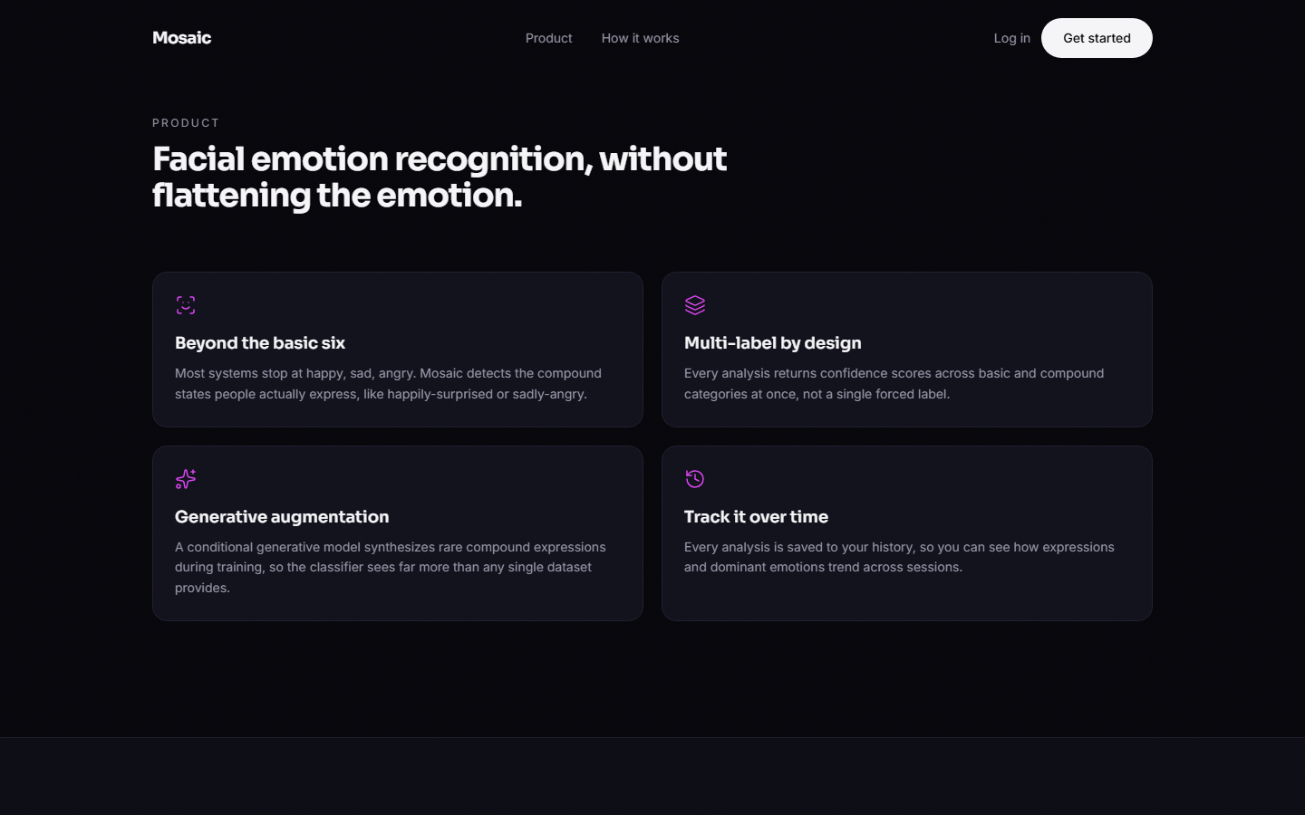  Figure 40: Landing page: the four product features (compound states, multi-label scores, generative augmentation, history).

The landing page presents the product claim, See every emotion, not just one. The feature cards describe compound emotions, simultaneous scores across basic and compound categories, generative augmentation during training and a saved history. The text is marketing copy of the product; Chapter 8 states what the measurements show about the compound categories.
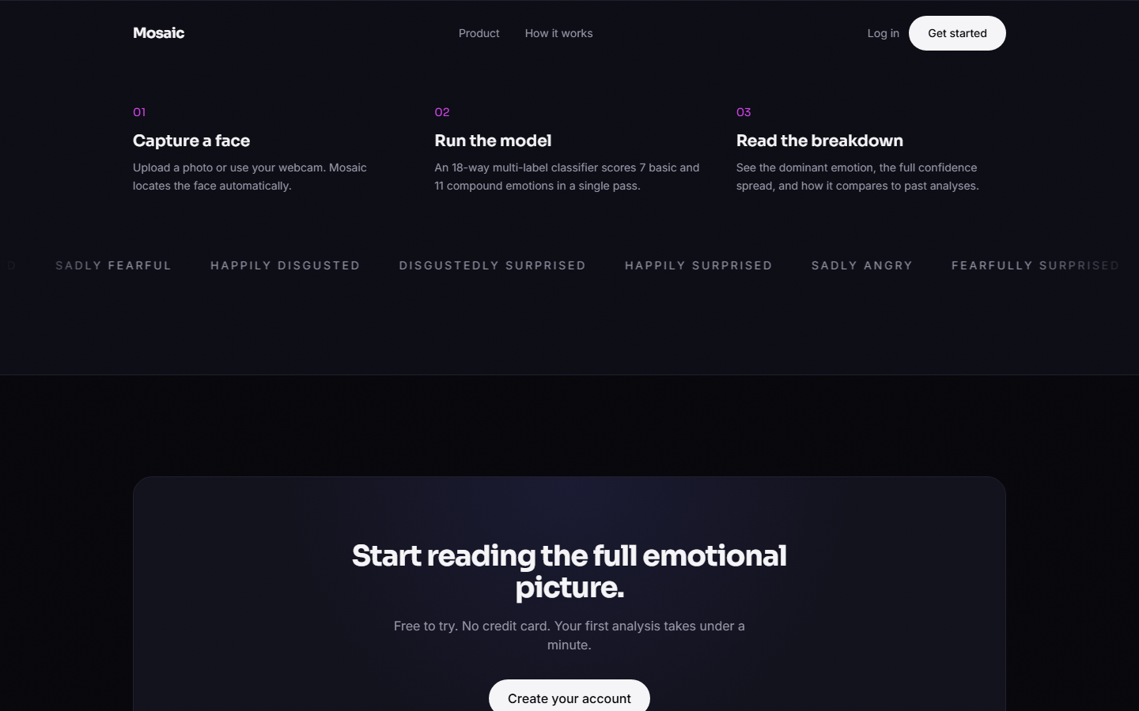  Figure 41: Landing page: the three steps and the ribbon of compound-emotion names. | 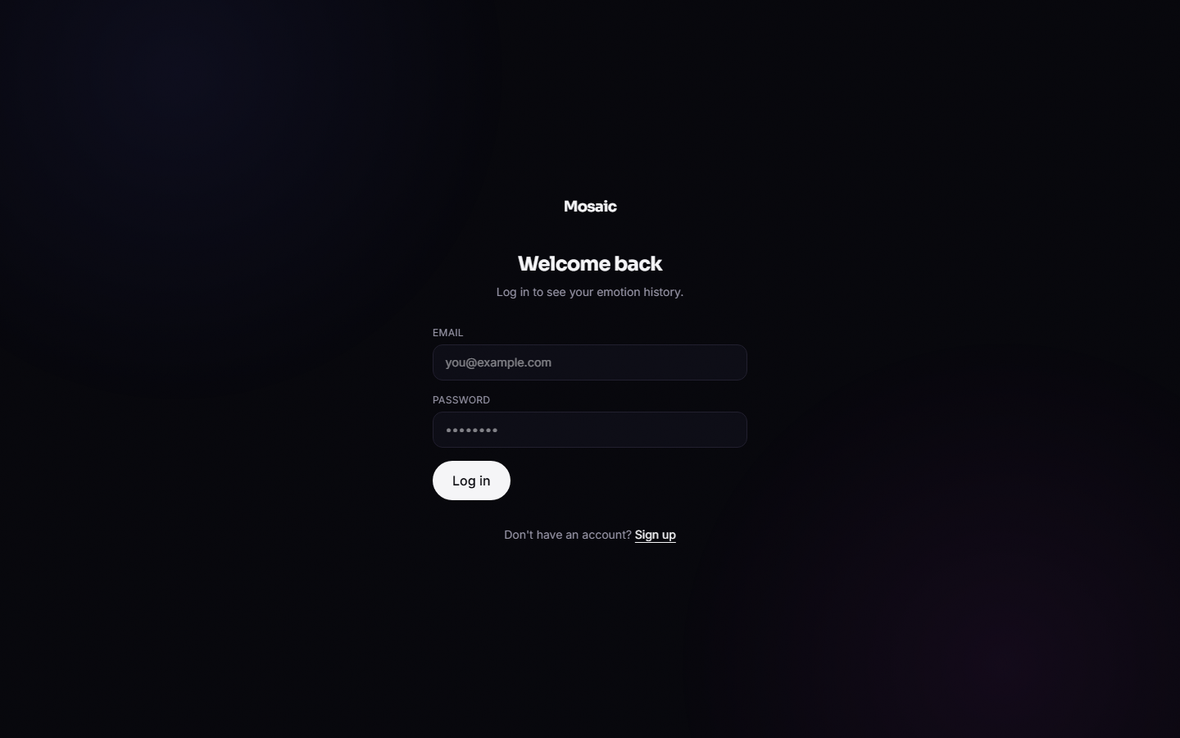  Figure 42: Log-in page: e-mail and password fields.

The three steps are capture a face, run the model (an 18-way multi-label classifier that scores 7 basic and 11 compound emotions in a single pass) and read the breakdown. The log-in page asks for an e-mail address and a password and links to registration.
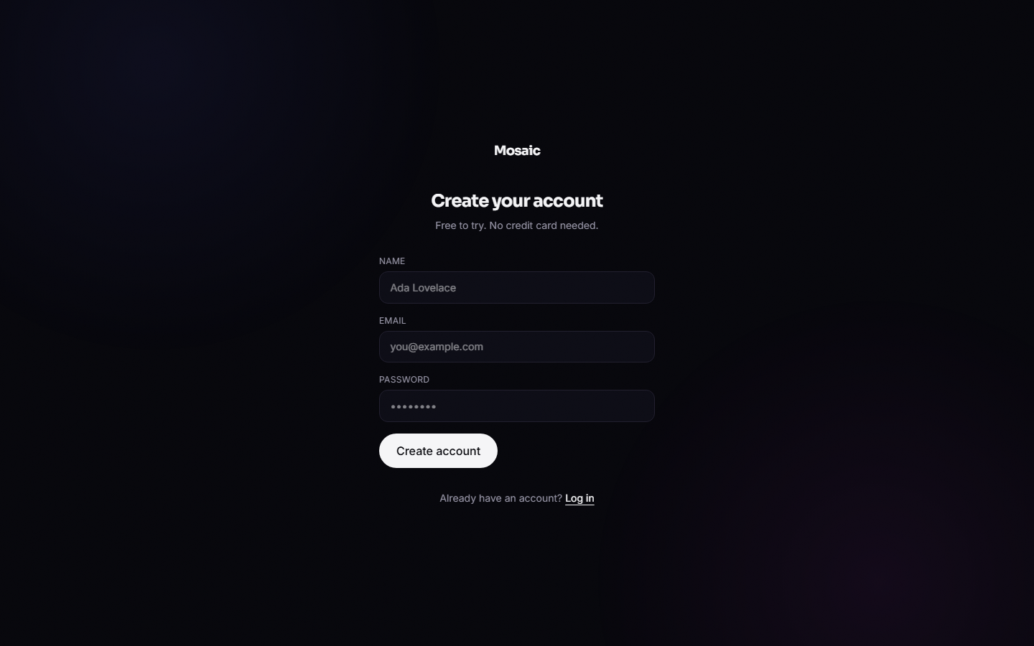  Figure 43: Registration page before input. | 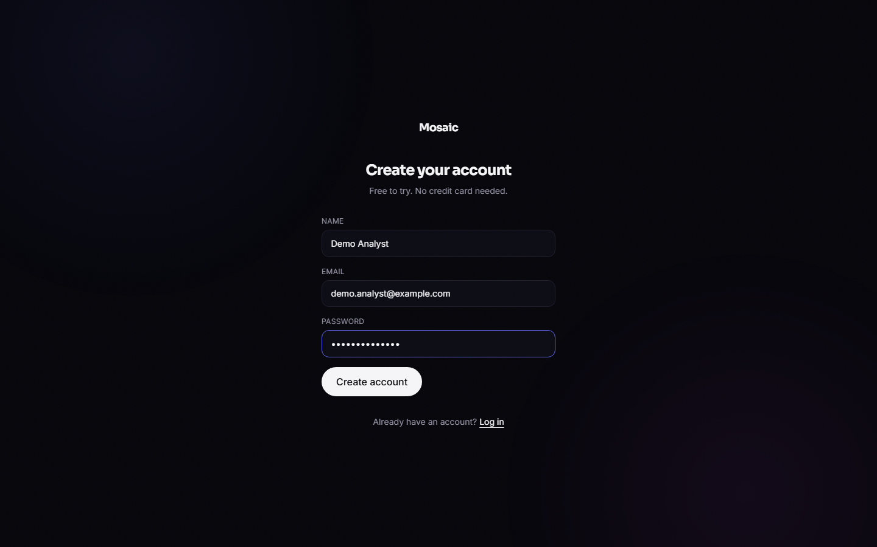  Figure 44: Registration page filled in with the demonstration account (the password field is masked).

Registration needs a name, an e-mail address and a password of at least six characters. After a successful registration the service returns a token and the console opens the analysis page.
Figure 45: Analysis page before any image: upload area and the placeholder results panel. | Figure 46: Analysis page re-opened from the side bar; the Webcam tab was not exercised in this run, the image shows the Upload tab.

The left panel offers Upload and Webcam tabs and a drop zone; the right panel reads Your results will appear here. The side bar shows the signed-in user and the Log out button. The webcam path was not tested because the capture was made with an automated browser; only the file-upload path was exercised.
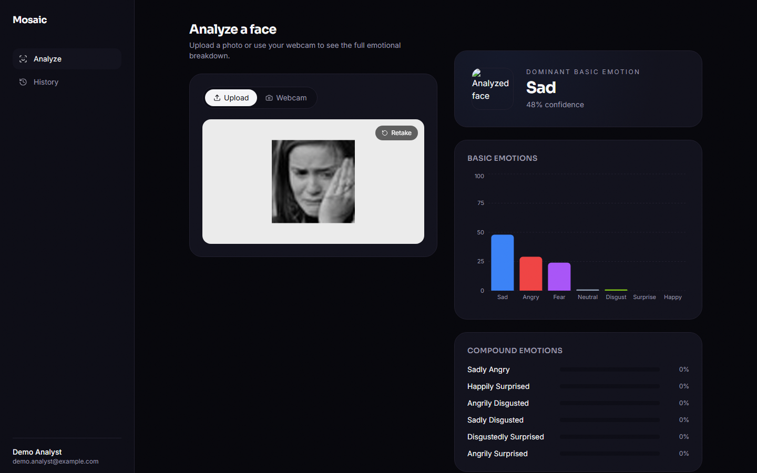  Figure 47: Result for a real FER2013 face labelled sad: dominant emotion Sad. | 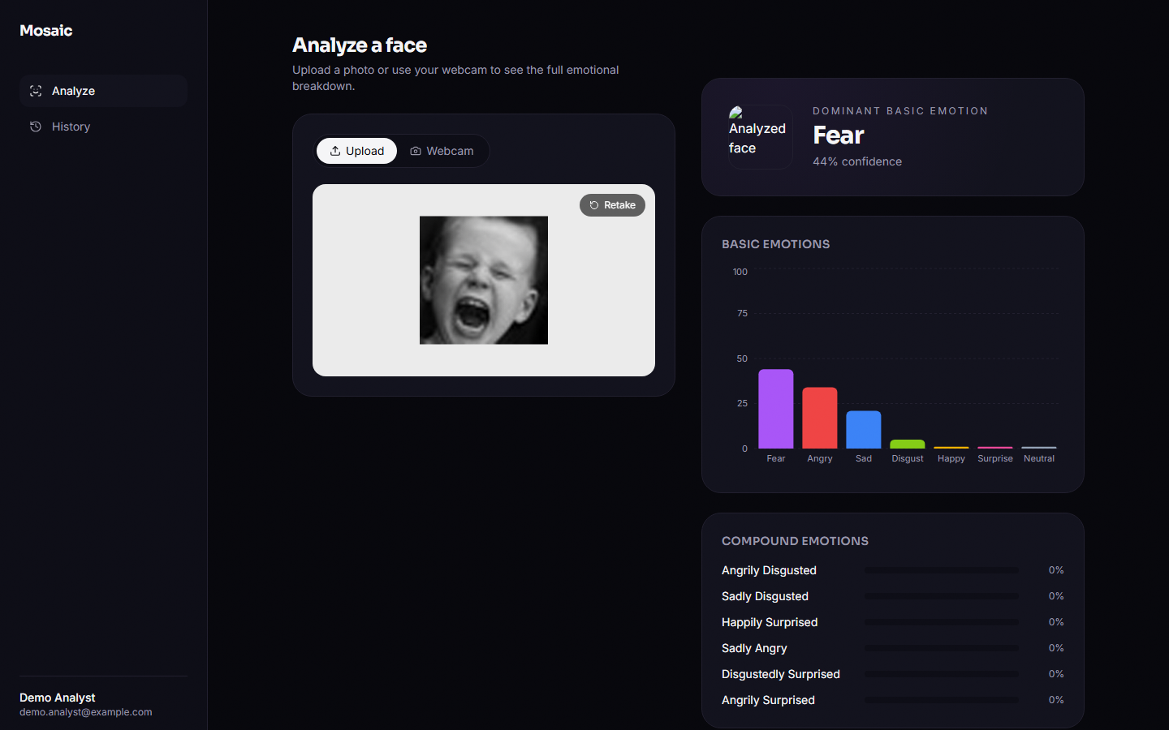  Figure 48: Result for a real FER2013 face labelled fear: dominant emotion Fear.

In both captures the dominant basic emotion agrees with the dataset label and all compound bars stay at about 0 to 1 %. The small image to the left of the dominant emotion is the face thumbnail returned by the API; it renders as a broken image in the console (known defect).
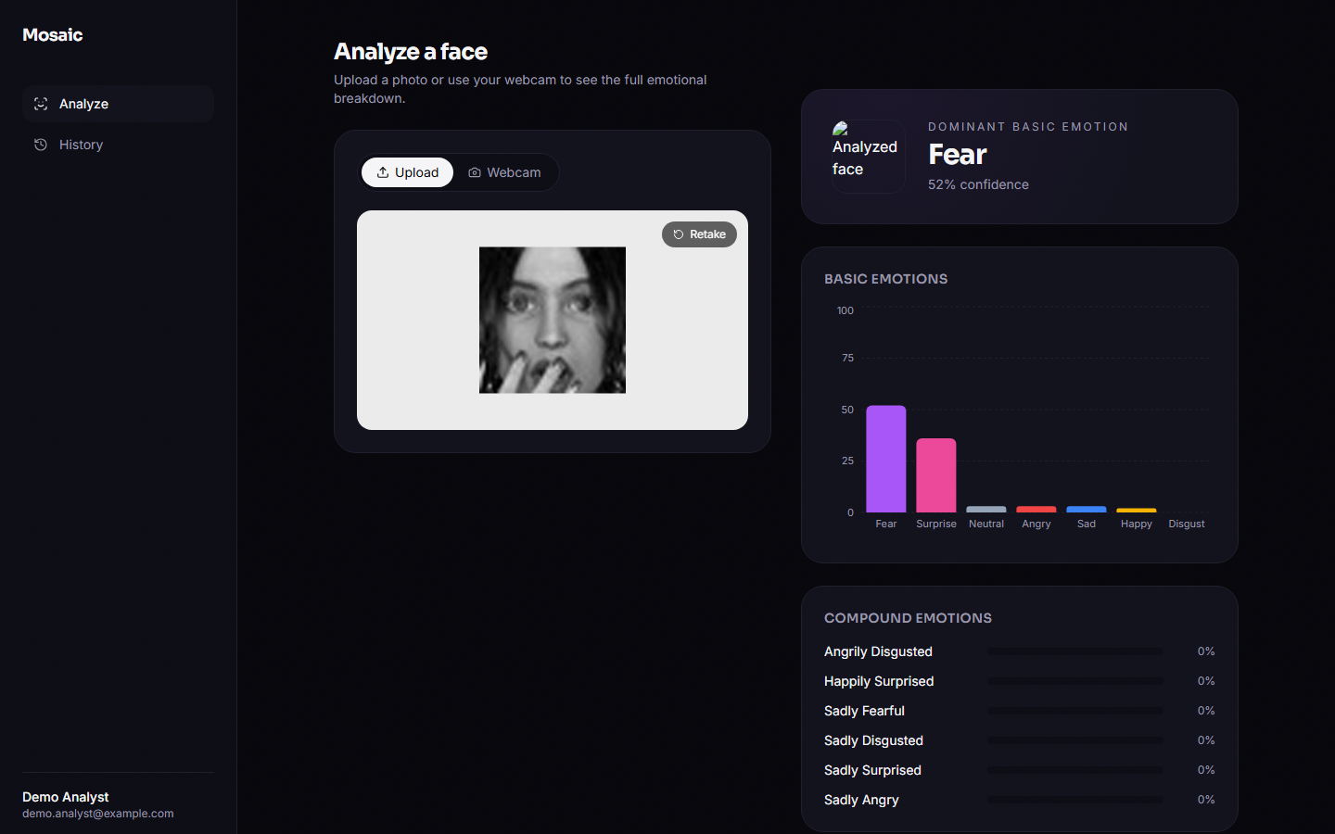  Figure 49: Result for a real FER2013 face labelled surprise, read as Fear. | 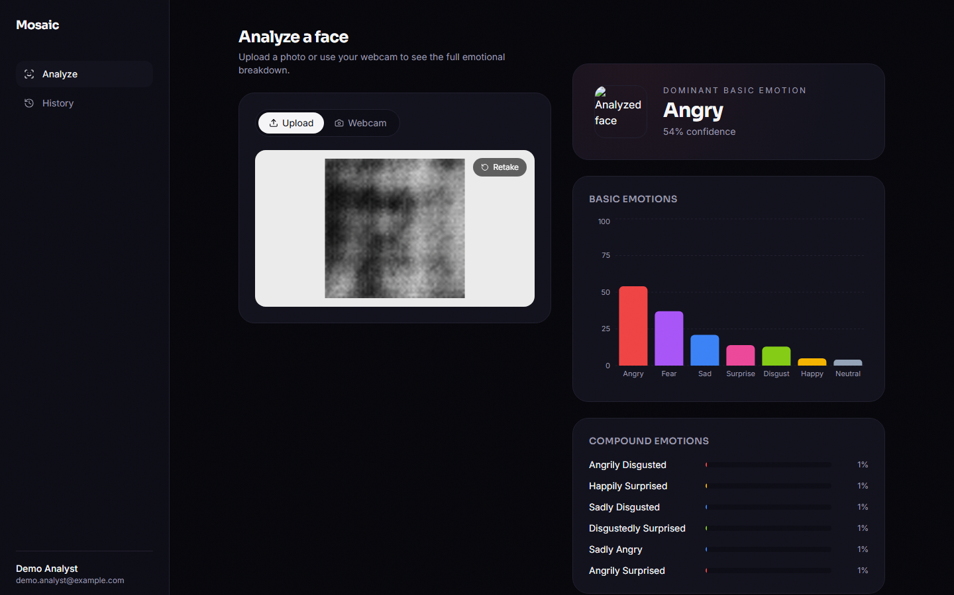  Figure 50: Result for a cEmoGAN-generated face conditioned on angrily disgusted: dominant Angry, compound bars about 1 %.

The first capture is a misclassification: a face labelled surprise is scored Fear (52 %) with Surprise second, in line with the confusion between these two classes reported in Chapter 8. The second is generator output, not a real photograph; the classifier reads it as Angry and gives each compound class only about 1 %, so even a synthetic compound face does not make a compound emotion dominant.

